

**The Roti Spot**

An Online Store for Caribbean Cuisine

Crew:

Sylvester DelVillar

Genesis Novas

Chigaziri Nwoke

CSIT 355-01

FALL 2017

**Table Of Contents**

**Project Requirements**2

Participants 2

Product Developers 2

Client 2

Business and Practices 2

Products 3

Basic Plan of Implementation 3

Collecting Requirements 4

Sources 4

**Analysis of Problem**4

**Design of Solution**5

General Assumptions 5

ER Diagram 6

Logical Model 7

Relational Model 8

Database Tables 8

Admin 9

Category 9

Customer 9

Employee 9

Manager 10

Order Items 10

Orders 10

Product 10

Analysis of Data Model 10

Normal Forms Discussion 11

Data Views 11

**Test Plan**26

**Results**33

Summary of Findings 33

Challenges 33

Conclusions 33

**Appendix of Code**33

**Citations**102

# Project Requirements

## Participants

### Product Developers

Genesis Novas

Sylvester DelVillar

Chigaziri Nwoke

### Client

Shamar Michaels, Owner of The Roti Spot

## Business and Practices

The client, Shamar Michaels, is interested in expanding their availability to the online world. Shamar Michaels is looking for a website for The Roti Spot, in order to expand their ordering platform to the online community. Customers would be allowed to place orders in advance, that employees could look at based on date and time, while also being able to check it off as a completed order. This would also increase publicity, as well as having an easy ever changing menu that customers could access whenever they wanted. The Roti Shop will have a variety of products, from the trademark roti, available in different fashions, to dahl, and jerk chicken. There of course will be some rice and beans for the added sides. The Roti Shop also sells various Caribbean flags for convenience of purchase to represent the islands.

We expect customers of the Roti Shop to be the primary users of the website, along with the employees of the establishment to check in on any online orders. The orders will be received through a database, and a list of orders will be retrieved from an employee account. The lowest level will be someone logging in with no account. They can just browse the products, but cannot place an order. The next level will be a logged in customer, they can place orders and review their previous order history. The next level will be an employee, they can check every order a customer has made. A step above this will be the manager, who can modify inventory and check what the employees are doing. Finally, there is the administrator, Shamar Michaels, who will be able to manage accounts (that is to say, delete customers and employees as needed) along with everything the employee can do.

## Products

**Roti**

* Dhal Puri
* Bussup Shut Roti
* Pepper Roti
* Sada Roti
* Aloo Roti

**Patties**

* Beef Patty
* Spinach Patty
* Jerk Chicken Patty
* Vegetable Patty

**Main Dishes**

* Ackee and Saltfish
* Jerk Chicken with Rice and Beans
* Tandoori Chicken
* Oxtail with Rice and Beans
* Curry Chicken and Rice
* Curry Goat with Rice and Beans

**Sides**

* Rice and Beans
* Boiled Dumpling
* Callaloo
* Festival
* Kola Champagne
* Ginger Beer

**Flags**

* Jamaica
* Trinidad
* Guyana
* Barbados
* Dominican Republic
* Hondurian Flag

## Basic Plan of Implementation

The members involved in the development of the Roti Spot website are Genesis

Novas, Sylvester DelVillar, and Chigaziri Nwoke. Based on what the client is asking for within the restaurant's website, we as a group have decided to delegate different tasks among each other. Sylvester Delvillar will be responsible for finding out information on the products the Roti Spot wants to have displayed on the web. Chigaziri Nwoke will be responsible for the miscellaneous information such as the location, and phone number of the Roti Spot. The group members will also be responsible for the implementation of these factors into the product i.e the website, itself. Lastly, Genesis Novas will be responsible for collecting information from the employee at the shop. As the project is developed there will be more tasks that will be entrusted to each member of the group. Each member will participate in both the coding and data model aspects of the project. Everyone will code whether its front end or backend.

## Collecting Requirements

Our team plans to survey The Roti Spot in order to find out about their varied products, and to get a feel for the most popular items. We are getting our requirements from our client Shamar Michaels. He owns the Roti Spot and will be giving us a list of prices, pictures, foods, and list of other miscellaneous items they sell like flags.

## Sources

The Roti Spot is our primary source for all information, along with the Internet to find out information about the products. The Caribbean flags for example, can be researched upon in order to find an optimal display for them. The client, Shamar Michaels, will absolutely provide key information required for the implementation of this product.

# Analysis of Problem

The internet has made accessing everything much easier and has kept everything accessible from the home. While this is a good thing for many big companies like Amazon, Ebay, Walmart and etc. Small companies usually do not have the money to have companies like uber eats work with them so they must depend on people actually going to their store or having people call in to order which can be sometimes tedious for the people working in the restaurant at the time. A website that allows people to place orders before time will allow the people working at the restaurant to see every and any order coming up without having to wait for the person on the phone to announce the order. This is what caused Shamar Michaels to call us up and ask us if we wanted the opportunity to work on a website for his Store the Roti Spot.

# Design of Solution

## General Assumptions

* Administrator depicted as Roti Spot itself.
* Roti Spot does not offer delivery at the moment.
* Roti Spot offers predetermined food options.
* Customer can ask for special needs when submitting order through order description attribute.
* Product is generalized since food orders are generic bases, and The Roti Spot also sells different types of flags.
* Food comes with two sides, free of charge.
* As a small business, other than the client, Shamar Michaels, there is no real supervisor, especially not a constant one that needs to be depicted for a specific employee.
* However, position may play a role in the conduction of The Roti Spot.
* As a traditional shop, we assume that each product will have its own unique name.

### ER Diagram

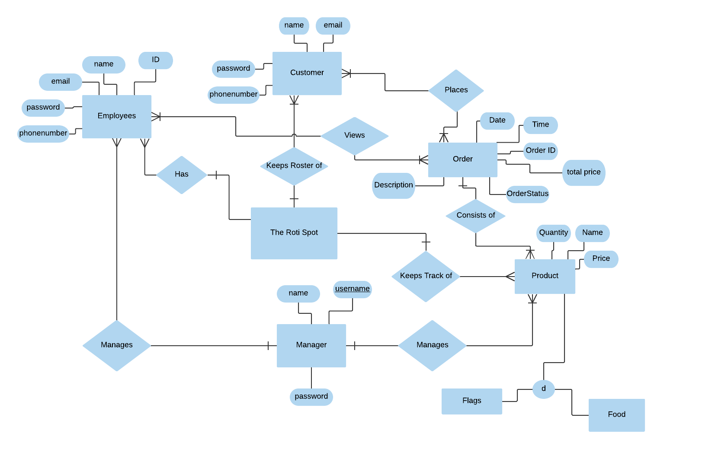

### Logical Model

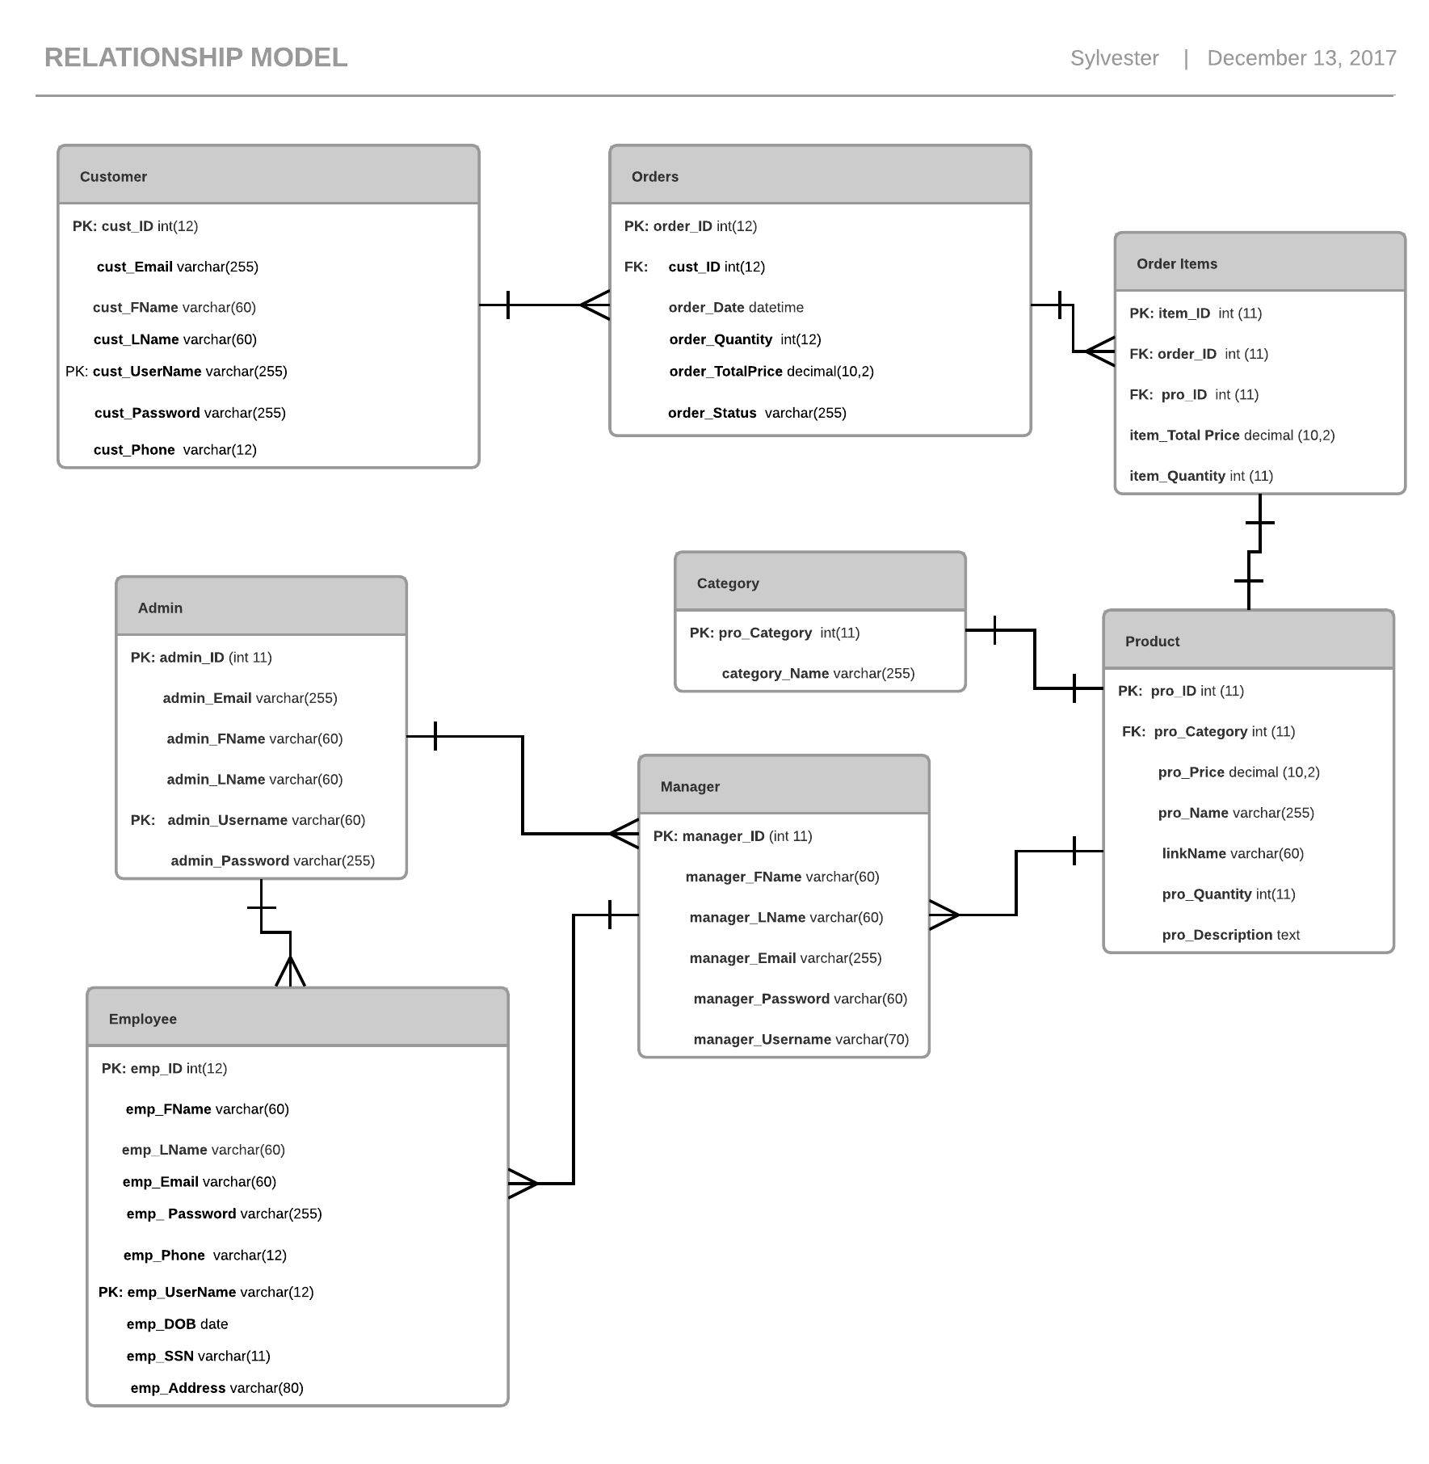

### Relational Model

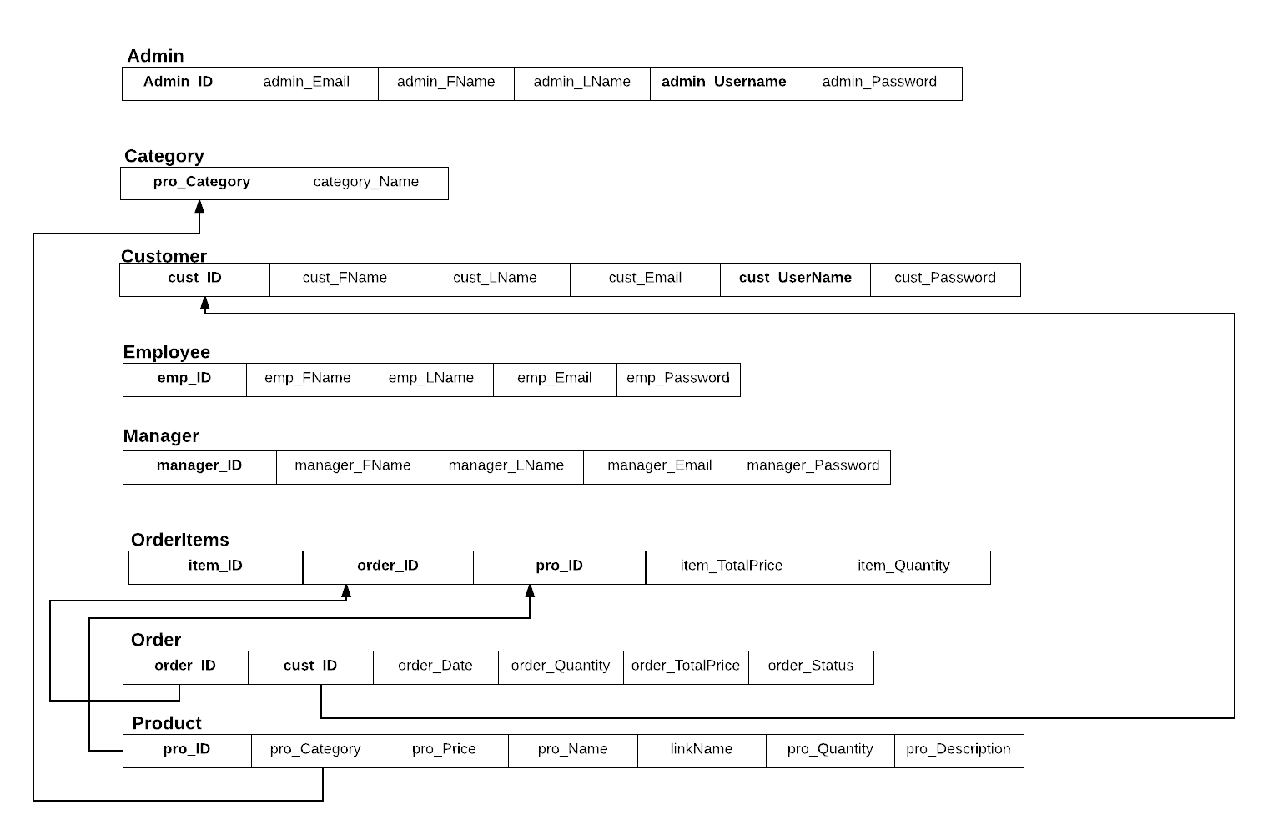

### Database Tables

##### Admin

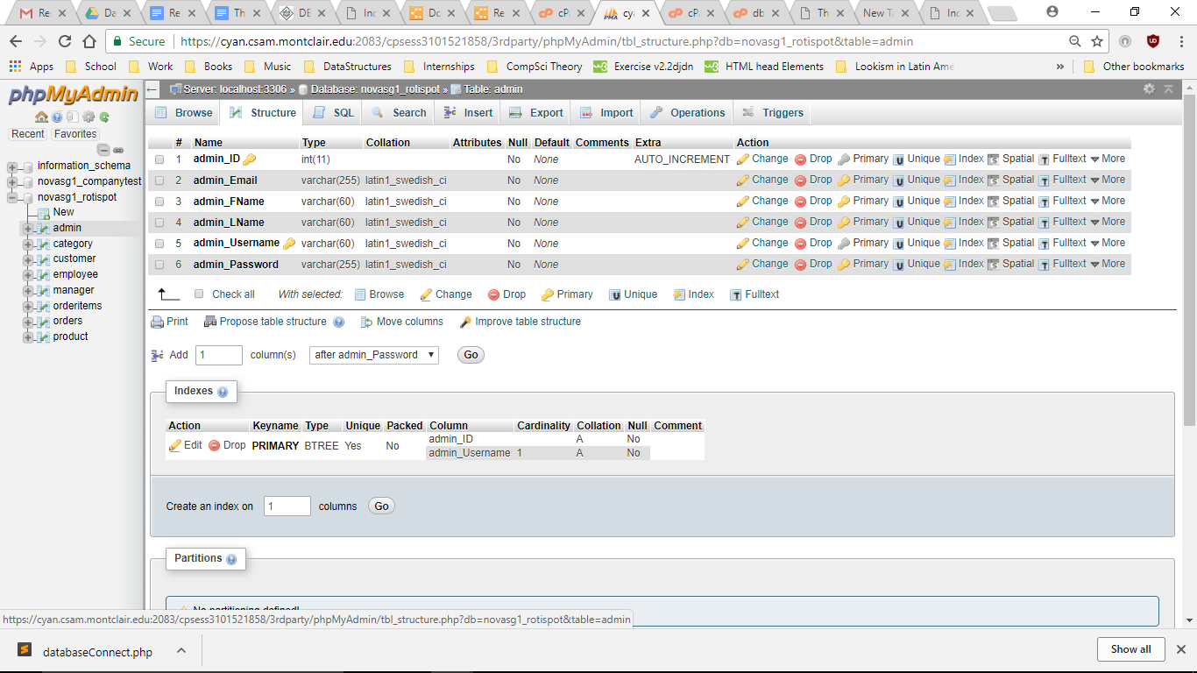

##### Category

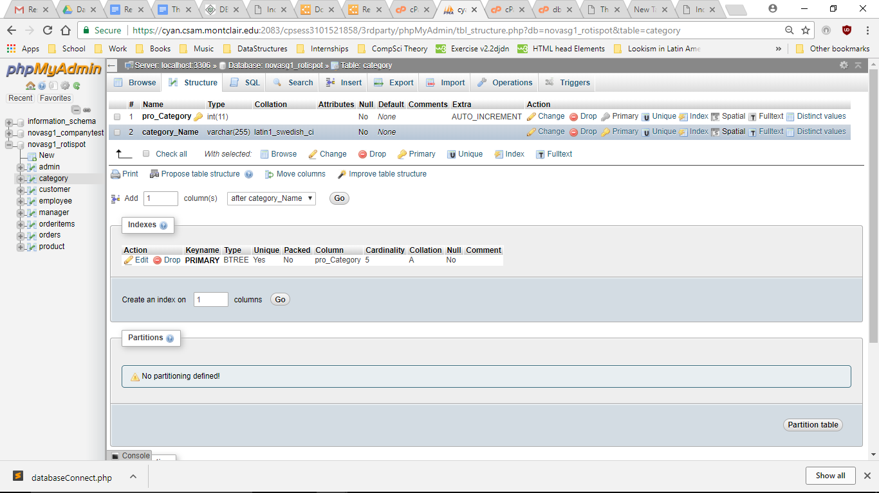

##### Customer

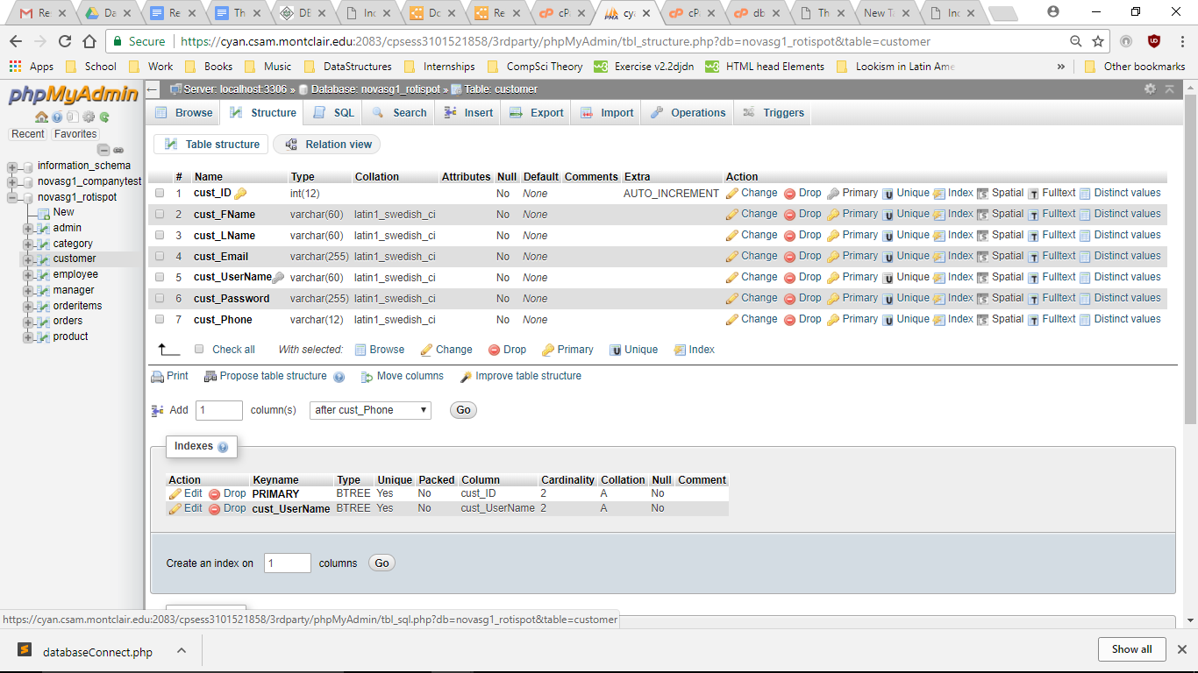

##### Employee

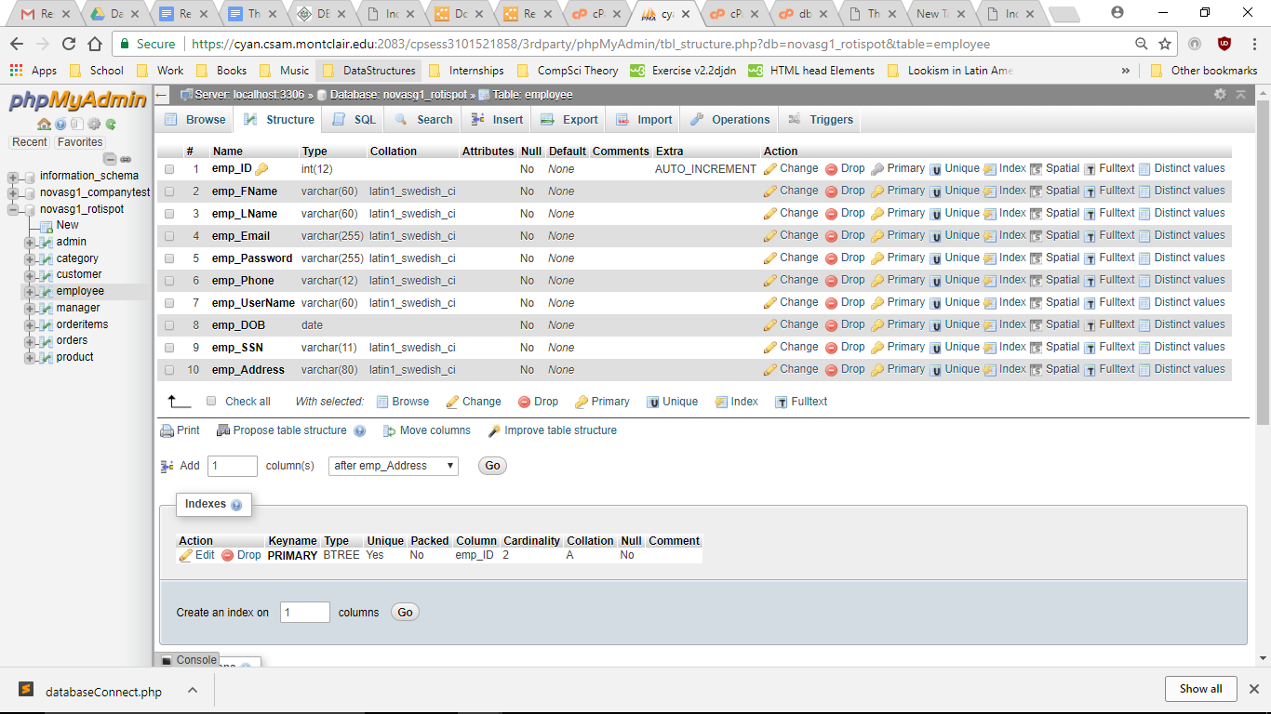

##### Manager

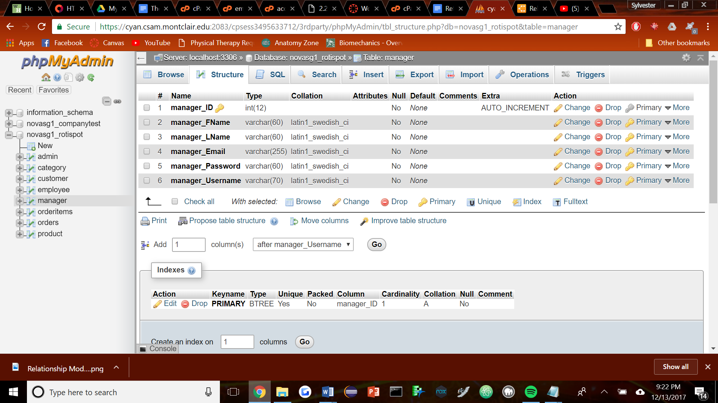

##### Order Items

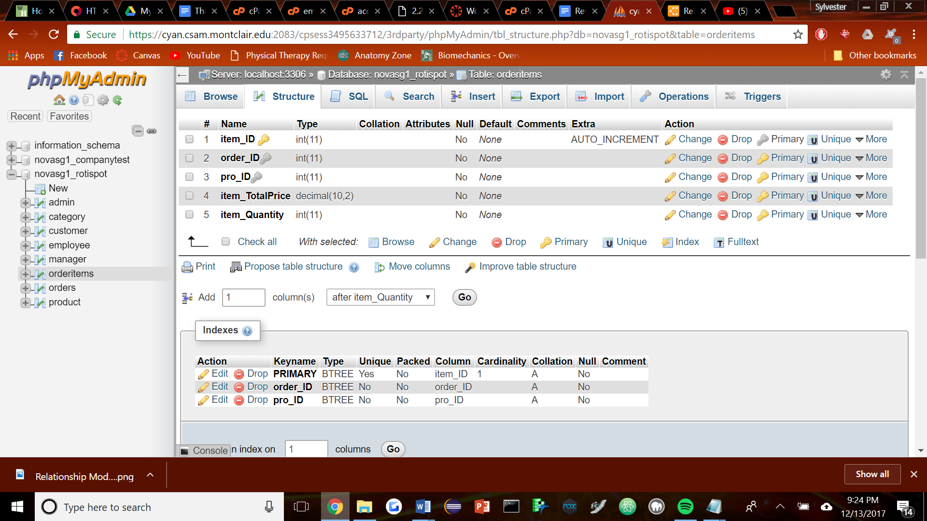

##### Orders

#### 

##### Product

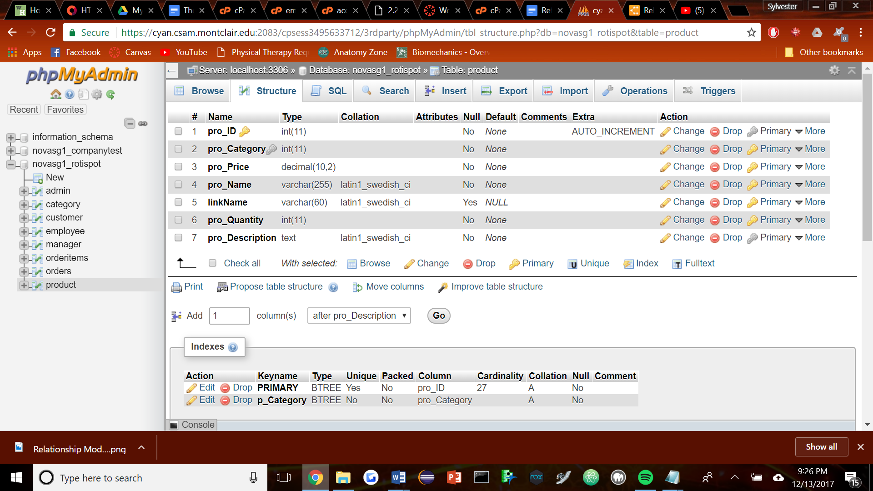

### 

### Analysis of Data Model

Our ER diagram shows the connections between the entities and what they do concerning their attributes. For example, an employee can see an order through their view. This means that employees view the all orders that come through to the restaurant's website. Our table basically specifies what role each person or the entity is doing in relation to another entity or attribute. When employees see the order they also see the date, time, price, status of order, description and the id of the order.

### Normal Forms Discussion

Each table above implements 1NF as they each have a primary key. The interactions go from order down in a fluid motion. An order must consist of order items, which are simply products put together with their proper quantity. As shown, they relate through proper foreign keys down this fluid method. An order also relates to the proper customer who ordered it, and has a foreign key referencing it. Products are also in categories and a foreign key is assigned that way.

### Data Views

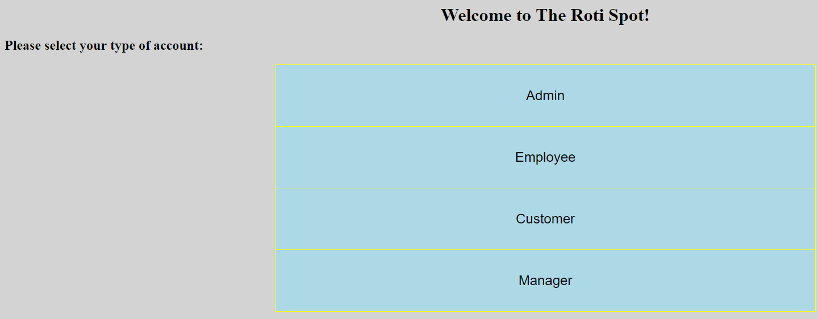

In order to access the website, the user has to choose one of the four different views of the site. Each of these different views give off a different perspective of the website. Each view has different levels of access to the database and what they can see on the website. For example, the customer has the least amount of access to the database while the admin can see everything that the customer can see and more. It goes from customer, employee, manager, and then admin in that order of power.

Customer

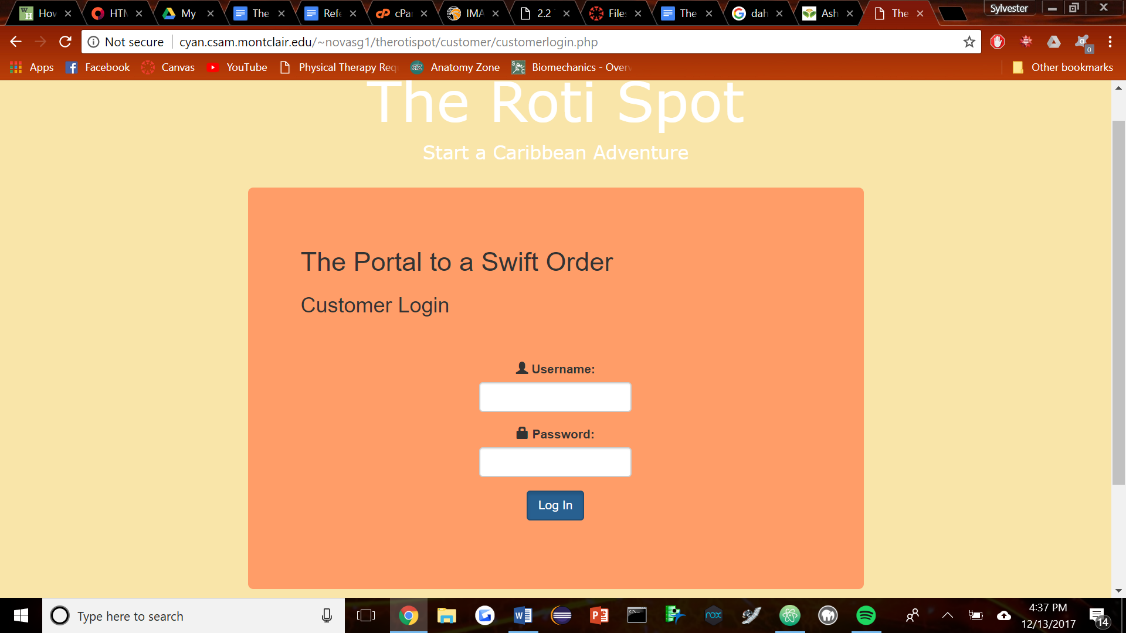

Figure Customer 1

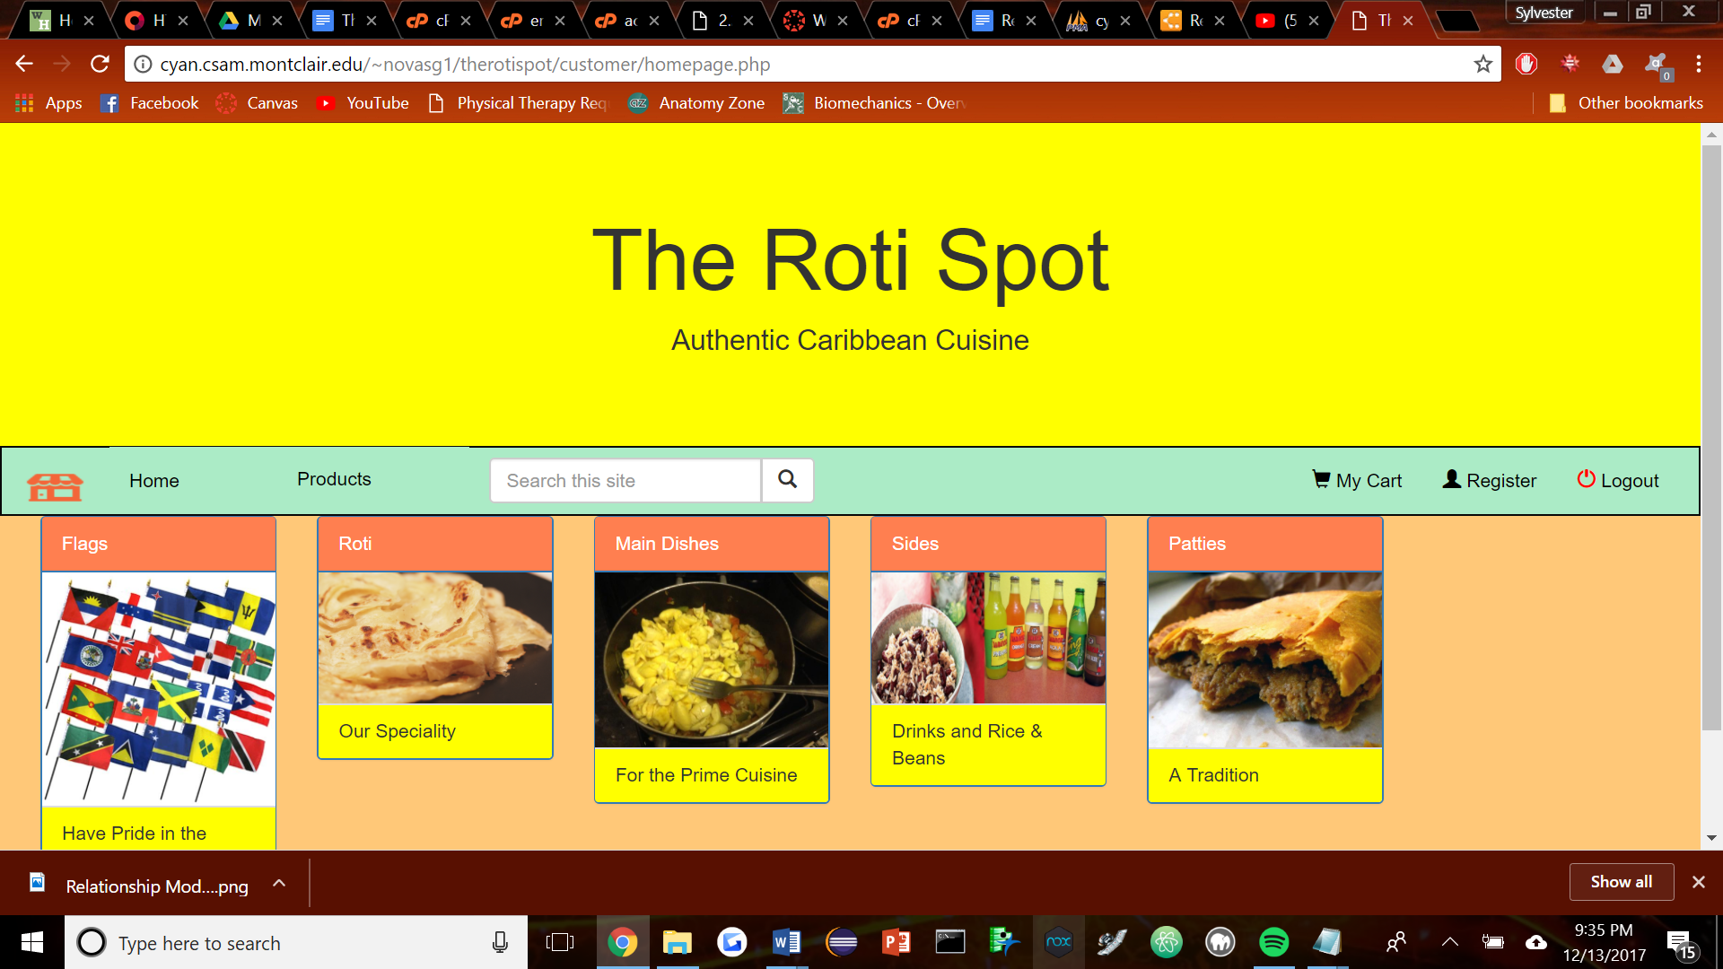

Figure Customer 2

The first page that comes up for customer is the login page. As shown in (**Figure Customer 1**). The user must be registered within the website's database in order to access the users. Once they enter the correct credentials they are greeted with the homescreen for customers which allows them to view a general list of the different foods and products sold at the store look at (**Figure Customer 2**).

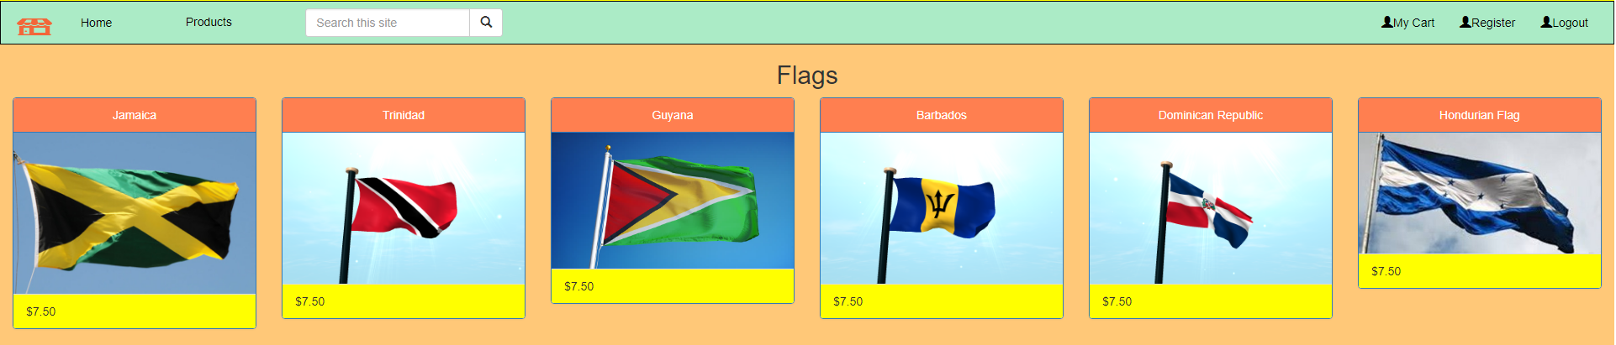

Figure Customer 3

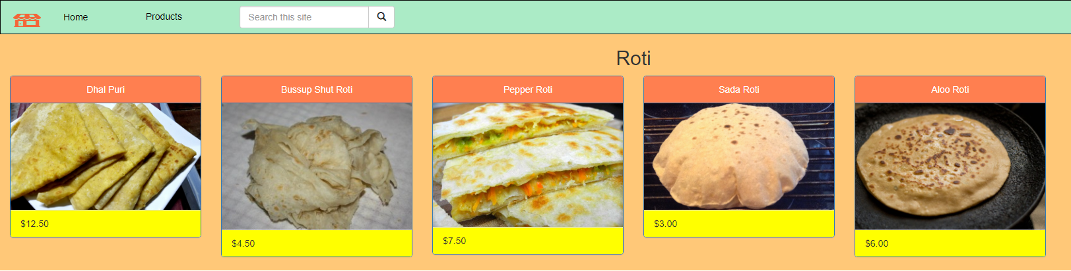

Figure Customer 4

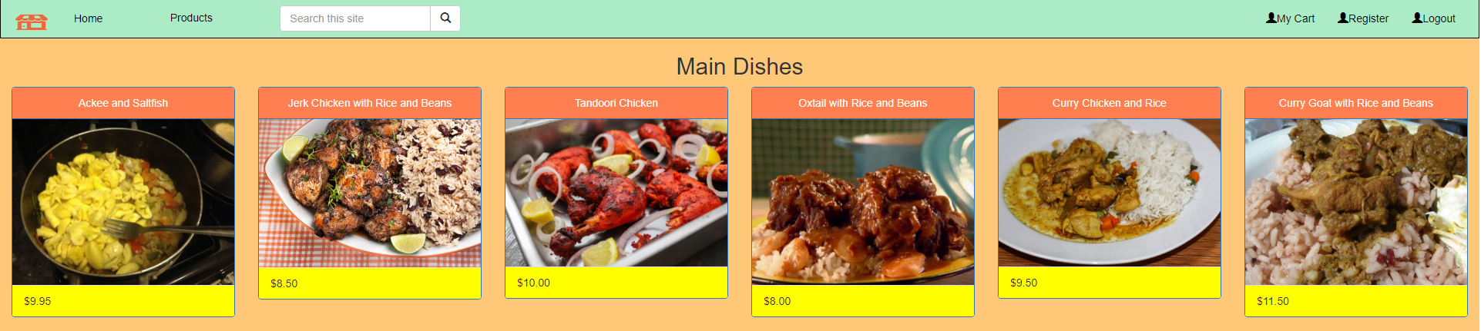

Figure Customer 5

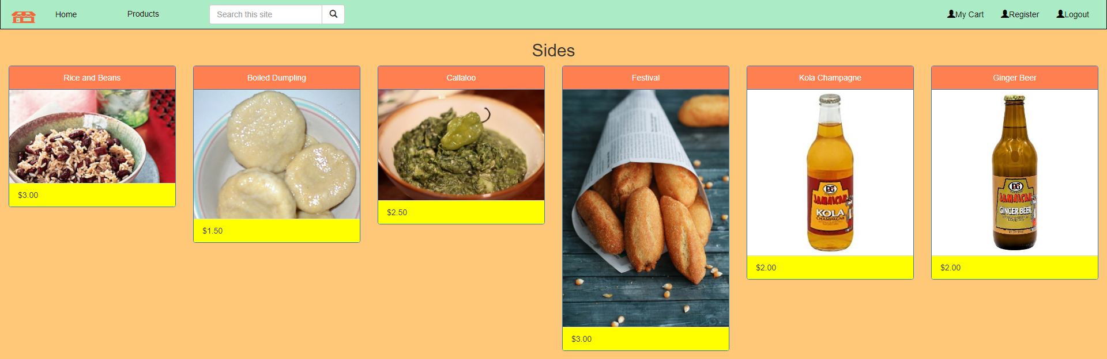

Figure Customer 6

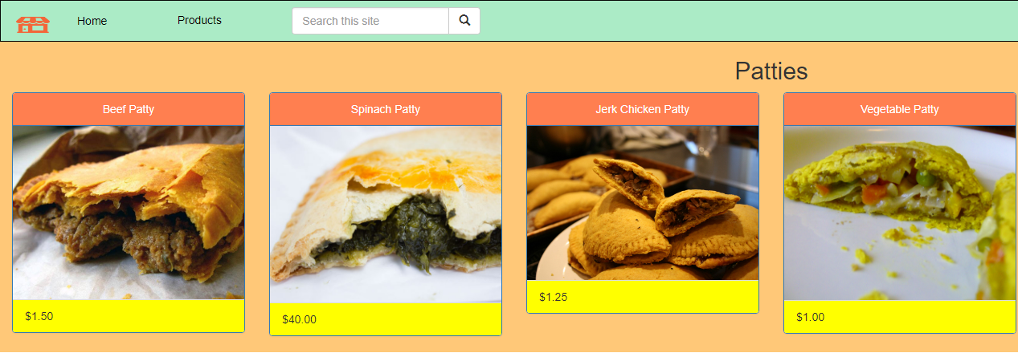

Figure Customer 7

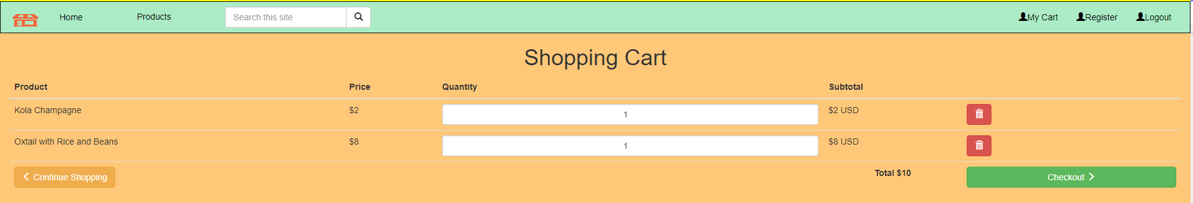

FIgure Customer 8

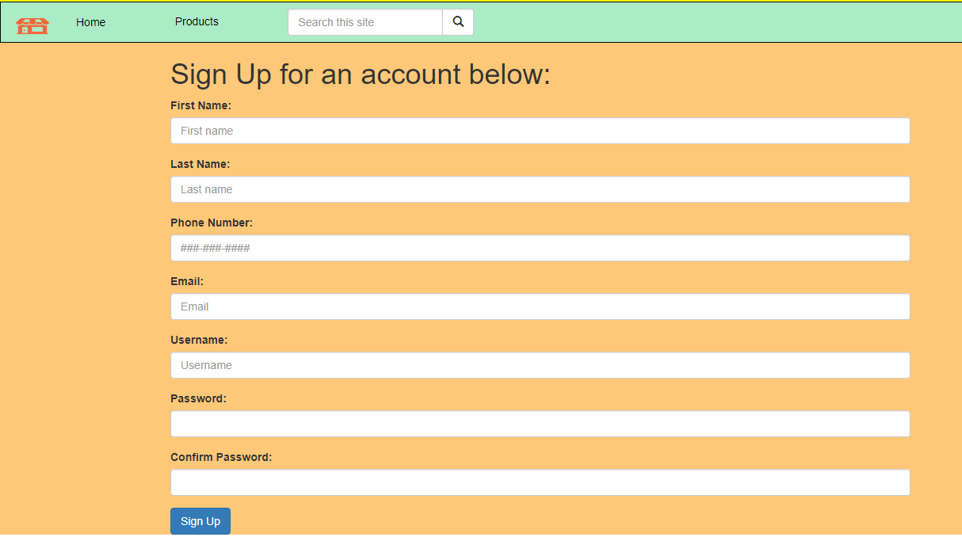

Figure Customer 9

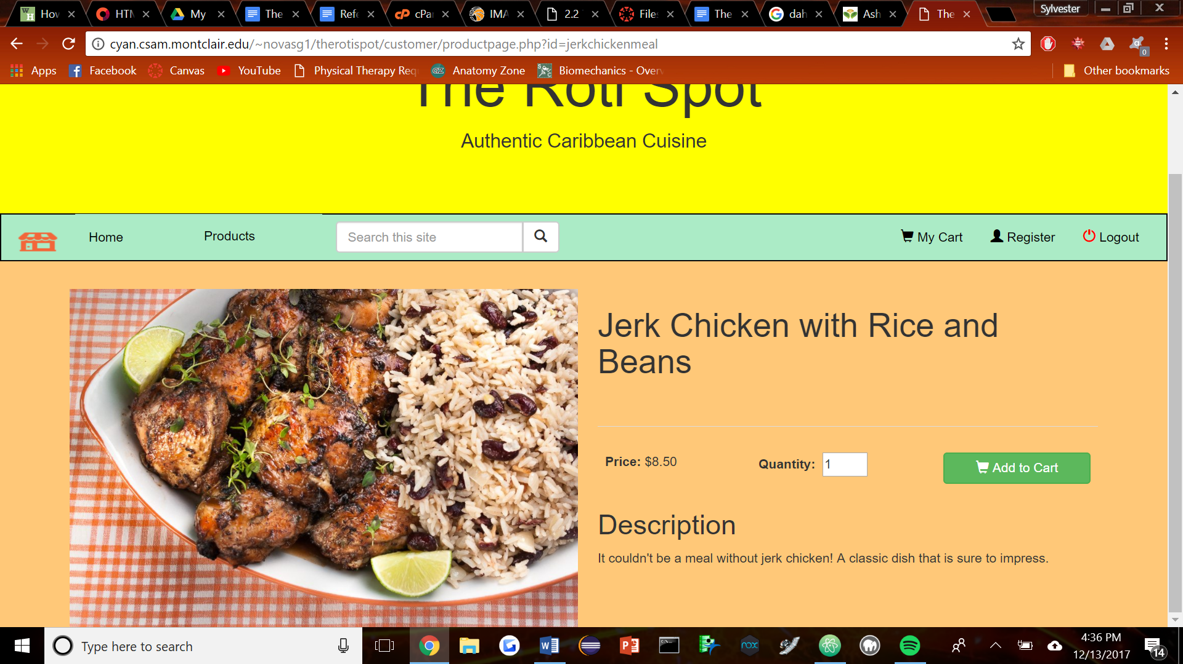

Figure Customer 10

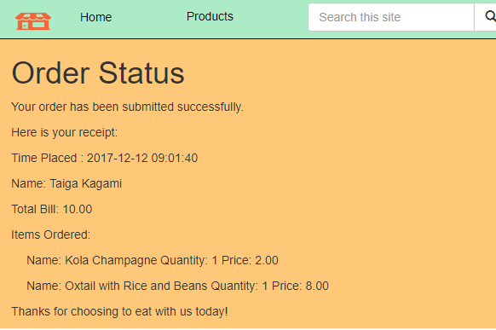

Figure Customer 11

These screenshots show the portion of the website the customer sees while browsing and traversing the site. **Figures 3-7** show a more detailed view of the items sold at the Roti Spot. **Figure 10** gives you more information on any given item that is clicked and allows you to add it to the cart while selecting the quantity. Figure 8 brings up the cart and allows you to modify your order and then when your order is placed you get to Figure 11 which shows you your order and the total of your bill. **Figure 9** is our registration page for any new members who want to join and be able to order from the store. People who register through this way are only given customer level access to the site.

Employee

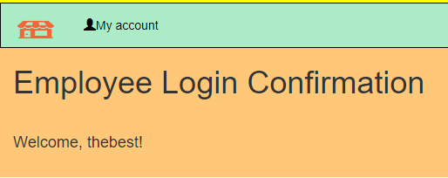

Figure Employee 1

With employee view you go through the same process as you would when logging into customer, a login page. The only difference is that you are not directed onto the same page that the customer is sent to. After entering your credentials you land on a page that confirms that you are logged onto a employee account.

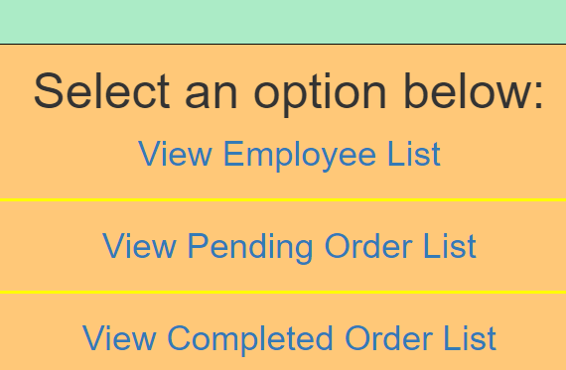

Figure Employee 2

The employee has access to view other employee accounts, any pending orders and the completed order lists of the database.

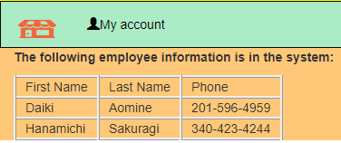

Figure Employee 3

When the employee selects to view other employees, they are given access to the names and phone numbers of other employees. With this information they can then communicate with any employees they made need to be in contact with to change their schedule or speak to them about things concerning work.

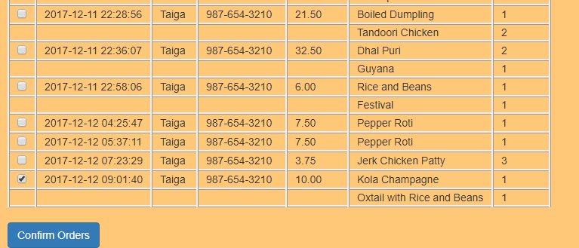

Figure Employee 4

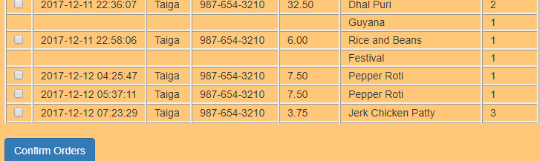

Figure Employee 5

This is the pending order list that the Employee sees. This information is taken from the database and gives the employee the date, name of person placing the order, the number associated with the account, the price, the item desired and the amount being ordered. When the order is completed, the employee checks the order and then hits confirm order and then the order is removed from the list as see in **Figure 5**.

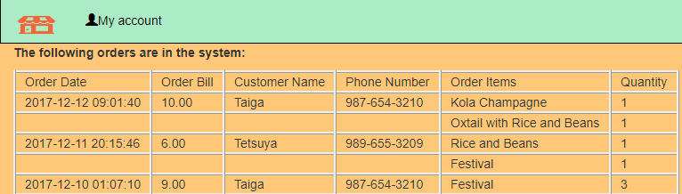

Figure Employee 6

This is the completed order list page that the employee sees. Once the employee check marks that the order has been completed it is then displayed within another table that shows all the orders that have completed within the site. This page draws from the completed order list in the database and brings the order date, bill, customer name, phone number, order items and quantity. The checked pending order that was seen in (**Figure Employee 4**) was removed from the list and brought to the completed order list which is seen in( **Figure Employee 6**).

Manager

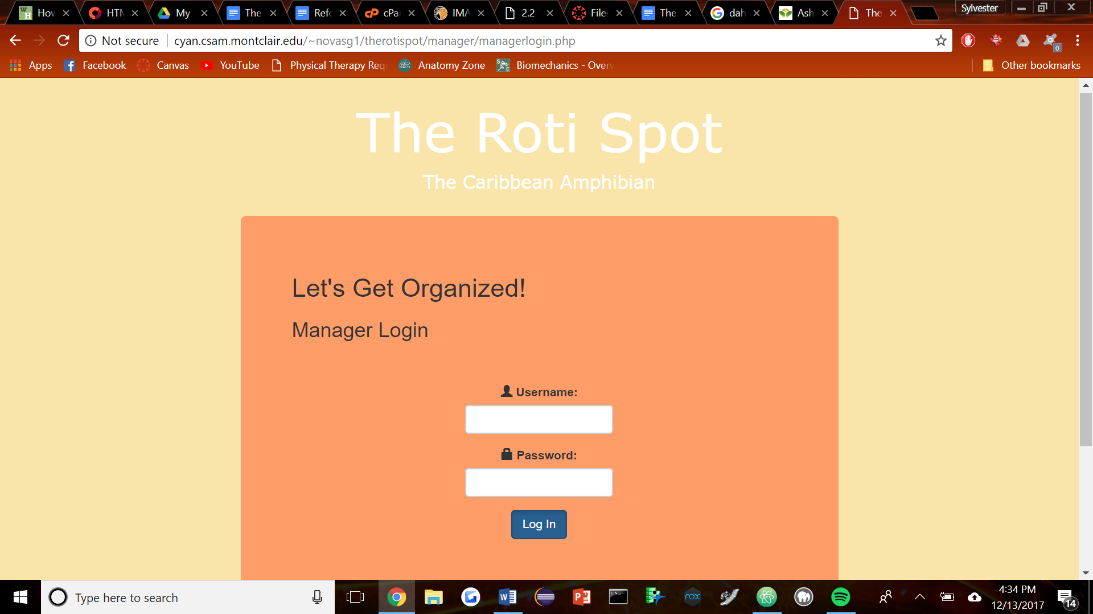

Figure Manager 1

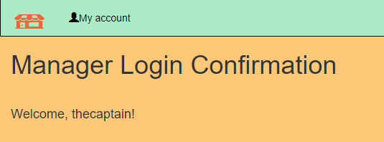

Figure Manager 2

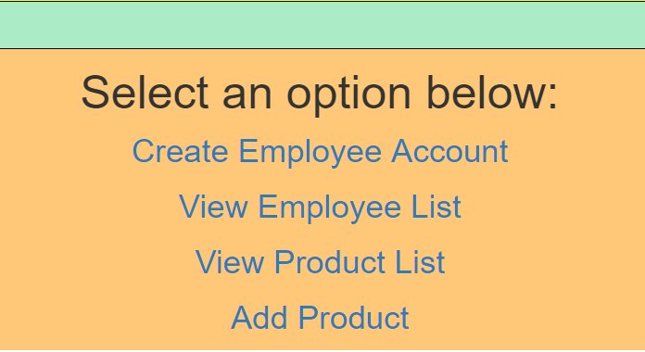

Figure Manager 3

**Figure Manager 1-3** demonstrate the views of the manager. They have more privileges in the database than that of the customer or employee views. (**Figure Manager 2**) shows the confirmation page the manager is directed to ensure that he/she has logged into the system. When the Manager clicks on account you are presented with four options Create Employee Account, View Employee List, View Product List, and Add Product.

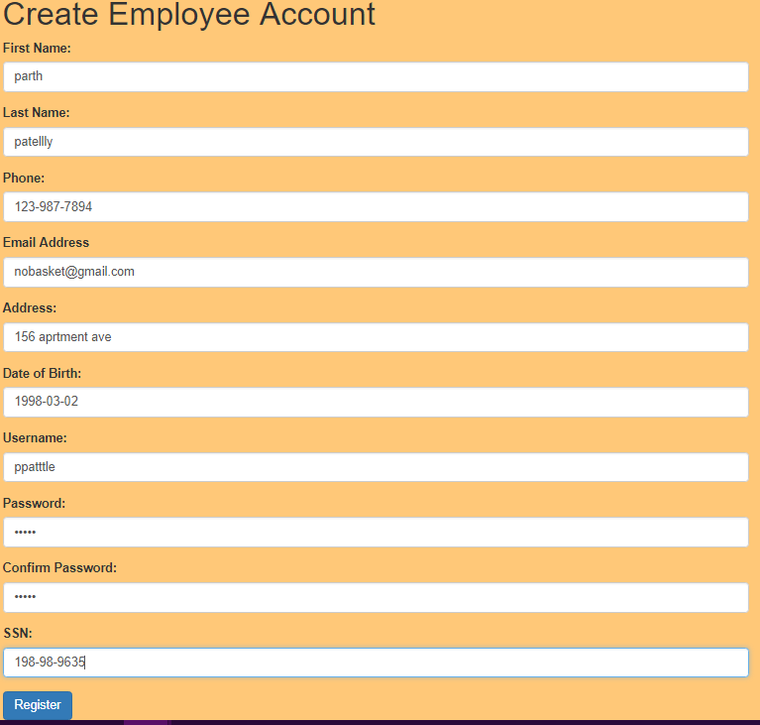

Figure Manager 4

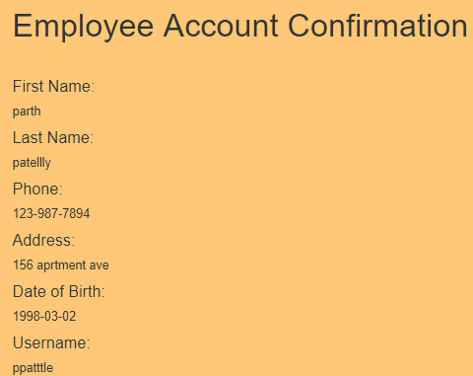

Figure Manager 5

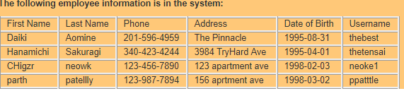

Figure Manager 6

The page in **Figure Manager 4** is the create an employee registration page. Once all information is entered onto the page, the user hits register and the information is confirmed on the next page (**Figure Manager 5**). Once that information is confirmed it can be viewed on the view employee list page seen in **Figure Manager 6**. Which contains lists of all the employees on the that work at the store along with their information.

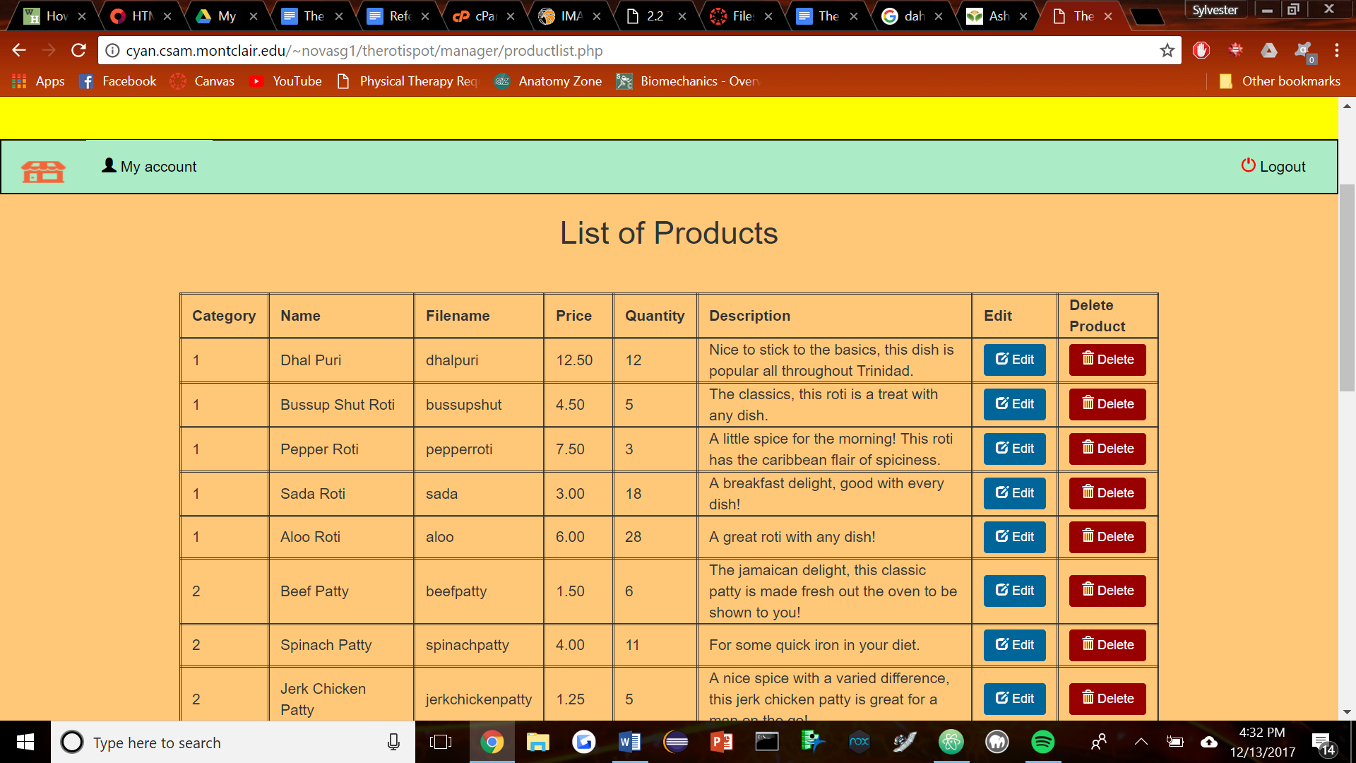

Figure Manager 7

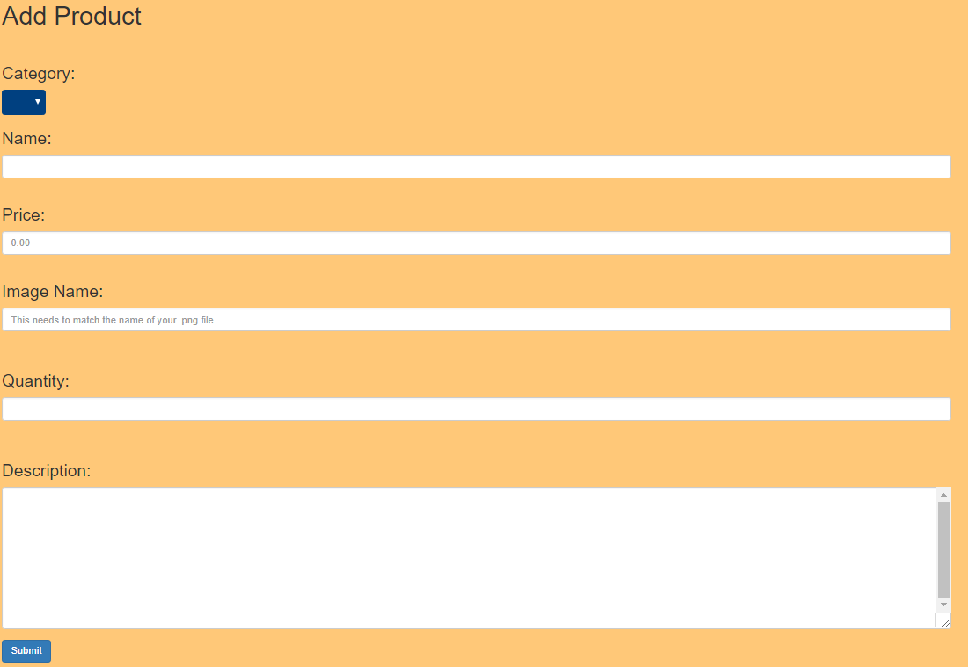

Figure Manager 8

The next two pages for the Manager has to deal with the products being sold. The first page is our view products page (**Figure Manager 7**). This page allows for the manager to check the items in the store, as well as the ability to edit and delete items. The edit page is exactly the same as the add product page that is seen in **Figure Manager 8**. The add product page adds items to the database. You can attach an image to the item by the url.

Administrator

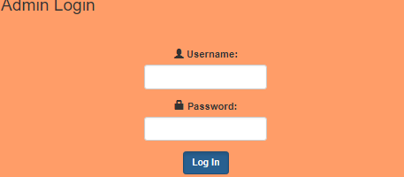

Figure Admin 1

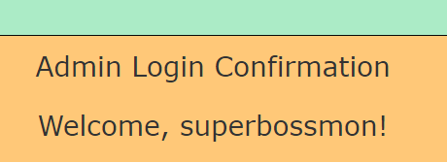

Figure Admin 2

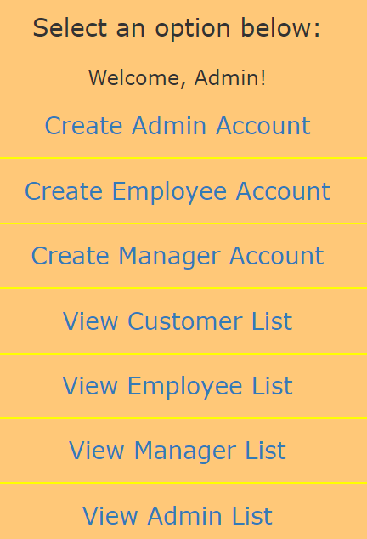

Figure Admin 3

Last but not least there is the Admin user. This user goes through the same process of having to log in to access their view of the website. Admins are given permission to create and remove other admins, managers and or employee accounts. The admin has the most privilege and access to the database when it comes to the people that have access to the website.

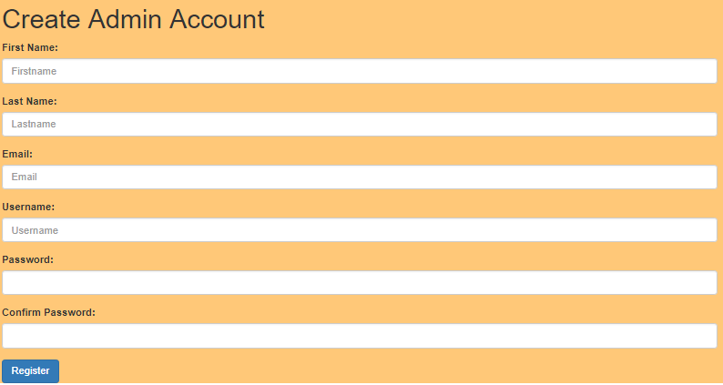

Figure Admin 4

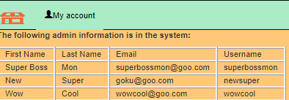

Figure Admin 5

**Figure Admin 4** shows the page that allows the admin to register other admins to the database. When the admin is registered they are added to the list that is seen in **Figure Admin 5** and they receive admin abilities.

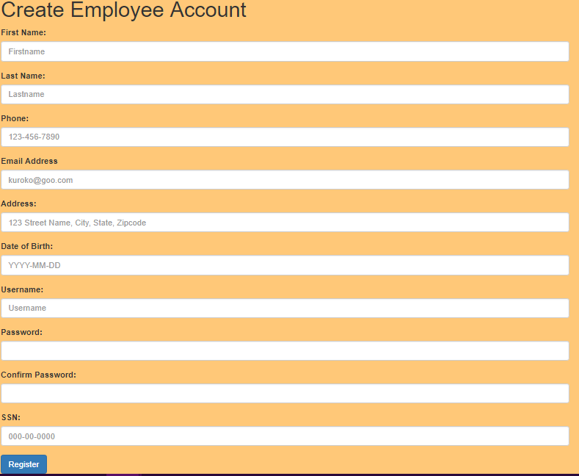

Figure Admin 6

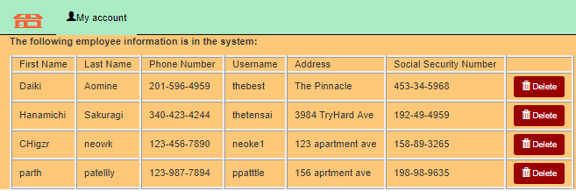

Figure Admin 7

Just like when registering admins the same steps apply to adding employees. **Figure Admin 6** is the registration page for the employees. **Figure Admin 7** is the page that shows which employees have been registered to the database. The only difference between the view of this page and the way the employee sees this page is that the admin gets to see the social security number, username, address of the person plus they are allowed to delete employees while other employees are not allowed to delete others themselves.

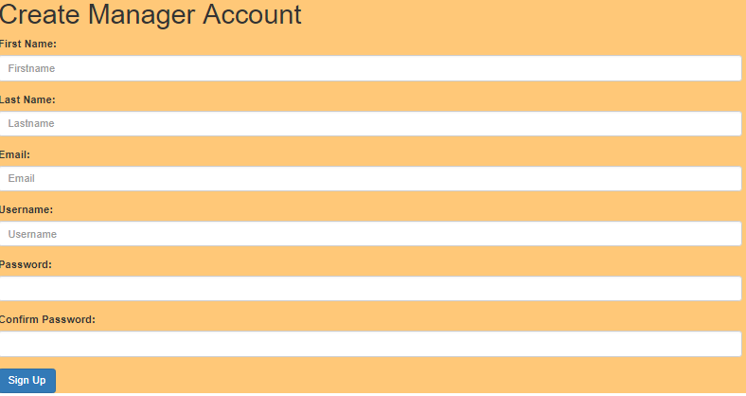

Figure Admin 8

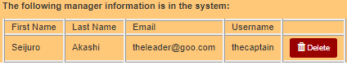

Figure Admin 9

**Figure Admin 8** shows the admins ability to register users as admins in the database. When registered their first and last name, email and username are shown in the list of managers(**Figure Admin 9**). On this page admins are allowed to remove managers from the database. Only admins are allowed to add and remove managers from the system.

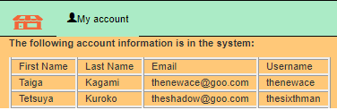

Figure Admin 10

**Figure Admin 10** shows the list of customers that are registered to the database. Admin does not have any rights to delete or add any customers.

# Test Plan

When we began working on the coding part of our project we started with practicing getting things connected to the database first. Without learning how to get things connected to the database we knew the project would fall apart when trying to get the major things to work. So what we did was to take some sample files, create a sample database, put it on cyan and made sure that it worked there. We tested out a few times and when it finally connected we knew things would get easier from there on out.

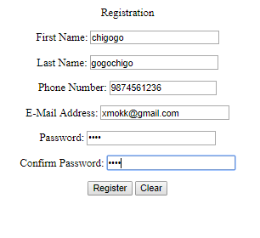

Figure Test 1

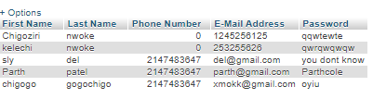

Figure Test 2

**Figure Test 1 and 2** are demonstrations of our sample tests of connecting the html to the php which then sent the information over to the database. We then started working on the project which we tested on Sylvester’s machine. After getting the login system to work, we started working on getting the cart and other parts of the website up and running.

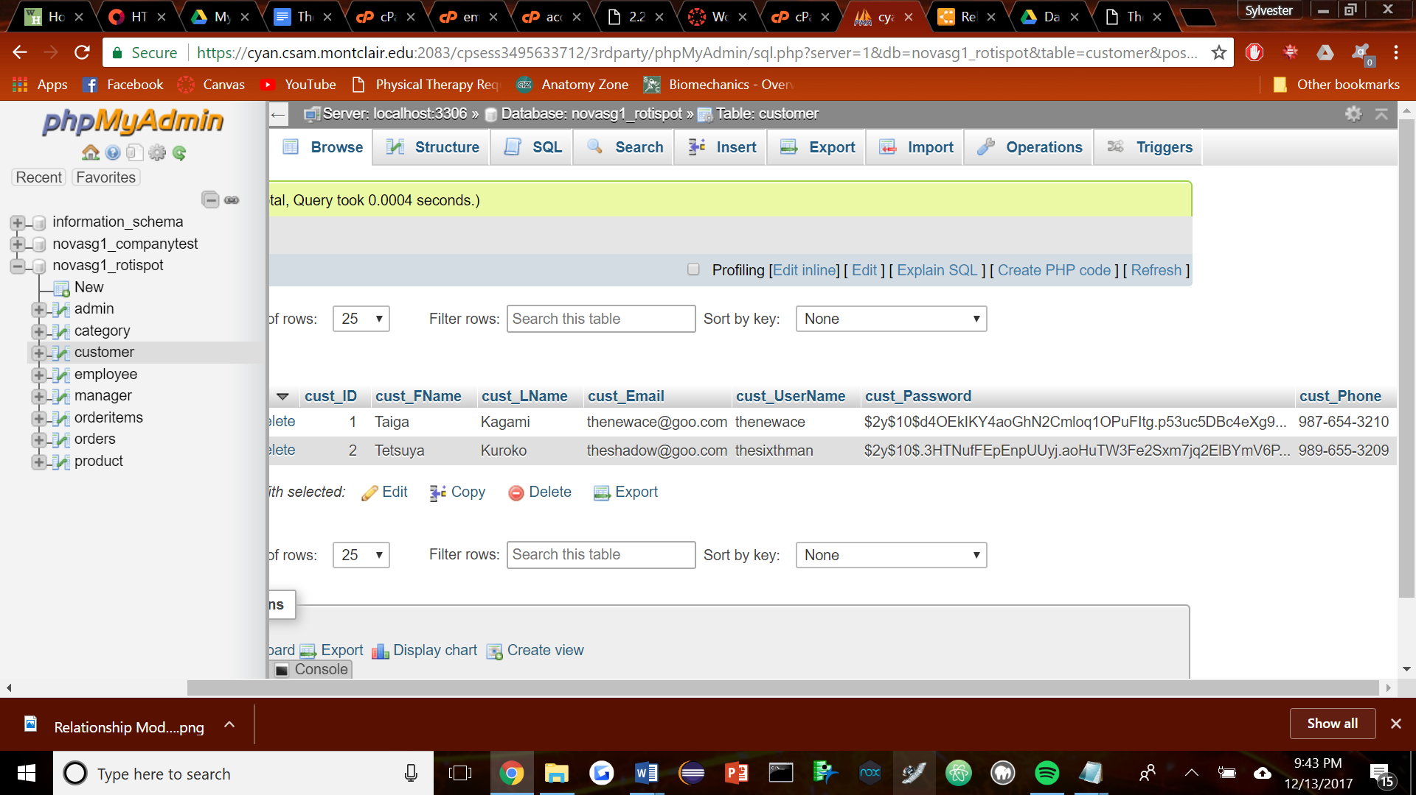

Figure Test 3

Testing the security was the next phase of testing for our project. After the simple password input we started hashing passwords, as demonstrated in **test figure 3.**

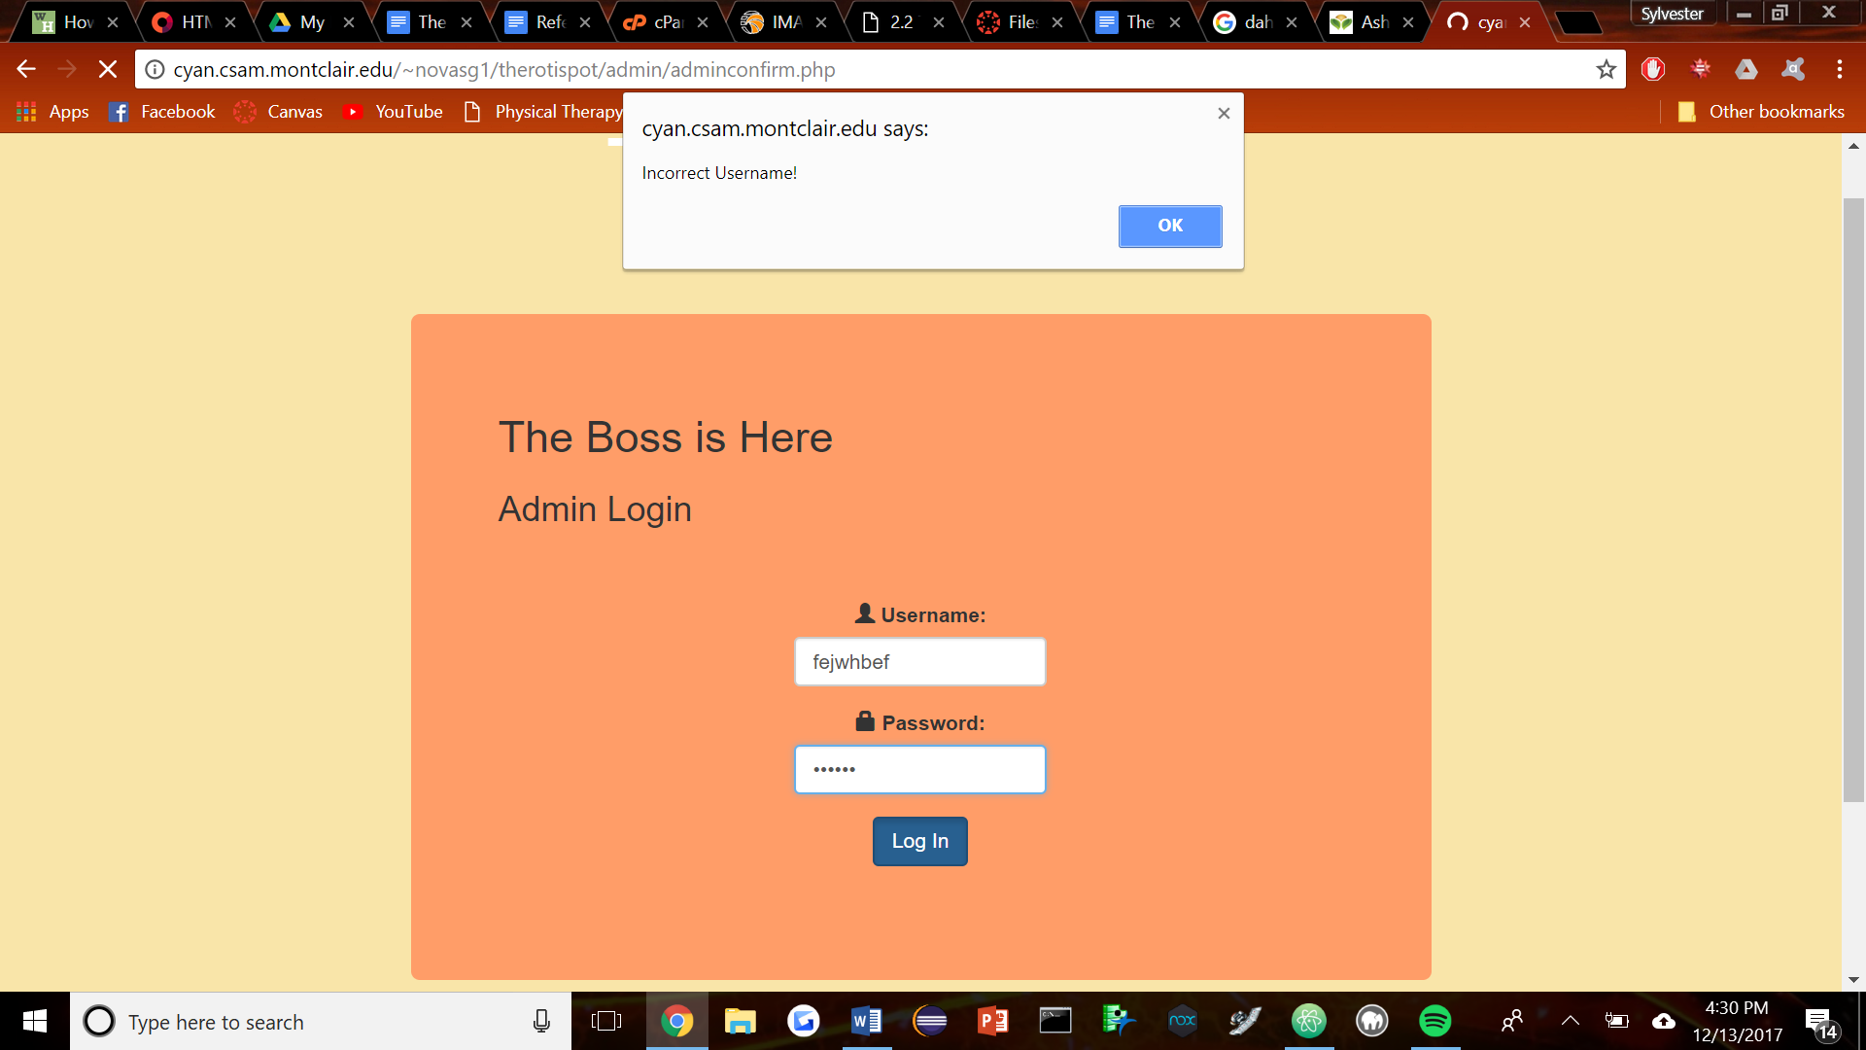

Figure Test 4

When the wrong username and password are entered an alert box would appear at the top of the screen telling the user that their username or password are correct. This was an important thing to test since we would not want any unauthorized users to be able to access the information stored on the database. That was working fine so the next thing to do was to test our shopping cart.

When testing our shopping cart we would add different items to the cart and hit confirm order. Only thing was to test that the orders were registered in the database and sent to the order list for the employees to see. When that was up and running we were able to check that completed orders were sent to the completed orders list.

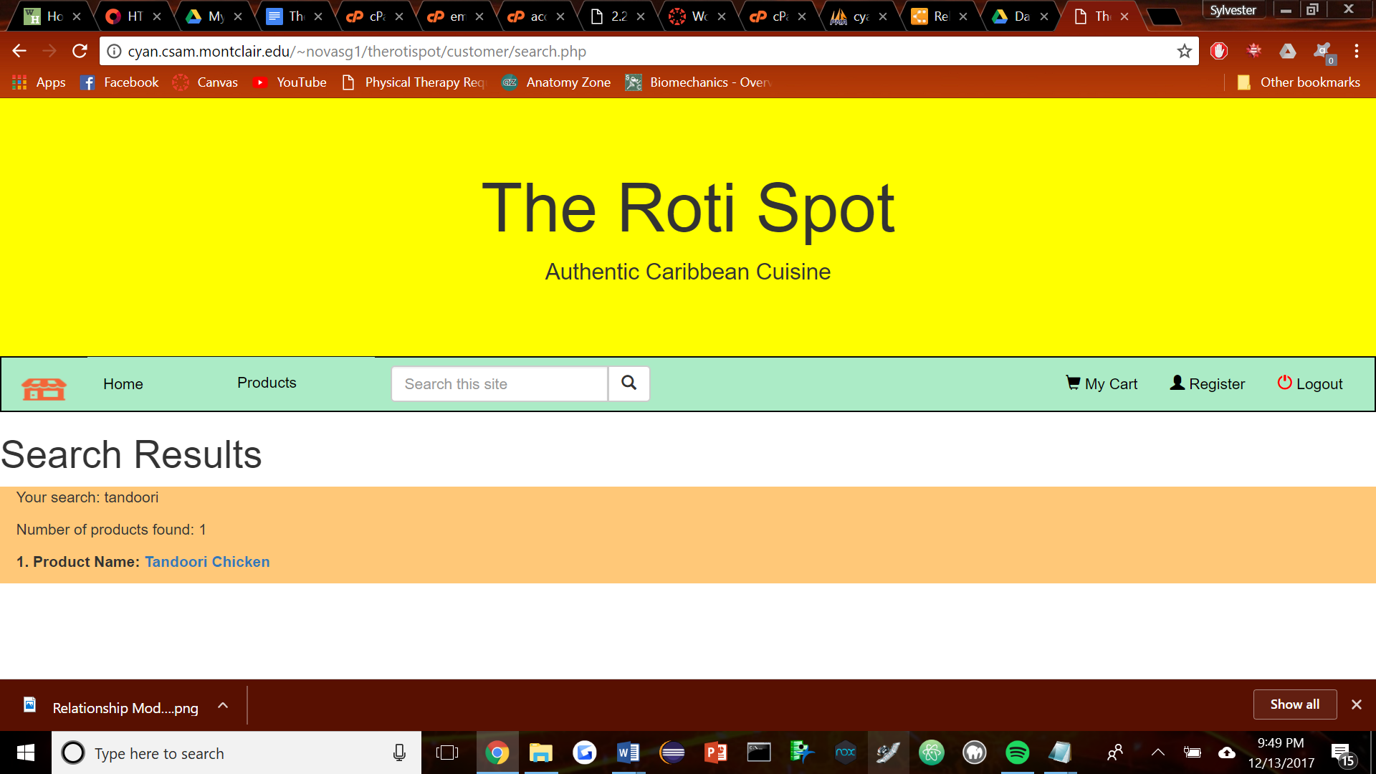

Figure 5

The search function took a bit of work, but after looking at the powerpoint it became clear on how to implement the code. This particular search takes into account the linkName and implements it into the actual code, so clicking on the product that comes up in the search will actually take the customer to that page.

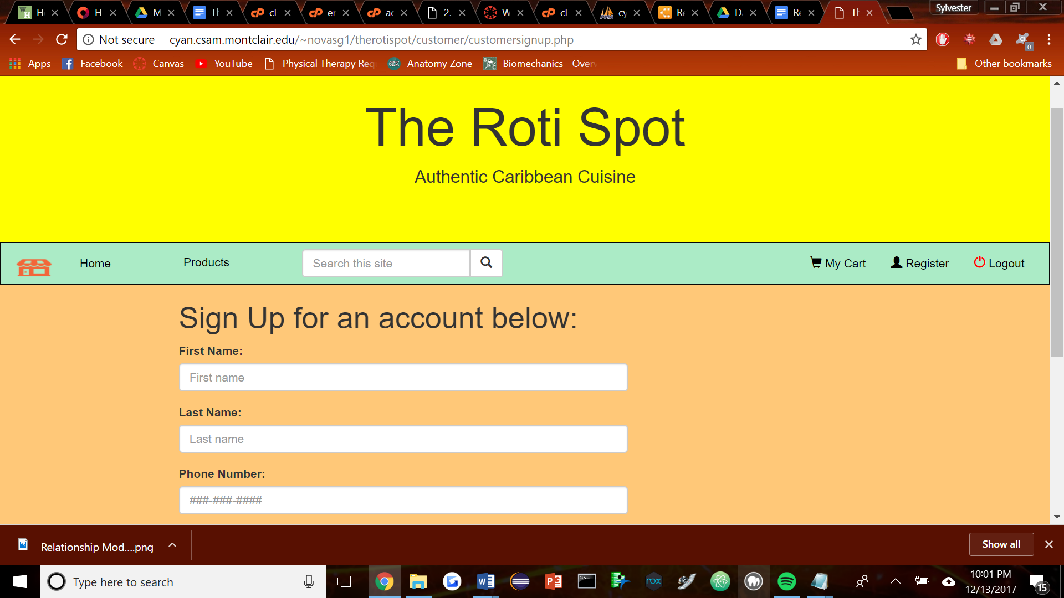

Figure 6

In order to test adding, things such as adding accounts were taken into account. Escape strings are must in order to prevent invalid input, then submit it.

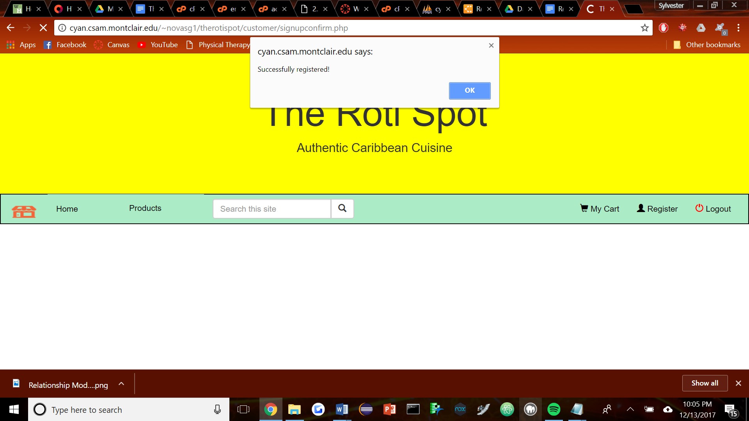

Figure 7

If successful it confirms this.

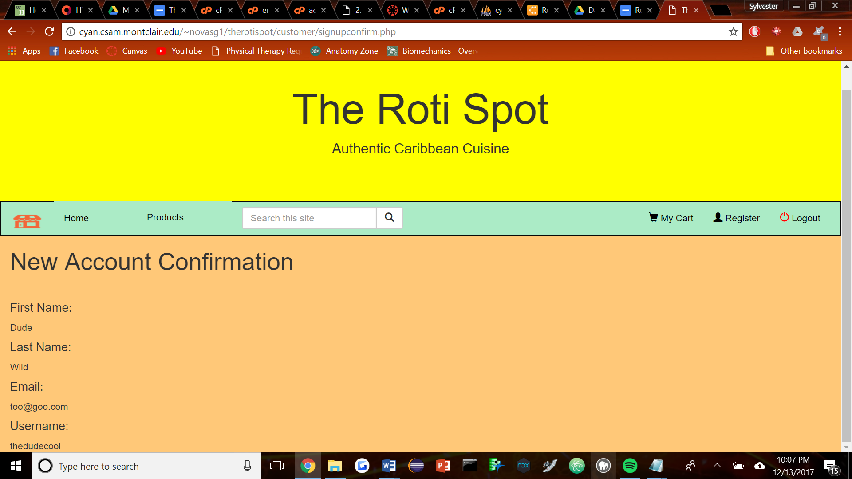

Figure 8

The confirmation. This writes to the database by using the inputs and printing this page.

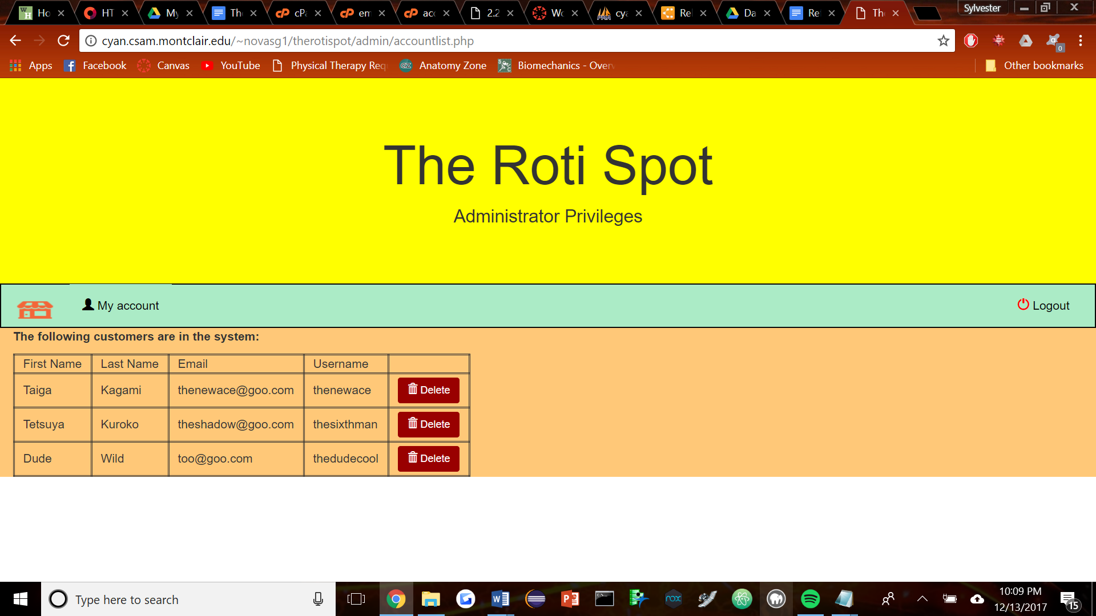

Figure 9

Looking into a certain list shows an example of delete. Delete will bring up

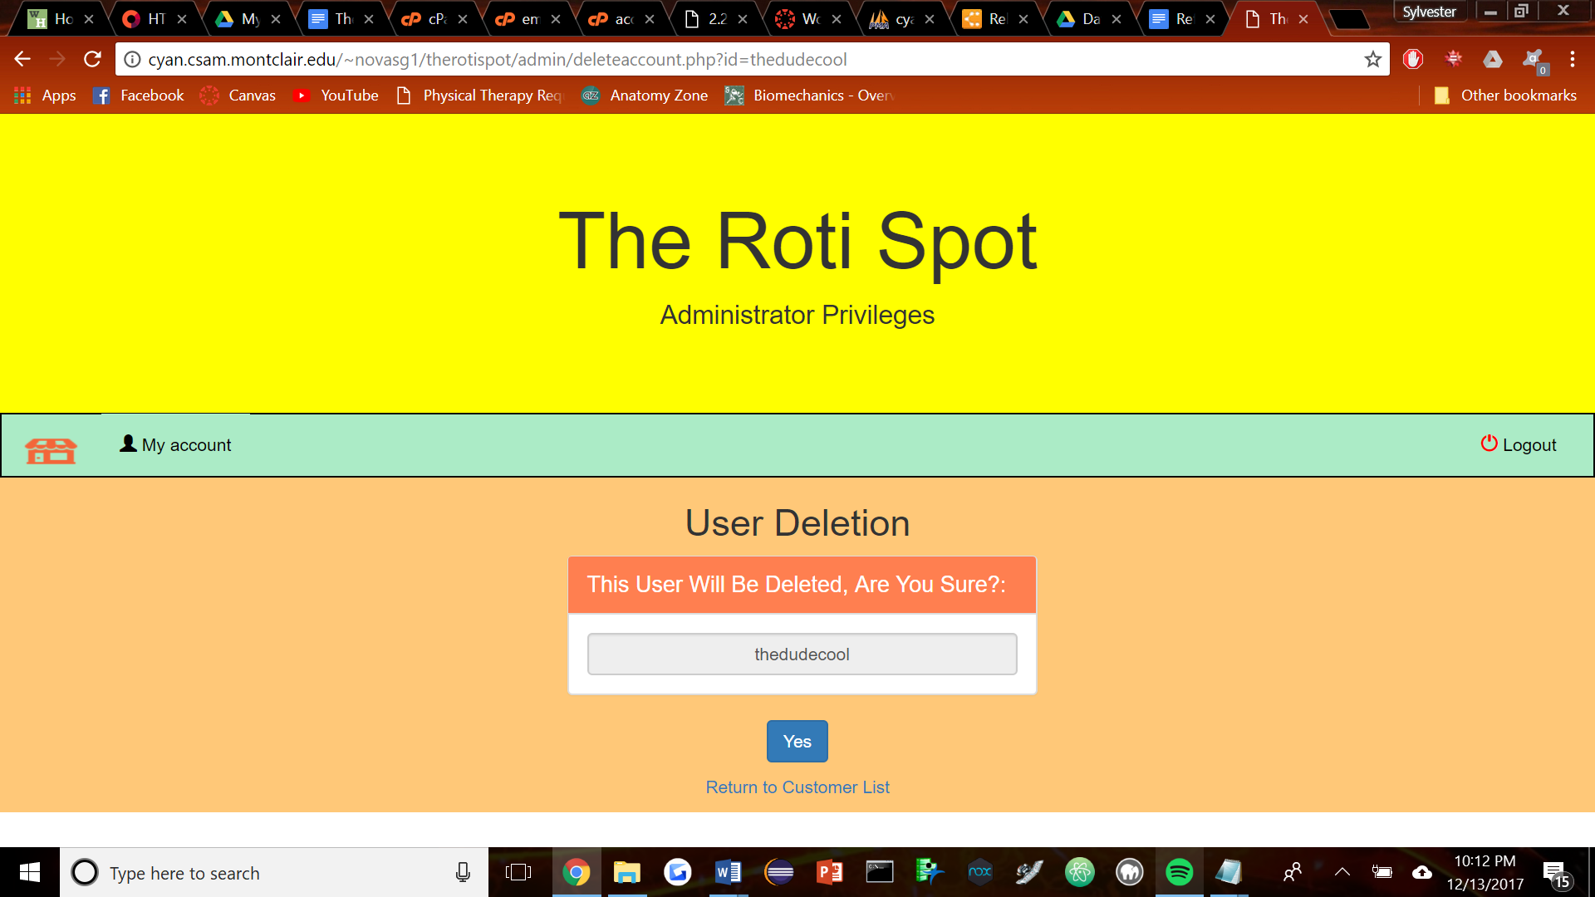

Figure 9

While delete using a get feature first, a post is needed to actually delete the specific user, which is only set off by clicking the yes button. Anything else will not do so.

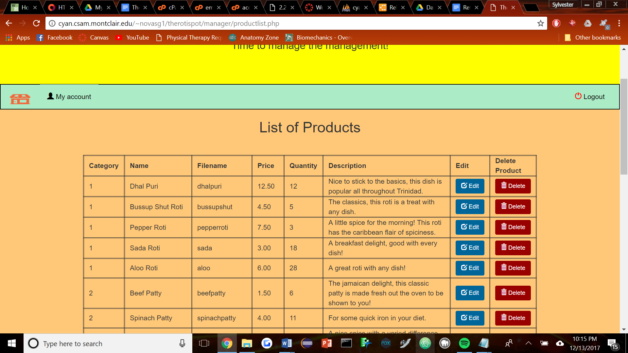

Figure 10

This is an example of editing in the database.

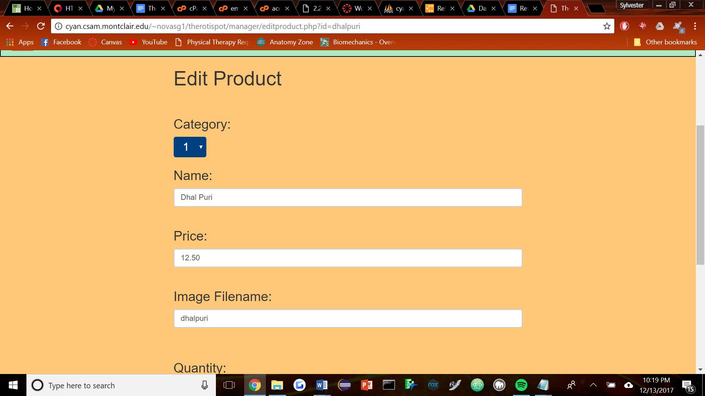

Figure 11

This is the interface that comes up.

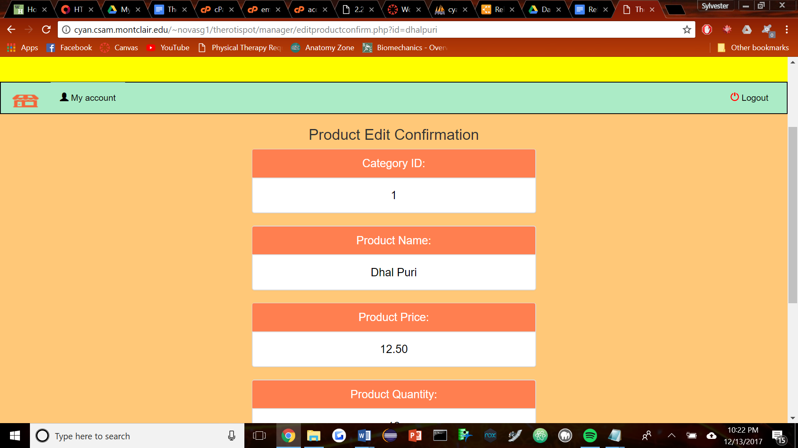

Figure 12

It is processed then a confirmation page is shown properly, through a POST method.

# Results

#### Summary of Findings

This project was a nice way to get introduced to php, we found it interesting how php works with the server to produce a safer environment that can be implemented on the server side. It was interesting to see how php interact with other executable environments, such as writing to a database. This project was a great start to learning how to tackle the environment as a whole, and creating a usable database turned out to need a lot of relational datas.

#### Challenges

Understanding the actual usage of php was a challenge at first, understanding what it was exactly doing was a bit confusing. Really it was just communicating with the languages in sql and html to get them to coordinate. As such the syntax was a little confusing at first, but once that was understood it was definitely easier to understand as a whole.

#### Conclusions

Creating this project, putting it on a server, and connecting to a database was definitely something fun to do, php is interesting in the way it operates as it is a way of fluidly implementing variables and coordinating with multiple points of access.

### 

### 

### 

### 

# Appendix of Code

novasg1_rotispot.sql

-- phpMyAdmin SQL Dump

-- version 4.7.3

-- https://www.phpmyadmin.net/

--

-- Host: localhost:3306

-- Generation Time: Dec 13, 2017 at 05:04 PM

-- Server version: 5.6.38

-- PHP Version: 5.6.30

SET SQL_MODE = "NO_AUTO_VALUE_ON_ZERO";

SET AUTOCOMMIT = 0;

START TRANSACTION;

SET time_zone = "+00:00";

/*!40101 SET @OLD_CHARACTER_SET_CLIENT=@@CHARACTER_SET_CLIENT */;

/*!40101 SET @OLD_CHARACTER_SET_RESULTS=@@CHARACTER_SET_RESULTS */;

/*!40101 SET @OLD_COLLATION_CONNECTION=@@COLLATION_CONNECTION */;

/*!40101 SET NAMES utf8mb4 */;

--

-- Database: `novasg1_rotispot`

--

-- --------------------------------------------------------

--

-- Table structure for table `admin`

--

CREATE TABLE `admin` (

`admin_ID` int(11) NOT NULL,

`admin_Email` varchar(255) NOT NULL,

`admin_FName` varchar(60) NOT NULL,

`admin_LName` varchar(60) NOT NULL,

`admin_Username` varchar(60) NOT NULL,

`admin_Password` varchar(255) NOT NULL

) ENGINE=MyISAM DEFAULT CHARSET=latin1;

--

-- Dumping data for table `admin`

--

INSERT INTO `admin` (`admin_ID`, `admin_Email`, `admin_FName`, `admin_LName`, `admin_Username`, `admin_Password`) VALUES

(4, 'superboss@goo.com', 'The Super', 'Boss', 'wowcool', '$2y$10$1mtSzPCPvs7bbRTRbHN/MOTWrVA1qViYc4.vFod4NtR78TnyRt8Z.');

-- --------------------------------------------------------

--

-- Table structure for table `category`

--

CREATE TABLE `category` (

`pro_Category` int(11) NOT NULL,

`category_Name` varchar(255) NOT NULL

) ENGINE=MyISAM DEFAULT CHARSET=latin1;

--

-- Dumping data for table `category`

--

INSERT INTO `category` (`pro_Category`, `category_Name`) VALUES

(1, 'Roti'),

(2, 'Patties'),

(3, 'Main Dishes'),

(4, 'Sides'),

(5, 'Flags');

-- --------------------------------------------------------

--

-- Table structure for table `customer`

--

CREATE TABLE `customer` (

`cust_ID` int(12) NOT NULL,

`cust_FName` varchar(60) NOT NULL,

`cust_LName` varchar(60) NOT NULL,

`cust_Email` varchar(255) NOT NULL,

`cust_UserName` varchar(60) NOT NULL,

`cust_Password` varchar(255) NOT NULL,

`cust_Phone` varchar(12) NOT NULL

) ENGINE=InnoDB DEFAULT CHARSET=latin1;

--

-- Dumping data for table `customer`

--

INSERT INTO `customer` (`cust_ID`, `cust_FName`, `cust_LName`, `cust_Email`, `cust_UserName`, `cust_Password`, `cust_Phone`) VALUES

(1, 'Taiga', 'Kagami', 'thenewace@goo.com', 'thenewace', '$2y$10$d4OEkIKY4aoGhN2Cmloq1OPuFItg.p53uc5DBc4eXg9PJI1To18DG', '987-654-3210'),

(2, 'Tetsuya', 'Kuroko', 'theshadow@goo.com', 'thesixthman', '$2y$10$.3HTNufFEpEnpUUyj.aoHuTW3Fe2Sxm7jq2ElBYmV6P9udE0i0RIe', '989-655-3209');

-- --------------------------------------------------------

--

-- Table structure for table `employee`

--

CREATE TABLE `employee` (

`emp_ID` int(12) NOT NULL,

`emp_FName` varchar(60) NOT NULL,

`emp_LName` varchar(60) NOT NULL,

`emp_Email` varchar(255) NOT NULL,

`emp_Password` varchar(255) NOT NULL,

`emp_Phone` varchar(12) NOT NULL,

`emp_UserName` varchar(60) NOT NULL,

`emp_DOB` date NOT NULL,

`emp_SSN` varchar(11) NOT NULL,

`emp_Address` varchar(80) NOT NULL

) ENGINE=MyISAM DEFAULT CHARSET=latin1;

--

-- Dumping data for table `employee`

--

INSERT INTO `employee` (`emp_ID`, `emp_FName`, `emp_LName`, `emp_Email`, `emp_Password`, `emp_Phone`, `emp_UserName`, `emp_DOB`, `emp_SSN`, `emp_Address`) VALUES

(3, 'Daiki', 'Aomine', 'thebest@goo.com', '$2y$10$Ii5EMaNAmSSFYlL46uU57uMkL/ENMQmGWq7nxk5HPWeJYRCnYHTFa', '201-596-4959', 'thebest', '1995-08-31', '453-34-5968', 'The Pinnacle'),

(8, 'Hanamichi', 'Sakuragi', 'thegenius@goo.com', '$2y$10$3p1wLtW65SnWrL4xt7ZfvOxNGoPtp8AbQ5K/Agnd2uKeTYmtmv9tK', '340-423-4244', 'thetensai', '1995-04-01', '192-49-4959', '3984 TryHard Ave');

-- --------------------------------------------------------

--

-- Table structure for table `manager`

--

CREATE TABLE `manager` (

`manager_ID` int(12) NOT NULL,

`manager_FName` varchar(60) NOT NULL,

`manager_LName` varchar(60) NOT NULL,

`manager_Email` varchar(255) NOT NULL,

`manager_Password` varchar(60) NOT NULL,

`manager_Username` varchar(70) NOT NULL

) ENGINE=MyISAM DEFAULT CHARSET=latin1;

--

-- Dumping data for table `manager`

--

INSERT INTO `manager` (`manager_ID`, `manager_FName`, `manager_LName`, `manager_Email`, `manager_Password`, `manager_Username`) VALUES

(7, 'Seijuro', 'Akashi', 'theleader@goo.com', '$2y$10$tKvNBajg8rgJJxSGJ8WoleRYGEtBpHIUdX8LR2DQlKcKe3QVMgZpm', 'thecaptain');

-- --------------------------------------------------------

--

-- Table structure for table `orderitems`

--

CREATE TABLE `orderitems` (

`item_ID` int(11) NOT NULL,

`order_ID` int(11) NOT NULL,

`pro_ID` int(11) NOT NULL,

`item_TotalPrice` decimal(10,2) NOT NULL,

`item_Quantity` int(11) NOT NULL

) ENGINE=MyISAM DEFAULT CHARSET=latin1;

-- --------------------------------------------------------

--

-- Table structure for table `orders`

--

CREATE TABLE `orders` (

`order_ID` int(12) NOT NULL,

`cust_ID` int(12) NOT NULL,

`order_Date` datetime NOT NULL,

`order_Quantity` int(12) NOT NULL,

`order_TotalPrice` decimal(10,2) NOT NULL,

`order_Status` varchar(255) NOT NULL DEFAULT 'N'

) ENGINE=MyISAM DEFAULT CHARSET=latin1;

-- --------------------------------------------------------

--

-- Table structure for table `product`

--

CREATE TABLE `product` (

`pro_ID` int(11) NOT NULL,

`pro_Category` int(11) NOT NULL,

`pro_Price` decimal(10,2) NOT NULL,

`pro_Name` varchar(255) NOT NULL,

`linkName` varchar(60) DEFAULT NULL,

`pro_Quantity` int(11) NOT NULL,

`pro_Description` text NOT NULL

) ENGINE=MyISAM DEFAULT CHARSET=latin1;

--

-- Dumping data for table `product`

--

INSERT INTO `product` (`pro_ID`, `pro_Category`, `pro_Price`, `pro_Name`, `linkName`, `pro_Quantity`, `pro_Description`) VALUES

(1, 1, '12.50', 'Dhal Puri', 'dhalpuri', 12, 'Nice to stick to the basics, this dish is popular all throughout Trinidad.'),

(2, 1, '4.50', 'Bussup Shut Roti', 'bussupshut', 5, 'The classics, this roti is a treat with any dish.'),

(3, 1, '7.50', 'Pepper Roti', 'pepperroti', 3, 'A little spice for the morning! This roti has the caribbean flair of spiciness.'),

(4, 1, '3.00', 'Sada Roti', 'sada', 18, 'A breakfast delight, good with every dish!'),

(5, 1, '6.00', 'Aloo Roti', 'aloo', 28, 'A great roti with any dish!'),

(7, 2, '1.50', 'Beef Patty', 'beefpatty', 6, 'The jamaican delight, this classic patty is made fresh out the oven to be shown to you!'),

(8, 2, '4.00', 'Spinach Patty', 'spinachpatty', 11, 'For some quick iron in your diet.'),

(9, 2, '1.25', 'Jerk Chicken Patty', 'jerkchickenpatty', 5, 'A nice spice with a varied difference, this jerk chicken patty is great for a man on the go!'),

(10, 2, '100.00', 'Vegetable Patty', 'veggiepatty', 6, 'Don\'t order this one there are better options on the menu.'),

(13, 3, '9.95', 'Ackee and Saltfish', 'ackeeandsalfish', 7, 'A classic dish named ackee and saltfish!!!'),

(14, 3, '8.50', 'Jerk Chicken with Rice and Beans', 'jerkchickenmeal', 7, 'It couldn\'t be a meal without jerk chicken! A classic dish that is sure to impress.'),

(15, 3, '10.00', 'Tandoori Chicken', 'tandoorichicken', 3, 'This one\'s fire.'),

(16, 3, '8.00', 'Oxtail with Rice and Beans', 'oxtail', 14, 'A nice oxtail meal that goes complete with any dish.'),

(17, 3, '9.50', 'Curry Chicken and Rice', 'currychicken', 7, 'A nice dish that really taps into the west indian side, sure to be a hit.'),

(18, 3, '11.50', 'Curry Goat with Rice and Beans', 'currygoatmeal', 5, 'Curry Goat is a step above and is great to eat, a west indian treat!'),

(19, 4, '3.00', 'Rice and Beans', 'ricebeans', 12, 'A nice side order to any dish, make it complete with rice and beans!'),

(20, 4, '1.50', 'Boiled Dumpling', 'boileddumpling', 26, 'Boiled Dumpling delight! A great treat to go with some ackee and saltfish.'),

(21, 4, '2.50', 'Callaloo ', 'callaloo', 7, 'A traditional treat that is nutritious too, goes well with any dish!'),

(22, 4, '3.00', 'Festival', 'festival', 4, 'A traditional treat similar to fried dumpling, a great side to any meal!'),

(23, 4, '2.00', 'Kola Champagne', 'kolachampagne', 9, 'Can\'t go wrong with a traditional kola champagne! Have a taste of Jamaica!'),

(24, 4, '2.00', 'Ginger Beer', 'gingerbeer', 22, 'A good mix-up from the regular champagne, this traditional drink hits the spot with any meal!'),

(25, 5, '7.50', 'Jamaica', 'jamaicanflag', 4, 'Represent Jamaica with this great flag!'),

(26, 5, '7.50', 'Trinidad', 'trinidadflag', 8, 'Represent Trinidad with this great flag!'),

(27, 5, '7.50', 'Guyana', 'guyaneseflag', 18, 'Represent Guyana with this great flag!'),

(28, 5, '7.50', 'Barbados', 'barbadosflag', 11, 'Represent Barbados with this great flag!'),

(29, 5, '7.50', 'Dominican Republic', 'drflag', 30, 'Represent Dominican Republic with this great flag!'),

(30, 5, '7.50', 'Hondurian Flag', 'hondurasflag', 10, 'Represent Honduras with this great flag!');

--

-- Indexes for dumped tables

--

--

-- Indexes for table `admin`

--

ALTER TABLE `admin`

ADD PRIMARY KEY (`admin_ID`,`admin_Username`);

--

-- Indexes for table `category`

--

ALTER TABLE `category`

ADD PRIMARY KEY (`pro_Category`);

--

-- Indexes for table `customer`

--

ALTER TABLE `customer`

ADD PRIMARY KEY (`cust_ID`),

ADD UNIQUE KEY `cust_UserName` (`cust_UserName`) USING BTREE;

--

-- Indexes for table `employee`

--

ALTER TABLE `employee`

ADD PRIMARY KEY (`emp_ID`);

--

-- Indexes for table `manager`

--

ALTER TABLE `manager`

ADD PRIMARY KEY (`manager_ID`);

--

-- Indexes for table `orderitems`

--

ALTER TABLE `orderitems`

ADD PRIMARY KEY (`item_ID`),

ADD KEY `order_ID` (`order_ID`),

ADD KEY `pro_ID` (`pro_ID`) USING BTREE;

--

-- Indexes for table `orders`

--

ALTER TABLE `orders`

ADD PRIMARY KEY (`order_ID`),

ADD KEY `cust_ID` (`cust_ID`) USING BTREE;

--

-- Indexes for table `product`

--

ALTER TABLE `product`

ADD PRIMARY KEY (`pro_ID`),

ADD KEY `p_Category` (`pro_Category`);

--

-- AUTO_INCREMENT for dumped tables

--

--

-- AUTO_INCREMENT for table `admin`

--

ALTER TABLE `admin`

MODIFY `admin_ID` int(11) NOT NULL AUTO_INCREMENT, AUTO_INCREMENT=4;

--

-- AUTO_INCREMENT for table `category`

--

ALTER TABLE `category`

MODIFY `pro_Category` int(11) NOT NULL AUTO_INCREMENT, AUTO_INCREMENT=6;

--

-- AUTO_INCREMENT for table `customer`

--

ALTER TABLE `customer`

MODIFY `cust_ID` int(12) NOT NULL AUTO_INCREMENT, AUTO_INCREMENT=9;

--

-- AUTO_INCREMENT for table `employee`

--

ALTER TABLE `employee`

MODIFY `emp_ID` int(12) NOT NULL AUTO_INCREMENT, AUTO_INCREMENT=14;

--

-- AUTO_INCREMENT for table `manager`

--

ALTER TABLE `manager`

MODIFY `manager_ID` int(12) NOT NULL AUTO_INCREMENT, AUTO_INCREMENT=8;

--

-- AUTO_INCREMENT for table `orderitems`

--

ALTER TABLE `orderitems`

MODIFY `item_ID` int(11) NOT NULL AUTO_INCREMENT, AUTO_INCREMENT=49;

--

-- AUTO_INCREMENT for table `orders`

--

ALTER TABLE `orders`

MODIFY `order_ID` int(12) NOT NULL AUTO_INCREMENT, AUTO_INCREMENT=34;

--

-- AUTO_INCREMENT for table `product`

--

ALTER TABLE `product`

MODIFY `pro_ID` int(11) NOT NULL AUTO_INCREMENT, AUTO_INCREMENT=74;COMMIT;

/*!40101 SET CHARACTER_SET_CLIENT=@OLD_CHARACTER_SET_CLIENT */;

/*!40101 SET CHARACTER_SET_RESULTS=@OLD_CHARACTER_SET_RESULTS */;

/*!40101 SET COLLATION_CONNECTION=@OLD_COLLATION_CONNECTION */;

**databaseconnect.php**

<?php

$dsn = 'mysql:host=localhost;dbname=novasg1_rotispot';

$username = 'novasg1';

$password = 'Montclair123';

try

{

$db = new PDO($dsn, $username, $password);

}

catch (PDOException $e)

{

$error_message = $e->getMessage();

echo '<h1>Not connected to database </h1>

';

exit();

}

?>

**dbh.php**

<?php

$db = mysqli_connect("localhost", "novasg1", "Montclair123", "novasg1_rotispot");

if(!$db)

{

die("Connection failed: ".mysqli_connect_error());

}

?>

**index.html**

<!DOCTYPE html>

<!-- Choose login page.-->

<html>

<head>

<meta charset = "utf-8">

<title>Login Page</title>

<style type="text/css">

center{

font-size: 35px;

font-family:verdana;

}

button{

font-family:verdana;

}

body{

background-color: lightgrey;

}

h2{

font-family:verdana;

}

.button-group button {

font-size: 24px;

background-color: lightblue; /* Green background */

border: 1px solid yellow; /* Green border */

color: black; /* White text */

padding: 40px 24px; /* Some padding */

cursor: pointer; /* Pointer/hand icon */

width: 50%; /* Set a width if needed */

display: block; /* Make the buttons appear below each other */

margin: 0 auto;

}

.button-group button:not(:last-child) {

border-bottom: none; /* Prevent double borders */

}

/* Add a background color on hover */

.button-group button:hover {

background-color:lightgreen;

}

</style>

</head>

<body>

<h1><center>Welcome to The Roti Spot!</center></h1>

<h2>Please select your type of account:</h2>

<div class="button-group" style="text-align: center;">

<button onclick="window.location.href='admin/adminlogin.php'">Admin</button>

<button onclick="window.location.href='employee/employeelogin.php'">Employee</button>

<button onclick="window.location.href='customer/customerlogin.php'">Customer</button>

<button onclick="window.location.href='manager/managerlogin.php'">Manager</button>

</div>

</body>

</html>

**modifyStyle.css**

.navbar

{

margin-bottom: 0px;

border-radius: 0;

}

.jumbotron

{

margin-bottom: 0;

}

footer

{

background-color: #f2f2f2;

padding: 0px;

}

.dropbtn

{

display: inline-block;

color: #9d9d9d;

text-align: center;

padding: 14px 16px;

text-decoration: none;

font-size: 14px;

min-width: 200px;

background-color: #222222;

border: none;

}

.dropdown

{

position: relative;

display: inline-block;

float: left;

}

.dropdown-content

{

display: none;

position: absolute;

background-color: #666666;

min-width: 200px;

z-index:1000;

}

.dropdown-content a

{

color: white;

padding: 12px 16px;

text-decoration: none;

display: block;

text-align: center;

font-size: 14px;

}

.dropdown-content a:hover

{

background-color: #c9f497;

}

.dropdown:hover .dropdown-content

{

display: block;

}

.dropdown:hover .dropbtn

{

background-color: #71BC78;

color: #fff;

}

#wrap

{

width:1000px;

margin:0 auto;

background:white;

}

#picture

{

float:left;

width:450px;

padding:10px;

background:white;

}

#description

{

float:right;

width:550px;

padding:10px;

background:white;

}

#description h2

{

color: #990000;

}

#features

{

clear:both;

margin-left:300px;

background:white;

padding-top: 10px;

padding-bottom: 10px;

}

.cartButton

{

background-color: #990000;

border: none;

color: white;

padding: 15px 32px;

text-align: center;

text-decoration: none;

display: inline-block;

font-size: 16px;

cursor: pointer;

margin-left: 10px;

border-radius: 10px;

}

**accountconfirm.php**

//to add a new admin to the database

<?php include 'adminheader.php';

include '../dbh.php';

global $db;

if($_SERVER["REQUEST_METHOD"] == "POST")

{

$first_name = mysqli_real_escape_string($db, $_POST['firstname']);

$last_name = mysqli_real_escape_string($db, $_POST['lastname']);

$email_address = mysqli_real_escape_string($db, $_POST['email']);

$user_name = mysqli_real_escape_string($db, $_POST['username']);

$password = mysqli_real_escape_string($db, $_POST['pass']);

$bool = true;

$query = mysqli_query($db, "SELECT * FROM admin");

while($row = mysqli_fetch_array($query))

{

$table_username = $row['admin_Username'];

//checks if there are any matching fields

if($user_name == $table_username)

{

$bool = false;

//tell the user that the username has been taken

print '<script>alert("Username has been taken!");</script>';

//redirects to createaccount.php

print '<script>window.location.assign("createaccount.php");</script>';

}

/*the first email row is passed on to $table_email,

and so on until the query is finished */

$table_email = $row['admin_Email'];

//checks if there are any matching fields

if($email_address == $table_email)

{

$bool = false;

//tell the user that the email has been taken

print '<script>alert("Email has already been used!");</script>';

//redirects to createaccount.php

print '<script>window.location.assign("createaccount.php");</script>';

}

}

if($bool)

{

//hash the created password

$hash = password_hash($password, PASSWORD_DEFAULT);

//put into admin table

mysqli_query($db, "INSERT INTO admin (admin_FName, admin_LName, admin_Email, admin_Username, admin_Password)

VALUES ('$first_name', '$last_name', '$email_address', '$user_name', '$hash')");

print '<script>alert("Registration Successful");</script>';

}

}

?>

<!DOCTYPE html>

<html>

<body>

<!--Print out confirmation-->

<h1>Admin Account Confirmation</h1><br>

<h4>First Name:</h4>

<?php echo $first_name; ?><br>

<h4>Last Name:</h4>

<?php echo $last_name; ?><br>

<h4>Email:</h4>

<?php echo $email_address; ?><br>

<h4>Username:</h4>

<?php echo $user_name; ?><br>

</body>

</html>

**accountlist.php**

<?php include 'adminheader.php';

//include the header and connect to the database

include '../databaseConnect.php';

global $db;

//query from customer

$query = "SELECT *

FROM customer";

$result = $db->prepare($query);

$result->execute();

$accounts = $result->fetchAll();

$result->closeCursor();

?>

<html>

<head>

<style>

td

{

border-style: double;

padding-left: 10px;

padding-right: 10px;

}

</style>

</head>

<body>

<div class="container-fluid" style = "background-color: #ffc878;">

<p><b>The following customers are in the system:</b></p>

<table>

<tbody>

<tr>

<td>First Name</td>

<td>Last Name</td>

<td>Email</td>

<td>Username</td>

<td> </td>

</tr>

<?php foreach ($accounts as $account) : ?>

<!--Shows first name, last name, email, username-->

<tr>

<td><?php echo $account['cust_FName']; ?></td>

<td><?php echo $account['cust_LName']; ?></td>

<td><?php echo $account['cust_Email']; ?></td>

<td><?php echo $account['cust_UserName']; ?></td>

<td align="center" style="padding-top: 4px; padding-bottom: 4px;">

<a href="deleteaccount.php?id=<?php echo $account['cust_UserName']; ?>" class="btn btn-default btn-sm"

style="background-color:#990000; color:white; border-color:#990000">

<span class="glyphicon glyphicon-trash"></span> Delete</a></td>

</tr>

<?php endforeach; ?></p>

</tbody>

</table>

</body>

</html>

**accountconfirm.php**

<?php

session_start();

include '../dbh.php';

global $db;

$user_name = mysqli_real_escape_string($db, $_POST['username']);

$password = mysqli_real_escape_string($db, $_POST['pass']);

//query the admin table

$query = mysqli_query($db, "SELECT * FROM admin WHERE admin_Username='$user_name'");

$exists = mysqli_num_rows($query);

$table_users = "";

$table_password = "";

if ($exists > 0){

while($row = mysqli_fetch_assoc($query))

{

$table_users = $row['admin_Username'];

$table_password = $row['admin_Password'];

}

//takes username while also checking against hashed password

if($user_name == $table_users && password_verify($password, $table_password))

{

$_SESSION['user_name'] = $user_name;

}

else

{

print '<script>alert("Incorrect Password!");</script>';

print '<script>window.location.assign("adminlogin.php");</script>';

}

}

else

{

print '<script>alert("Incorrect Username!");</script>';

print '<script>window.location.assign("adminlogin.php");</script>';

}

?>

<!DOCTYPE html>

<html>

<?php include 'adminheader.php'; ?>

<style type=text/css>

center{

font-family:verdana;

font-size:35px;

}

</style>

<body>

<div class="container-fluid" style = "background-color: #ffc878;">

<h1><center>Admin Login Confirmation </center></h1><br>

<h4><center>Welcome, <?php echo $_SESSION['user_name']; ?>!</center></h4><br>

</div>

</body>

</html>

**adminfunctions.php**

<?php include 'adminheader.php'; ?>

<!DOCTYPE html>

<html>

<!--List of what admins can do-->

<style type="text/css">

p{

text-align: center;

font-size: 35px;

}

a{

text-align: center;

font-family: verdana;

}

h1{

text-align: center;

font-family: verdana;

}

h4{

text-align: center;

font-family: verdana;

}

</style>

<div class="container-fluid" style = "background-color: #ffc878;">

<h1>Select an option below: </h1><br>

<h4 style="font-size: 30px;">Welcome, Admin!</h4><br>

<p><a href="createaccount.php">Create Admin Account</a></p>

<hr style="border-width: 3px; border-color: yellow;" >

<p><a href="employeecreateaccount.php">Create Employee Account</a></p>

<hr style="border-width: 3px; border-color: yellow;">

<p><a href="createmanager.php">Create Manager Account</a></p>

<hr style="border-width: 3px; border-color: yellow;">

<p><a href="accountlist.php">View Customer List</a></p>

<hr style="border-width: 3px; border-color: yellow;">

<p><a href="employeelist.php">View Employee List</a></p>

<hr style="border-width: 3px; border-color: yellow;">

<p><a href="managerlist.php">View Manager List</a></p>

<hr style="border-width: 3px; border-color: yellow;">

<p><a href="adminlist.php">View Admin List</a></p>

</body>

</html>

**adminheader.php**

<?php include 'adminheader.php'; ?>

<!DOCTYPE html>

<html>

<!--List of what admins can do-->

<style type="text/css">

p{

text-align: center;

font-size: 35px;

}

a{

text-align: center;

font-family: verdana;

}

h1{

text-align: center;

font-family: verdana;

}

h4{

text-align: center;

font-family: verdana;

}

</style>

<div class="container-fluid" style = "background-color: #ffc878;">

<h1>Select an option below: </h1><br>

<h4 style="font-size: 30px;">Welcome, Admin!</h4><br>

<p><a href="createaccount.php">Create Admin Account</a></p>

<hr style="border-width: 3px; border-color: yellow;" >

<p><a href="employeecreateaccount.php">Create Employee Account</a></p>

<hr style="border-width: 3px; border-color: yellow;">

<p><a href="createmanager.php">Create Manager Account</a></p>

<hr style="border-width: 3px; border-color: yellow;">

<p><a href="accountlist.php">View Customer List</a></p>

<hr style="border-width: 3px; border-color: yellow;">

<p><a href="employeelist.php">View Employee List</a></p>

<hr style="border-width: 3px; border-color: yellow;">

<p><a href="managerlist.php">View Manager List</a></p>

<hr style="border-width: 3px; border-color: yellow;">

<p><a href="adminlist.php">View Admin List</a></p>

</body>

</html>

**adminlist.php**

<?php include 'adminheader.php';

//connect to the database

include '../databaseConnect.php';

global $db;

//gets ready to display admins

$queryAdmins = "SELECT *

FROM admin";

$result = $db->prepare($queryAdmins);

$result->execute();

$admin = $result->fetchAll();

$result->closeCursor();

?>

<html>

<head>

<style>

td

{

border-style: double;

padding-left: 10px;

padding-right: 10px;

}

</style>

</head>

<body>

<div class="container-fluid" style = "background-color: #ffc878;">

<p><b>The following admin information is in the system:</b></p>

<table>

<tbody>

<tr>

<td>First Name</td>

<td>Last Name</td>

<td>Email</td>

<td>Username</td>

</tr>

<?php foreach ($admin as $admin) : ?>

<tr>

<td><?php echo $admin['admin_FName']; ?></td>

<td><?php echo $admin['admin_LName']; ?></td>

<td><?php echo $admin['admin_Email']; ?></td>

<td><?php echo $admin['admin_Username']; ?></td>

</tr>

<?php endforeach; ?></p>

</tbody>

</table>

</body>

</html>

**Adminlogin.php**

<!DOCTYPE html>

<html>

<head>

<!--Admin login-->

<meta http-equiv="Content-Type" content="text/html; charset=utf-8">

<title>The Headquarter</title>

<meta name="viewport" content="width=device-width, initial-scale=1">

<link rel="stylesheet" href="https://maxcdn.bootstrapcdn.com/bootstrap/3.3.7/css/bootstrap.min.css">

<script src="https://ajax.googleapis.com/ajax/libs/jquery/3.1.1/jquery.min.js"></script>

<script src="https://maxcdn.bootstrapcdn.com/bootstrap/3.3.7/js/bootstrap.min.js"></script>

<style type=text/css>

.myJumbotron {

background-color:#ff3600;

color:white;

padding: 10px;

font-family:verdana;

min-height: 100px;

margin-bottom: 0;

}

.mylogin{

min-height:100px;

width:700px;

margin: 0 auto;

}

</style>

</head>

<body>

<div class="jumbotron myJumbotron" style="background-color:#f9e5a9; ">

<div class="container text-center">

<h1>The Roti Spot</h1>

<p>For the Boss Themselves</p>

</div>

</div>

<div style="background-color:#f9e5a9;">

<div class="container">

<div class="jumbotron mylogin" style="background-color:#ff9d68;">

<h2>The Boss is Here</h2>

<h3>Admin Login </h3>

<br></br>

<form method="POST" action="adminconfirm.php">

<div class="form-group row" style= "text-align:center; padding-left: 35%; position:relative;">

<div class="col-xs-6" >

<div class="form-group"> <span class="glyphicon glyphicon-user"></span>

<label for="usr">Username:</label>

<input type="text" class="form-control" id="usr" name="username" required>

</div>

<div class="form-group"> <div class="form-group"> <span class="glyphicon glyphicon-lock"></span>

<label for="pwd">Password:</label>

<input type="password" class="form-control" id="pwd" name="pass" required>

</div>

<button type="submit" name="submit" class="btn btn-primary active">Log In</button>

</div>

</div>

</form>

</div>

</div>

<div class="row">

</div>

</div>

<div class="jumbotron" style="background-color:#f9e5a9;">

<p align="center"><a href="../index.html">Return to Index</a></p>

</div>

<div class="container">

</div>

</body>

</html>

**Adminlogout.php**

<?php

//time to logout

session_start();

session_destroy();

//go back to proper login page

header("Location: adminlogin.php");

?>

**Createaccount.php**

<?php include 'adminheader.php'; ?>

<html>

<body>

<!--Form to Create Admin-->

<div class="container-fluid" style = "background-color: #ffc878;">

<h1 style="padding-left:200px">Create Admin Account</h1>

<form action="accountconfirm.php" method="POST" style="width:60%; padding-left:200px">

<div class="form-group">

<label>First Name:</label>

<input class="form-control" type="text" name="firstname" placeholder="Firstname" required>

</div>

<div class="form-group">

<label>Last Name:</label>

<input class="form-control" type="text" name="lastname" placeholder="Lastname" required>

</div>

<div class="form-group">

<label>Email:</label>

<input class="form-control" type="email" name="email" placeholder="Email" required>

</div>

<div class="form-group">

<label>Username:</label>

<input class="form-control" type="text" name="username" placeholder="Username" required>

</div>

<div class="form-group">

<label>Password:</label>

<input class="form-control" name="pass" required="required" type="password" id="password">

</div>

<div class="form-group">

<label>Confirm Password:</label>

<input class="form-control" name="password_confirm" required="required" type="password" id="password_confirm" oninput="check(this)">

<script language='javascript' type='text/javascript'>

function check(input) {

if (input.value != document.getElementById('password').value) {

input.setCustomValidity('Password Must be Matching.');

} else {

input.setCustomValidity('');

}

}

</script>

</div>

<button type="submit" class="btn btn-primary"/>Register</button>

</form>

</body>

**Createemployee.php**

<?php include 'adminheader.php'; ?>

<!DOCTYPE html>

<html>

<body>

<!--Employee Creation Form-->

<div class="container-fluid" style = "background-color: #ffc878;">

<h1 style="padding-left:200px">Create Employee Account</h1>

<form action="employeeaccountconfirm.php" method="POST" style="width:60%; padding-left:200px">

<div class="form-group">

<label>First Name:</label>

<input class="form-control" type="text" name="firstname" placeholder="Firstname" required>

</div>

<div class="form-group">

<label>Last Name:</label>

<input class="form-control" type="text" name="lastname" placeholder="Lastname" required>

</div>

<div class="form-group">

<label>Address</label>

<input class="form-control" type="text" name="address" placeholder="Home Address" required>

<div class="form-group">

<label>Phone:</label>

<input class="form-control" type="tel" name="phone" placeholder="123-456-7890" pattern="^\d{3}-\d{3}-\d{4}$" required>

</div>

<div class="form-group">

<label>Date of Birth:</label>

<input class="form-control" type="text" name="dob" placeholder="YYYY-MM-DD" pattern="[0-9]{4}-(0[1-9]|1[012])-(0[1-9]|1[0-9]|2[0-9]|3[01])" required>

</div>

<div class="form-group">

<label>SSN:</label>

<input class="form-control" type="text" name="ssn" placeholder="000-00-0000" pattern="\d{3}-?\d{2}-?\d{4}" required>

</div>

<div class="form-group">

<label>Username:</label>

<input class="form-control" type="text" name="username" placeholder="Username" required>

</div>

<div class="form-group">

<label>Password:</label>

<input class="form-control" name="pass" required="required" type="password" id="password">

</div>

<div class="form-group">

<label>Confirm Password:</label>

<input class="form-control" name="password_confirm" required="required" type="password" id="password_confirm" oninput="check(this)">

<script language='javascript' type='text/javascript'>

function check(input) {

if (input.value != document.getElementById('password').value) {

input.setCustomValidity('Password Must be Matching.');

} else {

// input is valid -- reset the error message

input.setCustomValidity('');

}

}

</script>

</div>

<button type="submit" class="btn btn-primary" name="submit">Register</button>

</form>

</body>

</html>

**Createmanager.php**

<?php include 'adminheader.php'; ?>

<html>

<body>

<!--Form to Create Manager-->

<div class="container-fluid" style = "background-color: #ffc878;">

<h1 style="padding-left:200px">Create Manager Account</h1>

<form action="manageraccountconfirm.php" method="POST" style="width:60%; padding-left:200px">

<div class="form-group">

<label>First Name:</label>

<input class="form-control" type="text" name="firstname" placeholder="Firstname" required>

</div>

<div class="form-group">

<label>Last Name:</label>

<input class="form-control" type="text" name="lastname" placeholder="Lastname" required>

</div>

<div class="form-group">

<label>Email:</label>

<input class="form-control" type="email" name="email" placeholder="Email" required>

</div>

<div class="form-group">

<label>Username:</label>

<input class="form-control" type="text" name="username" placeholder="Username" required>

</div>

<div class="form-group">

<label>Password:</label>

<input class="form-control" name="pass" required="required" type="password" id="password">

</div>

<div class="form-group">

<label>Confirm Password:</label>

<input class="form-control" name="password_confirm" required="required" type="password" id="password_confirm" oninput="check(this)">

<script language='javascript' type='text/javascript'>

function check(input) {

if (input.value != document.getElementById('password').value) {

input.setCustomValidity('Password Must be Matching.');

} else {

input.setCustomValidity('');

}

}

</script>

</div>

<button type="submit" class="btn btn-primary"/>Sign Up</button>

</form>

</body>

**Deleteaccount.php**

<?php include 'adminheader.php';

//connect to database

include '../databaseConnect.php';

global $db;

$username = $_GET['id'];

?>

<link rel="stylesheet" type="text/css" href="../productStyle.css">

<main>

<!-- To Delete a User-->

<form action="#" method="post">

<div class="container-fluid" style = "background-color: #ffc878;">

<h2 align="center">User Deletion</h2>

<div class="container" style="padding-left: 400px;">

<div class="panel panel-default" style="width:50%;">

<div class="panel-heading" style="background-color: #4d79ff; color: white; background-color: coral; font-size:18px;">

This User Will Be Deleted, Are You Sure?:</div>

<div class="panel-body" style="font-size:18px; color: #000"><input name = "user" type="text" readonly = "true" class="form-control text-center"

value="<?php echo $username; ?>"</input></div>

</div>

</div>

<center><button type='submit' name = 'submit' class="btn btn-primary"/>Yes</button></center>

</form>

<?php

//deletes the employee upon a yes

if(( isset( $_POST['submit'] ) )){

$newname = $_POST['user'];

$stmt = $db->query("SELECT * FROM customer");

$db->exec("DELETE FROM customer WHERE cust_UserName = '$newname'");

print '<script>window.location.assign("accountlist.php");</script>';

}

?>

<p></p><p align="center"><a href="accountlist.php">Return to Customer List</a></p>

</main>

</div>

</body>

</html>

**Deleteemployee.php**

<?php include 'adminheader.php';

//connect to database

include '../databaseConnect.php';

global $db;

$username = $_GET['id'];

?>

<link rel="stylesheet" type="text/css" href="../productStyle.css">

<main>

<!-- To Delete a User-->

<form action="#" method="post">

<div class="container-fluid" style = "background-color: #ffc878;">

<h2 align="center">User Deletion</h2>

<div class="container" style="padding-left: 400px;">

<div class="panel panel-default" style="width:50%;">

<div class="panel-heading" style="background-color: #4d79ff; color: white; background-color: coral; font-size:18px;">

This User Will Be Deleted, Are You Sure?:</div>

<div class="panel-body" style="font-size:18px; color: #000"><input name = "user" type="text" readonly = "true" class="form-control text-center"

value="<?php echo $username; ?>"</input></div>

</div>

</div>

<center><button type='submit' name = 'submit' class="btn btn-primary"/>Yes</button></center>

</form>

<?php

//deletes the employee upon a yes

if(( isset( $_POST['submit'] ) )){

$newname = $_POST['user'];

$stmt = $db->query("SELECT * FROM employee");

$db->exec("DELETE FROM employee WHERE emp_UserName = '$newname'");

print '<script>window.location.assign("employeelist.php");</script>';

}

?>

<p></p><p align="center"><a href="employeelist.php">Return to Employee List</a></p>

</main>

</div>

</body>

</html>

**Deletemanager.php**

<?php include 'adminheader.php';

//connect to database

include '../databaseConnect.php';

global $db;

$username = $_GET['id'];

?>

<link rel="stylesheet" type="text/css" href="../modifyStyle.css">

<main>

<div class="container-fluid" style = "background-color: #ffc878;">

<form action="#" method="post">

<h2 align="center">User Deletion</h2>

<div class="container" style="padding-left: 400px;">

<div class="panel panel-default" style="width:50%;">

<div class="panel-heading" style="background-color: coral; color: white; font-size:18px;">

Are You Sure You Want to Delete:</div>

<div class="panel-body" style="font-size:18px; color: #000"><input name = "user" type="text" readonly = "true" class="form-control text-center"

value="<?php echo $username; ?>"</input></div>

</div>

</div>

<center><button type='submit' name = 'submit' class="btn btn-primary"/>Yes</button></center>

</form>

<?php

//deletes manager upon confirm

if(( isset( $_POST['submit'] ) )){

$newname = $_POST['user'];

$stmt = $db->query("SELECT * FROM manager");

$db->exec("DELETE FROM manager WHERE manager_Username = '$username'");

print '<script>window.location.assign("managerlist.php");</script>';

}

?>

<p></p><p align="center"><a href="managerlist.php">Return to Manager List</a></p>

</div>

</main>

</body>

</html>

**employeeaccountconfirm.php**

<?php include 'adminheader.php';

//connect to database

include '../dbh.php';

global $db;

//receives user input from form

if($_SERVER["REQUEST_METHOD"] == "POST")

{

$first_name = mysqli_real_escape_string($db, $_POST['firstname']);

$last_name = mysqli_real_escape_string($db, $_POST['lastname']);

$phone = mysqli_real_escape_string($db, $_POST['phone']);

$email = mysqli_real_escape_string($db, $_POST['email']);

$address = mysqli_real_escape_string($db, $_POST['address']);

$dob = mysqli_real_escape_string($db, $_POST['dob']);

$user_name = mysqli_real_escape_string($db, $_POST['username']);

$password = mysqli_real_escape_string($db, $_POST['pass']);

$ssn = mysqli_real_escape_string($db, $_POST['ssn']);

$bool = true;

//query the employee table

$query = mysqli_query($db, "SELECT * FROM employee");

//displaying all rows from query

while($row = mysqli_fetch_array($query))

{

/*the first username row is passed on to $table_username,

and so on until the query is finished */

$table_username = $row['emp_UserName'];

//checks if there are any matching fields

if($user_name == $table_username)

{

$bool = false;

//tell the user that the username has been taken

print '<script>alert("Username has been taken!");</script>';

//redirects to employeecreateaccount.php

print '<script>window.location.assign("employeecreateaccount.php");</script>';

}

}

//if there are no conflicts of username

if($bool)

{

$hash = password_hash($password, PASSWORD_DEFAULT);

//insert the values to table employee

mysqli_query($db, "INSERT INTO employee (emp_FName, emp_LName, emp_Phone, emp_Address, emp_Email, emp_DOB, emp_username, emp_password, emp_SSN)

VALUES ('$first_name', '$last_name', '$phone', '$address', '$email', '$dob', '$user_name', '$hash', '$ssn')");

print '<script>alert("Successfully registered!");</script>';

}

}

?>

<!DOCTYPE html>

<html>

<body>

<div class="container-fluid" style = "background-color: #ffc878;">

<h1>Employee Account Confirmation </h1><br>

<h4>First Name:</h4>

<?php echo $first_name; ?><br>

<h4>Last Name:</h4>

<?php echo $last_name; ?><br>

<h4>Phone:</h4>

<?php echo $phone; ?><br>

<h4>Address:</h4>

<?php echo $address; ?><br>

<h4>Date of Birth:</h4>

<?php echo $dob; ?><br>

<h4>Username:</h4>

<?php echo $user_name; ?><br>

</div>

</body>

</html>

**Employeecreateaccount.php**

<?php include 'adminheader.php'; ?>

<html>

<div class="container-fluid" style = "background-color: #ffc878;">

<h1 style="padding-left:200px">Create Employee Account</h1>

<form action="employeeaccountconfirm.php" method="POST" style="width:60%; padding-left:200px">

<div class="form-group">

<label>First Name:</label>

<input class="form-control" type="text" name="firstname" placeholder="Firstname" required>

</div>

<div class="form-group">

<label>Last Name:</label>

<input class="form-control" type="text" name="lastname" placeholder="Lastname" required>

</div>

<div class="form-group">

<label>Phone:</label>

<input class="form-control" type="tel" name="phone" placeholder="123-456-7890" pattern="^\d{3}-\d{3}-\d{4}$" required>

</div>

<div class="form-group">

<label>Email Address</label>

<input class="form-control" type="text" name="email" placeholder="kuroko@goo.com" required>

</div>

<div class="form-group">

<label>Address:</label>

<input class="form-control" type="text" name="address" placeholder="123 Street Name, City, State, Zipcode" required>

</div>

<div class="form-group">

<label>Date of Birth:</label>

<input class="form-control" type="text" name="dob" placeholder="YYYY-MM-DD" pattern="[0-9]{4}-(0[1-9]|1[012])-(0[1-9]|1[0-9]|2[0-9]|3[01])" required>

</div>

<div class="form-group">

<label>Username:</label>

<input class="form-control" type="text" name="username" placeholder="Username" required>

</div>

<div class="form-group">

<label>Password:</label>

<input class="form-control" name="pass" required="required" type="password" id="password">

</div>

<div class="form-group">

<label>Confirm Password:</label>

<input class="form-control" name="password_confirm" required="required" type="password" id="password_confirm" oninput="check(this)">

<script language='javascript' type='text/javascript'>

function check(input) {

if (input.value != document.getElementById('password').value) {

input.setCustomValidity('Password Must be Matching.');

} else {

input.setCustomValidity('');

}

}

</script>

</div>

<div class="form-group">

<label>SSN:</label>

<input class="form-control" type="text" name="ssn" placeholder="000-00-0000" pattern="\d{3}-?\d{2}-?\d{4}" required>

</div>

<button type="submit" class="btn btn-primary" name="submit">Register</button>

</form>

</body>

</html>

**Employeelist.php**

<?php include 'adminheader.php';

include '../databaseConnect.php';

$queryEmployees = "SELECT *

FROM employee";

$result = $db->prepare($queryEmployees);

$result->execute();

$employees = $result->fetchAll();

$result->closeCursor();

?>

<html>

<head>

<style>

td

{

border-style: double;

padding-left: 10px;

padding-right: 10px;

}

</style>

</head>

<body>

<div class="container-fluid" style = "background-color: #ffc878;">

<p><b>The following employee information is in the system:</b></p>

<table>

<tbody>

<tr>

<td>First Name</td>

<td>Last Name</td>

<td>Phone Number</td>

<td>Username</td>

<td>Address</td>

<td>Social Security Number</td>

<td> </td>

</tr>

<!-- Print out employees from database -->

<?php foreach ($employees as $employee) : ?>

<tr>

<td><?php echo $employee['emp_FName']; ?></td>

<td><?php echo $employee['emp_LName']; ?></td>

<td><?php echo $employee['emp_Phone']; ?></td>

<td><?php echo $employee['emp_UserName']; ?></td>

<td><?php echo $employee['emp_Address']; ?></td>

<td><?php echo $employee['emp_SSN']; ?></td>

<td align="center" style="padding-top: 4px; padding-bottom: 4px;">

<a href="deleteemployee.php?id=<?php echo $employee['emp_UserName']; ?>" class="btn btn-default btn-sm"

style="background-color:#990000; color:white; border-color:#990000">

<span class="glyphicon glyphicon-trash"></span> Delete</a></td>

</tr>

</tr>

<?php endforeach; ?></p>

</tbody>

</table>

</body>

</html>

**Manageraccountconfirm.php**

<?php include 'adminheader.php';

include '../dbh.php';

global $db;

if($_SERVER["REQUEST_METHOD"] == "POST")

{

$first_name = mysqli_real_escape_string($db, $_POST['firstname']);

$last_name = mysqli_real_escape_string($db, $_POST['lastname']);

$email = mysqli_real_escape_string($db, $_POST['email']);

$user_name = mysqli_real_escape_string($db, $_POST['username']);

$password = mysqli_real_escape_string($db, $_POST['pass']);

$bool = true;

$query = mysqli_query($db, "SELECT * FROM manager");

//check to see if username has been taken first

while($row = mysqli_fetch_array($query))

{

$table_username = $row['manager_Username'];

if($user_name == $table_username)

{

$bool = false;

print '<script>alert("Username has been taken!");</script>';

print '<script>window.location.assign("createmanager.php");</script>';

}

}

if($bool)

{

$hash = password_hash($password, PASSWORD_DEFAULT);

mysqli_query($db, "INSERT INTO manager (manager_FName, manager_LName, manager_Email, manager_Username, manager_Password)

VALUES ('$first_name', '$last_name', '$email', '$user_name', '$hash')");

print '<script>alert("Successfully registered!");</script>';

}

}

?>

<!DOCTYPE html>

<html>

<body>

<h1>Manager Account Confirmation </h1><br>

<h4>First Name:</h4>

<?php echo $first_name; ?><br>

<h4>Last Name:</h4>

<?php echo $last_name; ?><br>

<h4>Email:</h4>

<?php echo $email; ?><br>

<h4>Username:</h4>

<?php echo $user_name; ?><br>

<?php include '../footer.php'; ?>

</body>

</html>

**Managerlist.php**

<?php include 'adminheader.php';

//connect to database

include '../databaseConnect.php';

$query = "SELECT *

FROM manager";

$result = $db->prepare($query);

$result->execute();

$managers = $result->fetchAll();

$result->closeCursor();

?>

<html>

<head>

<style>

td

{

border-style: double;

padding-left: 10px;

padding-right: 10px;

}

</style>

</head>

<body>

<div class="container-fluid" style = "background-color: #ffc878;">

<p><b>The following manager information is in the system:</b></p>

<table>

<tbody>

<tr>

<td>First Name</td>

<td>Last Name</td>

<td>Email</td>

<td>Username</td>

<td> </td>

</tr>

<!-- Print Managers-->

<?php foreach ($managers as $manager) : ?>

<tr>

<td><?php echo $manager['manager_FName']; ?></td>

<td><?php echo $manager['manager_LName']; ?></td>

<td><?php echo $manager['manager_Email']; ?></td>

<td><?php echo $manager['manager_Username']; ?></td>

<td align="center" style="padding-top: 4px; padding-bottom: 4px;">

<a href="deletemanager.php?id=<?php echo $manager['manager_Username']; ?>" class="btn btn-default btn-sm"

style="background-color:#990000; color:white; border-color:#990000">

<span class="glyphicon glyphicon-trash"></span> Delete</a></td>

</tr>

<?php endforeach; ?></p>

</tbody>

</table>

</body>

</html>

**Categories.php**

<?php include 'customerheader.php';

include 'categoryfunctions.php'; //for use with displaying categories ?>

<!DOCTYPE html>

<html>

<!-- Creates a page which displays all categories. -->

<style type="text/css">

aside{

text-align: center;

font-size: 35px;

}

li{

list-style-type: none;

text-align: center;

}

hr{

border-width: 3px;

border-color: yellow;

}

</style>

<body>

<main>

<div class="container-fluid" style = "background-color: #ffc878;">

<aside>

<h1 style="font-size: 50px;">Categories</h1>

<nav>

<!-- Calls function from categoryfunctions.php to display categories. -->

<li><?php echo all_categories() ?></li>

</nav>

</aside>

</div>

</main>

</body>

</html>

**Categoryfunctions.php**

<?php

//connect to database

include '../databaseConnect.php';

//gets specific category

function get_category($category_id)

{

global $db;

$queryCategory = 'SELECT * FROM category

WHERE pro_Category = :category_id';

try

{

$statement1 = $db->prepare($queryCategory);

$statement1->bindValue(':category_id', $category_id);

$statement1->execute();

$category = $statement1->fetch();

$category_name = $category['category_Name'];

$statement1->closeCursor();

return $statement1;

}

catch (PDOException $e)

{

$error_message = $e->getMessage();

display_db_error($error_message);

}

}

//get all categories and print a list of categories

function all_categories()

{

global $db;

$queryAllCategories = 'SELECT * FROM category

ORDER BY pro_Category';

try

{

$statement2 = $db->prepare($queryAllCategories);

$statement2->execute();

$categories = $statement2->fetchAll();

$statement2->closeCursor();

echo "<ul>";

foreach ($categories as $category)

{

echo "<li>";

echo"<hr>";

echo '<a href="categorypage.php?id=' . $category['pro_Category'] . '">';

echo $category['category_Name'];

echo "</a>";

echo "</li>";

}

echo "</ul>";

}

catch (PDOException $e)

{

$error_message = $e->getMessage();

display_db_error($error_message);

}

}

function get_products()

{

global $db;

//sets default to 1 if no set category_id

$category_id = filter_input(INPUT_GET, 'category_id', FILTER_VALIDATE_INT);

if ($category_id == NULL || $category_id == FALSE)

{

$category_id = 1;

}

$queryProducts = 'SELECT * FROM product

WHERE pro_Category = :category_id

ORDER BY pro_ID';

try

{

$statement3 = $db->prepare($queryProducts);

$statement3->bindValue(':category_id', $category_id);

$statement3->execute();

$products = $statement3->fetchAll();

$statement3->closeCursor();

return $statement3;

}

catch (PDOException $e)

{

$error_message = $e->getMessage();

display_db_error($error_message);

}

}

?>

**Categorypage.php**

<?php include 'customerheader.php';

include 'categoryfunctions.php';

//displays the categories available

$category_id = filter_input(INPUT_GET, 'category_id', FILTER_VALIDATE_INT);

if ($category_id == NULL || $category_id == FALSE) {

$category_id = 1;

}

$cID = $_GET['id'];

$queryCategory = "SELECT *

FROM category

WHERE pro_Category = '$cID'";

$result = $db->prepare($queryCategory);

$result->bindValue('$cID', $category_id);

$result->execute();

$category = $result->fetch();

$category_name = $category['category_Name'];

$result->closeCursor();

//get products for selected category

$queryProducts = "SELECT * FROM product

WHERE pro_Category = '$cID'

ORDER BY pro_ID";

$statement3 = $db->prepare($queryProducts);

$statement3->bindValue('$cID', $category_id);

$statement3->execute();

$products = $statement3->fetchAll();

$statement3->closeCursor();

?>

<!DOCTYPE html>

<html>

<body>

<main>

<div class="container-fluid" style = "background-color: #ffc878;">

<h2><center><?php echo $category_name; ?></center></h2>

<div class="row">

<?php foreach ($products as $product) : ?>

<div class="col-sm-2">

<div class="panel panel-primary">

<div class="panel-heading" style = "background-color: coral;"><center><?php echo $product['pro_Name']; ?></center></div>

<div class="img-responsive"><a href = "productpage.php?id=<?php echo $product['linkName']; ?>">

<img src="../images/<?php echo $product['linkName'].'.png'; ?>" class="img-responsive" style="width:100%"

alt="../images/<?php echo $product['linkName'].'.png'; ?>"></a>

</div>

<div class="panel-footer" style = "background-color: yellow;"> $<?php echo $product['pro_Price']; ?></div>

</div>

</div>

<?php endforeach; ?>

</div>

</div>

</main>

</body>

</html>

**Checkout.php**

<?php include 'shopCart.php';

//connect to database

include '../databaseConnect.php';

include 'customerheader.php';

$cart= new shopCart;

if($cart->totalCartItems() <= 0){

header("Location: homepage.php");

}

//gets current session to confirm

$user = $_SESSION['user_name'];

$userQuery = $db->query("SELECT * FROM customer WHERE cust_UserName='$user'");

$row = $userQuery->fetch(PDO::FETCH_ASSOC);

//set proper id

$_SESSION['id'] = $row['cust_ID'];

$id = $_SESSION['id'];

//match it up to proper id

$query = $db->query("SELECT * FROM customer WHERE cust_ID = '$id'");

$Customer = $query->fetch(PDO::FETCH_ASSOC);

//display proper username

$_SESSION['firstname'] = $Customer['cust_FName'];

$_SESSION['lastname'] = $Customer['cust_LName'];

$query = $db->query("SELECT * FROM orders WHERE cust_ID = '$id'");

?>

<main>

<div class="container-fluid" style = "background-color: #ffc878;">

<h1>Order Preview</h1>

<table class="table">

<thead>

<tr>

<th>Product</th>

<th>Price</th>

<th>Quantity</th>

<th>Subtotal</th>

</tr>

</thead>

<tbody>

<?php

if($cart->totalCartItems() > 0){

//get items from session

$shopCartItems = $cart->shopCartContents();

foreach($shopCartItems as $item){

?>

<tr>

<td><?php echo $item["name"]; ?></td>

<td><?php echo '$'.$item["price"]; ?></td>

<td><?php echo $item["qty"]; ?></td>

<td><?php echo '$'.$item["subtotal"]; ?></td>

</tr>

<?php } }else{ ?>

<tr><td colspan="4"><p>Your cart is currently empty. Select "Continue Shopping" to add items to your cart.</p></td>

<?php } ?>

</tbody>

<tfoot>

<tr>

<td colspan="3"></td>

<?php if($cart->totalCartItems() > 0){ ?>

<td class="text-center"><strong>Total <?php echo '$'.$cart->shopCartPrice(); ?></strong></td>

<?php } ?>

</tr>

</tfoot>

</table>

<div class="row">

<div class="col-sm-4 col-md-4">

<h4>Name</h4>

<?php if (isset($Customer)) :?>

<p>

<?php echo $Customer['cust_FName']; ?>

<?php echo $Customer['cust_LName']; ?></p>

<?php else: ?>

<p style="color: #b30000">

Nobody is listed here!

</p>

<?php endif; ?>

</div>

</div>

<div class="footBtn">

<a href="homepage.php" class="btn btn-warning">

<i class="glyphicon glyphicon-menu-left"></i> Continue Shopping

</a>

<a href="shopCartAction.php?action=placeOrder" class="btn btn-success orderBtn">

Place Order <i class="glyphicon glyphicon-menu-right"></i>

</a>

</div>

</div>

</main><br>

</body>

</html>

**Customerconfirm.php**

<?php

session_start();

//connect to database

include '../dbh.php';

global $db;

//prevent sql injections

$user_name = mysqli_real_escape_string($db, $_POST['username']);

$password = mysqli_real_escape_string($db, $_POST['pass']);

//query the Customer table

$query = mysqli_query($db, "SELECT * FROM customer WHERE cust_UserName='$user_name'");

$exists = mysqli_num_rows($query);

$table_users = "";

$table_password = "";

//checks to see if username was wrong

if ($exists > 0){

//if it wasnt we check the password

while($row = mysqli_fetch_assoc($query))

{

$table_users = $row['cust_UserName'];

$table_password = $row['cust_Password'];

}

//have to read against hash

if(($user_name == $table_users) && password_verify($password, $table_password))

{

//password matches

$_SESSION['user_name'] = $user_name;

}

//password didnt match

else

{

print '<script>alert("Incorrect Password!");</script>';

//redirects to customerlogin.php

print '<script>window.location.assign("customerlogin.php");</script>';

}

}

else //username didnt match

{

print '<script>alert("Incorrect Username!");</script>';

//redirects to customerlogin.php

print '<script>window.location.assign("customerlogin.php");</script>';

}

header('Location: homepage.php');

?>

**Customerheader.php**

<?php session_start();

//REV UP THOSE SESSIONS

if (!isset($_SESSION['user_name'])) //cant access without being logged in

{

print '<script>window.location.assign("customerlogin.php");</script>';

die;

}?>

<!DOCTYPE html>

<html>

<head>

<meta http-equiv="Content-Type" content="text/html; charset=utf-8">

<title>The Roti Spot </title>

<meta name="viewport" content="width=device-width, initial-scale=1">

<link rel="stylesheet" href="https://maxcdn.bootstrapcdn.com/bootstrap/3.3.7/css/bootstrap.min.css">

<link rel="stylesheet" type="text/css" href="../modifyStyle.css">

<script src="https://ajax.googleapis.com/ajax/libs/jquery/3.1.1/jquery.min.js"></script>

<script src="https://maxcdn.bootstrapcdn.com/bootstrap/3.3.7/js/bootstrap.min.js"></script>

</head>

<body>

<div class="jumbotron" style = "background-color: yellow; margin-bottom: 0;">

<div class="container text-center" style = "background-color: yellow;">

<h1>The Roti Spot</h1>

<p>Authentic Caribbean Cuisine</p>

</div>

</div>

<nav class="navbar navbar-inverse" style = "background-color: #ABEBC6; margin-bottom: 0;">

<div class="container-fluid">

<div class="navbar-header">

<button type="button" class="navbar-toggle" data-toggle="collapse" data-target="#myNavbar" >

<span class="icon-bar"></span>

<span class="icon-bar"></span>

<span class="icon-bar"></span>

</button>

<a class = "navbar-brand" href="#"><img src="../images/store-icon.png" alt="Lo GOL" style="width:50px;height:30px;"></a>

</div>

<div class="collapse navbar-collapse" id="myNavbar">

<ul class="nav navbar-nav">

<li class="active"><a href="homepage.php" style = "background-color: #ABEBC6; color: black;">Home</a></li>

<div class="dropdown">

<a href = "categories.php"><button class="dropbtn" style = "background-color: #ABEBC6; color: black;" >Products</button></a>

<div class="dropdown-content" style = "background-color: #ABEBC6" >

<a href = "categorypage.php?id=1">Roti</a>

<a href = "categorypage.php?id=2">Patties</a>

<a href = "categorypage.php?id=3">Main Dishes</a>

<a href = "categorypage.php?id=4">Sides</a>

<a href = "categorypage.php?id=5">Flags</a>

</div>

</div>

<!-- add search form -->

<form class="navbar-form navbar-right" role="search" method="post" action="search.php">

<div class="input-group">

<input type="text" class="form-control" placeholder="Search this site" name="searchterm">

<span class="input-group-btn">

<button type="submit" class="btn btn-default">

<span class="glyphicon glyphicon-search"></span>

</button>

</span>

</div>

</form>

</ul>

<ul class="nav navbar-nav navbar-right">

<li><a href="viewCart.php" style = "color: black;"><span class="glyphicon glyphicon-shopping-cart" style = "color: black;"></span> My Cart</a></li>

<li><a href="customersignup.php" style = "color: black;"><span class="glyphicon glyphicon-user" style = "color: black;"></span> Register</a></li>

<li><a href="customerlogout.php" style = "color: black;"><span class="glyphicon glyphicon-off" style = "color: red;"></span> Logout</a></li>

</ul>

</div>

</div>

</nav>

</body>

</html>

**Customlogin.php**

<!DOCTYPE html>

<html>

<head>

<meta http-equiv="Content-Type" content="text/html; charset=utf-8">

<title>The Roti Spot</title>

<meta name="viewport" content="width=device-width, initial-scale=1">

<link rel="stylesheet" href="https://maxcdn.bootstrapcdn.com/bootstrap/3.3.7/css/bootstrap.min.css">

<link rel="stylesheet" type="text/css" href="modifyStyle.css">

<script src="https://ajax.googleapis.com/ajax/libs/jquery/3.1.1/jquery.min.js"></script>

<script src="https://maxcdn.bootstrapcdn.com/bootstrap/3.3.7/js/bootstrap.min.js"></script>

<style type=text/css>

.myJumbotron {

background-color:#ff3600;

color:white;

padding: 10px;

font-family:verdana;

min-height: 100px;

margin-bottom: 0;

}

.mylogin{

min-height:100px;

width:700px;

margin: 0 auto;

}

</style>

</head>

<body>

<div class="jumbotron myJumbotron" style="background-color:#f9e5a9;">

<div class="container text-center">

<h1>The Roti Spot</h1>

<p>Start a Caribbean Adventure</p>

</div>

</div>

<div style="background-color:#f9e5a9;">

<div class="container">

<div class="jumbotron mylogin" style="background-color:#ff9d68;">

<h2>The Portal to a Swift Order</h2>

<h3>Customer Login </h3>

<br></br>

<form method="POST" action="customerconfirm.php">

<div class="form-group row" style= "text-align:center; padding-left: 35%; position:relative;">

<div class="col-xs-6" >

<div class="form-group"> <span class="glyphicon glyphicon-user"></span>

<label for="usr">Username:</label>

<input type="text" class="form-control" id="usr" name="username" required>

</div>

<div class="form-group"> <div class="form-group"> <span class="glyphicon glyphicon-lock"></span>

<label for="pwd">Password:</label>

<input type="password" class="form-control" id="pwd" name="pass" required>

</div>

<button type="submit" name="submit" class="btn btn-primary active">Log In</button>

</div>

</div>

</form>

</div>

</div>

<div class="row">

</div>

</div>

<div class="jumbotron" style="background-color:#f9e5a9;">

<p align="center"><a href="../index.html">Return to Index</a></p>

</div>

<div class="container">

</div>

</body>

</html>

**Customerlogout.php**

<?php

session_start();

session_destroy();

header("Location: customerlogin.php");

//also added logout to header so user can logout of website

?>

**Customersignup.php**

<?php include 'customerheader.php'; ?>

<!DOCTYPE html>

<html>

<head>

<meta charset="UTF-8">

<title>Sign Up</title>

<link rel="stylesheet" type="text/css href="style.css">

</head>

<body>

<div class="container-fluid" style = "background-color: #ffc878;">

<h1 style="padding-left:200px">Sign Up for an account below:</h1>

<form action="signupconfirm.php" method="POST" style="width:60%; padding-left:200px">

<div class="form-group">

<label>First Name:</label>

<input class="form-control" type="text" name="firstname" placeholder="First name" required>

</div>

<div class="form-group">

<label>Last Name:</label>

<input class="form-control" type="text" name="lastname" placeholder="Last name" required>

</div>

<div class="form-group">

<label>Phone Number:</label>

<input class="form-control" type="phone" name="phonenumber" placeholder="###-###-####" required>

</div>

<div class="form-group">

<label>Email:</label>

<input class="form-control" type="email" name="email" placeholder="Email" required>

</div>

<div class="form-group">

<label>Username:</label>

<input class="form-control" type="text" name="username" placeholder="Username" required>

</div>

<div class="form-group">

<label>Password:</label>

<input class="form-control" name="pass" required="required" type="password" id="password">

</div>

<div class="form-group">

<label>Confirm Password:</label>

<input class="form-control" name="password_confirm" required="required" type="password" id="password_confirm" oninput="check(this)">

<script language='javascript' type='text/javascript'>

function check(input) {

if (input.value != document.getElementById('password').value) {

input.setCustomValidity('Password Must be Matching.');

} else {

// input is valid -- reset the error message

input.setCustomValidity('');

}

}

</script>

</div>

<button type="submit" class="btn btn-primary"/>Sign Up</button>

</div>

</form>

</body>

**Homepage.php**

<?php

include 'customerheader.php'; ?>

<!DOCTYPE html>

<html>

<div class="container-fluid" style = "background-color: #ffc878;">

<div class="col-sm-2">

<div class="panel panel-primary">

<div class="panel-heading" style = "background-color: coral;">Flags</div>

<div class="img-responsive"><a href = "categorypage.php?id=5"><img src="../images/caribbeanflags.png" class="img-responsive" style="width:100%" alt="Flags"></a></div>

<div class="panel-footer" style = "background-color: yellow;">Have Pride in the Caribbean</div>

</div>

</div>

<div class="col-sm-2">

<div class="panel panel-primary">

<div class="panel-heading" style = "background-color: coral;">Roti</div>

<div class="img-responsive"><a href = "categorypage.php?id=1"><img src="../images/roti.png" class="img-responsive" style="width:100%" alt="Roti"></a></div>

<div class="panel-footer" style = "background-color: yellow;">Our Speciality</div>

</div>

</div>

<div class="col-sm-2">

<div class="panel panel-primary">

<div class="panel-heading" style = "background-color: coral;">Main Dishes</div>

<div class="img-responsive"><a href = "categorypage.php?id=3"><img src="../images/ackeeandsalfish.png" class="img-responsive" style="width:100%" alt="Main Dishes"></a></div>

<div class="panel-footer" style = "background-color: yellow;">For the Prime Cuisine</div>

</div>

</div>

<div class="col-sm-2">

<div class="panel panel-primary">

<div class="panel-heading" style = "background-color: coral;">Sides</div>

<div class="img-responsive"><a href = "categorypage.php?id=4"><img src="../images/ricebeansdrinks.png" class="img-responsive" style="width:100%" alt="Sides"></a></div>

<div class="panel-footer" style = "background-color: yellow;">Drinks and Rice & Beans</div>

</div>

</div>

<div class="col-sm-2">

<div class="panel panel-primary">

<div class="panel-heading" style = "background-color: coral;">Patties</div>

<div class="img-responsive"><a href = "categorypage.php?id=2"><img src="../images/beefpatty.png" class="img-responsive" style="width:100%" alt="Patties"></a></div>

<div class="panel-footer" style = "background-color: yellow;">A Tradition</div>

</div>

</div>

</div><br><br>

</body>

</html>

**orderConfirmation.php**

<?php session_start();

include 'customerheader.php';

include '../databaseConnect.php';

global $db;

//get tables for orders

$queryOrders = "SELECT *

FROM orders INNER JOIN orderitems ON (orders.order_ID=orderitems.order_ID) INNER JOIN customer ON (orders.cust_id=customer.cust_id) INNER JOIN product ON (orderitems.pro_ID=product.pro_ID) WHERE orders.order_ID =".$_SESSION['order_ID'];

$result = $db->prepare($queryOrders);

$result->execute();

$orders = $result->fetchAll();

$result->closeCursor();?>

<main>

<div class="container-fluid" style = "background-color: #ffc878;">

<h1>Order Status</h1>

<p>Your order has been submitted successfully.</p>

<p>Here is your receipt: </p>

<?php foreach ($orders as $i => $order) : ?>

<?php if (($orders[$i] > 0) && ($orders[$i]['order_ID'] === $orders[$i-1]['order_ID'])){ ?>

<p><?php echo " "; ?></p>

<?php } else{ ?>

<p>Time Placed : <?php echo $orders[$i]['order_Date']; ?></p>

<p>Name: <?php echo $orders[$i]['cust_FName']; ?> <?php echo $orders[$i]['cust_LName']; ?></p>

<p>Total Bill: <?php echo $orders[$i]['order_TotalPrice']; ?></p>

<p>Items Ordered: </p>

<?php } ?>

<p>&emsp; Name: <?php echo $orders[$i]['pro_Name']; ?> Quantity: <?php echo $orders[$i]['item_Quantity']; ?> Price: <?php echo $orders[$i]['pro_Price']; ?></p>

<?php endforeach; ?></p>

<p>Thanks for choosing to eat with us today!</p>

</div>

</body>

</html>

**Productpage.php**

<?php include 'customerheader.php';

include 'categoryfunctions.php';

//query to get products

$pID = $_GET['id'];

$queryProduct = "SELECT *

FROM product

WHERE linkName = '$pID'";

$result = $db->prepare($queryProduct);

$result->execute();

$products = $result->fetchAll();

$result->closeCursor();

?>

<?php foreach ($products as $product) : ?>

<div class="container-fluid" style="padding-left: 60px; padding-right: 60px; padding-top: 30px; background-color: #ffc878;">

<div class="col-sm-6 col-md-6">

<img src="../images/<?php echo $product['linkName'].'.png'; ?>"

alt="../images/<?php echo $product['linkName'].'.png'; ?>"

width="550px"/>

</div>

<div class="col-sm-4 col-md-6">

<h1><?php echo htmlspecialchars($product['pro_Name']); ?></h1><br /><br />

<form action="shopCartAction.php?action=addToCart&id=<?php echo $product['pro_ID']; ?>"

method="get" id="add_to_cart_form">

<table class="table">

<tbody>

<tr>

<td><br />

<b>Price:</b>

<span class="price">

<?php echo '$' . $product['pro_Price']; ?>

</span>

</td>

<td><br />

<input type="hidden" name="action" value="addToCart" />

</td>

<td><br />

<input type="hidden" name="id"

value="<?php echo $product['pro_ID']; ?>" />

</td>

<td><br />

<!--Display quantity box-->

<b>Quantity:</b>&nbsp;

<input type="text" name="quantity" value="1" size="2" class="quantityBox" />

</td>

<td><br />

<input type="hidden" name="price" value="<?php echo $product['pro_Price']; ?>" />

</td>

<td><br />

<button type="submit" class="btn btn-success btn-block">

<span class="glyphicon glyphicon-shopping-cart"

aria-hidden="true"></span> Add to Cart

</button>

</td>

</tr>

<tbody>

</table>

</form>

<h2>Description</h2>

<p>

<?php echo $product['pro_Description'] ?>

</p>

<?php endforeach; ?>

</div>

</div>

</html>

**Search.php**

<?php include 'customerheader.php'; ?>

<html>

<head>

<title>Search Results</title>

</head>

<body>

<h1>Search Results</h1>

<div class="container-fluid" style = "background-color: #ffc878;">

<?php include '../dbh.php';

// shorten to a term to use

$searchterm=trim($_POST['searchterm']);

echo "<p>Your search: ".$searchterm."</p>";

// search term not found

if (!$searchterm) {

echo 'You have not entered search details. Please go back and try again.';

exit;

}

if (!get_magic_quotes_gpc()){

$searchterm = addslashes($searchterm);

}

//search the products for the search term

$query = "SELECT * FROM product WHERE `pro_Name` LIKE '%".$searchterm."%'";

$result = $db->query($query);

$num_results = $result->num_rows;

//display results

echo "<p>Number of products found: ".$num_results."</p>";

for ($i=0; $i <$num_results; $i++) {

$row = $result->fetch_assoc();

echo "<p><strong>".($i+1).". Product Name: ";

echo "<a href= 'productpage.php?id=".htmlspecialchars(stripslashes($row['linkName']))."'>".htmlspecialchars(stripslashes($row['pro_Name']))."</a>";

echo "</p>";

}

$result->free();

$db->close(); ?>

</div>

**shopCart.php**

<?php session_start();

class shopCart{

protected $itemsInCart = array();

public function __construct()

{

$this->itemsInCart = !empty($_SESSION['itemsInCart'])?$_SESSION['itemsInCart']:NULL;

if($this->itemsInCart === null)

{

$this->itemsInCart = array('shopCartTotal' => 0, 'totalCartItems' => 0);

}

}

public function shopCartContents()

{

$cart= array_reverse($this->itemsInCart);

unset($cart['totalCartItems']);

unset($cart['shopCartTotal']);

return $cart;

}

public function totalCartItems()

{

return $this->itemsInCart['totalCartItems'];

}

public function shopCartPrice()

{

return $this->itemsInCart['shopCartTotal'];

}

public function insert($item = array())

{

if(!is_array($item) OR count($item) === 0)

{

return FALSE;

}

else

{

if(!isset($item['id'], $item['name'], $item['price'], $item['qty']))

{

return FALSE;

}

else

{

$item['qty'] = (float) $item['qty'];

if($item['qty'] == 0)

{

return FALSE;

}

$item['price'] = (float) $item['price'];

$productID = md5($item['id']);

$previousQuantity = isset($this->itemsInCart[$productID]['qty']) ? (int)

$this->itemsInCart[$productID]['qty'] : 0;

$item['productID'] = $productID;

$item['qty'] += $previousQuantity;

$this->itemsInCart[$productID] = $item;

if($this->saveshopCart())

{

return isset($productID) ? $productID : TRUE;

}

else

{

return FALSE;

}

}

}

}

public function update($item = array())

{

if(!is_array($item) OR count($item) === 0)

{

return FLASE;

}

else

{

if(!isset($item['productID'], $this->itemsInCart[$item['productID']]))

{

return FALSE;

}

else

{

if(isset($item['qty']))

{

$item['qty'] = (float) $item['qty'];

if($item['qty'] == 0)

{

unset($this->itemsInCart[$item['productID']]);

return TRUE;

}

}

$keys = array_intersect(array_keys($this->itemsInCart[$item['productID']]), array_keys($item));

if(isset($item['price']))

{

$item['price'] = (float) $item['price'];

}

foreach($keys as $key)

{

$this->itemsInCart[$item['productID']][$key] = $item[$key];

}

$this->saveshopCart();

return TRUE;

}

}

}

protected function saveshopCart()

{

$this->itemsInCart['totalCartItems'] = $this->itemsInCart['shopCartTotal'] = 0;

foreach($this->itemsInCart as $key => $product)

{

//check the array items

if(!is_array($product) OR !isset($product['price'], $product['qty']))

{

continue;

}

$this->itemsInCart['shopCartTotal'] += ($product['price'] * $product['qty']);

$this->itemsInCart['totalCartItems'] += $product['qty'];

$this->itemsInCart[$key]['subtotal'] = ($this->itemsInCart[$key]['price'] * $this->itemsInCart[$key]['qty']);

}

if(count($this->itemsInCart) <= 2)

{

unset($_SESSION['itemsInCart']);

return FALSE;

}

else

{

$_SESSION['itemsInCart'] = $this->itemsInCart;

return TRUE;

}

}

public function remove($product_ID)

{

unset($this->itemsInCart[$product_ID]);

$this->saveshopCart();

return TRUE;

}

public function destroy()

{

$this->itemsInCart = array('shopCartTotal' => 0, 'totalCartItems' => 0);

unset($_SESSION['itemsInCart']);

}

}

?>

**shopCartAction.php**

<?php

include 'shopCart.php';

$cart= new shopCart;

//connect to database

include '../databaseConnect.php';

if(isset($_REQUEST['action']) && !empty($_REQUEST['action']))

{

if($_REQUEST['action'] == 'addToCart' && !empty($_REQUEST['id']))

{

$productID = $_GET['id'];

$productQuantity = filter_var( $_GET["quantity"], FILTER_VALIDATE_INT);

$query = $db->query("SELECT * FROM product WHERE pro_ID = '$productID'");

$row = $query->fetch(PDO::FETCH_ASSOC);

$itemData = array(

'id' => $row['pro_ID'],

'name' => $row['pro_Name'],

'price' => $row['pro_Price'],

'qty' => $productQuantity,

'linkName' => $row['linkName']

);

if ($productQuantity <= $row['pro_Quantity']){

$insertItem = $cart->insert($itemData);

$redirectLoc = $insertItem?'viewCart.php':'homepage.php'; //check this

header("Location: " . $redirectLoc);

}

else {

print '<script>alert("Please select a lower quantity!");</script>';

print '<script>window.location.assign("productpage.php?id='.$row['linkName'].'");</script>';

die;

}

}

elseif($_REQUEST['action'] == 'updateShopCartItem' && !empty($_REQUEST['id']))

{

$itemData = array(

'productID' => $_REQUEST['id'],

'qty' => $_REQUEST['qty'],

);

$updateItem = $cart->update($itemData);

echo $updateItem?'ok':'err';die;

}

elseif($_REQUEST['action'] == 'removeCartItem' && !empty($_REQUEST['id']))

{

$deleteItem = $cart->remove($_REQUEST['id']);

header("Location: viewCart.php");

}

elseif($_REQUEST['action'] == 'placeOrder' && $cart->totalCartItems() > 0 && !empty($_SESSION['id']))

{

$insertOrder = $db->query("INSERT INTO

orders (cust_ID, order_Quantity, order_TotalPrice, order_Date)

VALUES ('".$_SESSION['id']."', '".$cart->totalCartItems()."', '".$cart->shopCartPrice()."',

'".date("Y-m-d H:i:s")."')");

if($insertOrder)

{

$orderID = $db->lastInsertId();;

$_SESSION['order_ID'] = $orderID;

$sql = '';

$shopCartItems = $cart->shopCartContents();

foreach ($shopCartItems as $item)

{

$sql .= "INSERT INTO orderitems (order_ID, pro_ID, item_Quantity)

VALUES ('".$orderID."', '".$item['id']."', '".$item['qty']."');";

$updateStuff .= "UPDATE product SET pro_Quantity = pro_Quantity - ".$item['qty']."

WHERE pro_ID = ".$item['id'].";";

}

$insertOrderItems = $db->exec($sql);

$updateMagic = $db->exec($updateStuff);

if($updateMagic)

{

$cart->destroy();

header("Location: orderConfirmation.php");

}

else

{

header("Location: checkout.php");

}

}

else

{

header("Location: checkout.php");

}

}

else

{

header("location: homepage.php");

}

}

else

{

header("location: homepage.php");

}

?>

**Signupconfirm.php**

<?php

include 'customerheader.php';

include '../dbh.php';

global $db;

if($_SERVER["REQUEST_METHOD"] == "POST")

{

$first = mysqli_real_escape_string($db, $_POST['firstname']);

$last = mysqli_real_escape_string($db, $_POST['lastname']);

$email = mysqli_real_escape_string($db, $_POST['email']);

$phone = mysqli_real_escape_string($db, $_POST['phonenumber']);

$uid = mysqli_real_escape_string($db, $_POST['username']);

$pwd = mysqli_real_escape_string($db, $_POST['pass']);

$bool = true;

$query = mysqli_query($db, "SELECT * FROM customer");

while($row = mysqli_fetch_array($query))

{

$table_username = $row['cust_Username'];

if($uid == $table_username)

{

$bool = false;

print '<script>alert("Username has been taken! Please try again.");</script>';

print '<script>window.location.assign("customersignup.php");</script>';

}

}

if($bool)

{

$hash = password_hash($pwd, PASSWORD_DEFAULT);

mysqli_query($db, "INSERT INTO customer (cust_FName, cust_LName, cust_Phone, cust_Email, cust_Username, cust_Password)

VALUES ('$first', '$last', '$phone', '$email', '$uid', '$hash')");

print '<script>alert("Successfully registered!");</script>';

}

}

?>

<!DOCTYPE html>

<html>

<body>

<div class="container-fluid" style = "background-color: #ffc878;">

<h1>New Account Confirmation </h1><br>

<h4>First Name:</h4>

<?php echo $first; ?><br>

<h4>Last Name:</h4>

<?php echo $last; ?><br>

<h4>Email:</h4>

<?php echo $email; ?><br>

<h4>Username:</h4>

<?php echo $uid; ?><br>

</div>

</body>

</html>

**viewCart.php**

<?php

include 'shopCart.php';

include 'customerheader.php';

$cart= new shopCart; ?>

<main>

<div class="container-fluid" style = "background-color: #ffc878;">

<h1><center>Shopping Cart</center></h1>

<table class="table">

<thead>

<tr>

<th>Product</th>

<th>Price</th>

<th>Quantity</th>

<th>Subtotal</th>

<th>&nbsp;</th>

</tr>

</thead>

<tbody>

<?php

if($cart->totalCartItems() > 0)

{

$shopCartItems = $cart->shopCartContents();

foreach($shopCartItems as $item){

?>

<tr>

<td><?php echo $item['name']; ?></td>

<td><?php echo '$'.$item['price']; ?></td>

<td>

<input type="number" class="form-control text-center"

value="<?php echo $item['qty']; ?>"

onchange="updateShopCartItem(this, '<?php echo $item["productID"]; ?>')">

</td>

<td><?php echo '$'.$item["subtotal"].' USD'; ?></td>

<td>

<a href="shopCartAction.php?action=removeCartItem&id=<?php echo $item["productID"]; ?>"

class="btn btn-danger" onclick="return confirm('Are you sure you want to delete this item?')">

<i class="glyphicon glyphicon-trash"></i>

</a>

</td>

</tr>

<?php } }else{ ?>

<tr><td colspan="5"><p>Your cart is currently empty. Select "Continue Shopping" to add items to your cart.</p></td>

<?php } ?>

</tbody>

<tfoot>

<tr>

<td>

<a href="homepage.php" class="btn btn-warning">

<i class="glyphicon glyphicon-menu-left"></i> Continue Shopping

</a>

</td>

<td colspan="2"></td>

<?php if($cart->totalCartItems() > 0){ ?>

<td class="text-center">

<strong>Total <?php echo '$'.$cart->shopCartPrice(); ?></strong>

</td>

<td>

<a href="checkout.php" class="btn btn-success btn-block">

Checkout <i class="glyphicon glyphicon-menu-right"></i>

</a>

</td>

<?php } ?>

</tr>

</tfoot>

</table>

</div>

</main>

<!-- ALL HAIL THE MIGHTY JQUERY-->

<script src="https://ajax.googleapis.com/ajax/libs/jquery/1.12.4/jquery.min.js"></script>

<script>

function updateShopCartItem(obj,id)

{

$.get("shopCartAction.php",{action:"updateShopCartItem", id:id, qty:obj.value},

function(data){

if(data == 'ok'){

location.reload();

}

else{

alert('Please try again.');

}

});

}

</script>

</body>

</html>

**Completedorderlist.php**

<?php include 'employeeheader.php';

include '../databaseConnect.php';

//prepare the proper order list

$queryOrders = "SELECT *

FROM orders INNER JOIN orderitems ON (orders.order_ID=orderitems.order_ID) INNER JOIN product ON (orderitems.pro_ID=product.pro_ID) INNER JOIN customer ON (orders.cust_ID = customer.cust_ID) WHERE (orders.order_Status = 'Y') ORDER BY orders.order_Date DESC";

$result = $db->prepare($queryOrders);

$result->execute();

$orders = $result->fetchAll();

$result->closeCursor();

?>

<html>

<head>

<style>

td

{

border-style: double;

padding-left: 10px;

padding-right: 10px;

}

</style>

</head>

<body>

<div class="container-fluid" style = "background-color: #ffc878;">

<p><b>The following orders are in the system:</b></p>

<table>

<tbody>

<tr>

<td>Order Date</td>

<td>Order Bill</td>

<td>Customer Name</td>

<td> Phone Number</td>

<td> Order Items</td>

<td> Quantity </td>

</tr>

<?php foreach ($orders as $i => $order) : ?>

<tr>

<?php if (($orders[$i] > 0) && ($orders[$i]['order_ID'] === $orders[$i-1]['order_ID'])){ ?>

<td><?php echo " "; ?></td>

<td><?php echo " "; ?></td>

<td><?php echo " "; ?></td>

<td><?php echo " "; ?></td>

<?php } else{ ?>

<td><?php echo $orders[$i]['order_Date']; ?></td>

<td><?php echo $orders[$i]['order_TotalPrice']; ?></td>

<td><?php echo $orders[$i]['cust_FName']; ?></td>

<td><?php echo $orders[$i]['cust_Phone']; ?></td>

<?php } ?>

<td><?php echo $orders[$i]['pro_Name']; ?></td>

<td><?php echo $orders[$i]['item_Quantity']; ?></td>

</tr>

<?php endforeach; ?></p>

</tbody>

</table>

</div>

</body>

</html>

**Employeeconfirm.php**

<?php

session_start();

include '../dbh.php';

global $db;

$user_name = mysqli_real_escape_string($db, $_POST['username']);

$password = mysqli_real_escape_string($db, $_POST['pass']);

$query = mysqli_query($db, "SELECT * FROM employee WHERE emp_Username='$user_name'");

$exists = mysqli_num_rows($query);

$table_users = "";

$table_password = "";

if ($exists > 0){

while($row = mysqli_fetch_assoc($query))

{

$table_users = $row['emp_UserName'];

$table_password = $row['emp_Password'];

}

if(($user_name == $table_users) && password_verify($password, $table_password))

{

$_SESSION['user_name'] = $user_name;

}

else

{

print '<script>alert("Incorrect Password!");</script>';

print '<script>window.location.assign("employeelogin.php");</script>';

}

}

else

{

print '<script>alert("Incorrect Username!");</script>';

print '<script>window.location.assign("employeelogin.php");</script>';

}

?>

<!DOCTYPE html>

<html>

<?php include 'employeeheader.php'; ?>

<style type=text/css>

center{

font-family:verdana;

font-size:35px;

}

</style>

<body>

<div class="container-fluid" style = "background-color: #ffc878;">

<h1><center>Employee Login Confirmation</center></h1><br>

<h4><center>Welcome, <?php echo $_SESSION['user_name']; ?>!</center></h4><br>

</div>

</body>

</html>

**Employeeheader.php**

<?php session_start();

//REV UP THOSE SESSIONS

if (!isset($_SESSION['user_name'])) //cant access without being logged in

{

print '<script>window.location.assign("employeelogin.php");</script>';

die;

}?>

<!DOCTYPE html>

<html>

<head>

<meta http-equiv="Content-Type" content="text/html; charset=utf-8">

<title>The Roti Spot </title>

<meta name="viewport" content="width=device-width, initial-scale=1">

<link rel="stylesheet" href="https://maxcdn.bootstrapcdn.com/bootstrap/3.3.7/css/bootstrap.min.css">

<script src="https://ajax.googleapis.com/ajax/libs/jquery/3.1.1/jquery.min.js"></script>

<script src="https://maxcdn.bootstrapcdn.com/bootstrap/3.3.7/js/bootstrap.min.js"></script>

</head>

<body>

<div class="jumbotron" style = "background-color: yellow; margin-bottom: 0;">

<div class="container text-center" style = "background-color: yellow;">

<h1>The Roti Spot</h1>

<p>Hard work pays off</p>

</div>

</div>

<nav class="navbar navbar-inverse" style = "background-color: #ABEBC6; color: black; margin-bottom: 0;">

<div class="container-fluid">

<div class="navbar-header">

<button type="button" class="navbar-toggle" data-toggle="collapse" data-target="#myNavbar">

<span class="icon-bar"></span>

<span class="icon-bar"></span>

<span class="icon-bar"></span>

</button>

<a class = "navbar-brand" href="#"><img src="../images/store-icon.png" alt="Lo GOL" style="width:50px;height:30px;"></a>

</div>

<ul class="nav navbar-nav navbar-inverse">

<li><a href="employeeindex.php" style = "background-color: #ABEBC6; color: black;"><span class="glyphicon glyphicon-user"></span> My account</a></li>

</ul>

<ul class="nav navbar-nav navbar-right">

<li><a href="employeelogout.php" style = "background-color: #ABEBC6; color: black;"><span class="glyphicon glyphicon-off" style= "color: red;"></span> Logout</a></li>

</div>

</div>

</nav>

</body>

</html>

**Employeeindex.php**

<?php include 'employeeheader.php'; ?>

<style type="text/css">

aside{

text-align: center;

font-size: 35px;

}

li{

list-style-type: none;

text-align: center;

}

</style>

<!DOCTYPE html>

<html>

<body>

<!-- Prints the Employee List-->

<div class="container-fluid" style = "background-color: #ffc878;">

<aside>

<nav>

<p><h1 style="font-size: 50px;">Select an option below:</h1></p>

<p><a href="employeelist.php">View Employee List</a></p>

<hr style="border-width: 3px; border-color: yellow;" >

<p><a href="orderlist.php">View Pending Order List</a></p>

<hr style="border-width: 3px; border-color: yellow;" >

<p><a href="completedorderlist.php">View Completed Order List</a></p>

</nav>

</aside>

</div>

</body>

</html>

**Employeelist.php**

<?php include 'employeeheader.php';

include '../databaseConnect.php';

$queryEmployees = "SELECT *

FROM employee";

$result = $db->prepare($queryEmployees);

$result->execute();

$employees = $result->fetchAll();

$result->closeCursor();

?>

<html>

<head>

<style>

td

{

border-style: double;

padding-left:10px;

padding-right:10px;

}

</style>

</head>

<body>

<div class="container-fluid" style = "background-color: #ffc878;">

<p><b>The following employee information is in the system:</b></p>

<table>

<tbody>

<tr>

<td>First Name</td>

<td>Last Name</td>

<td>Phone</td>

</tr>

<?php foreach ($employees as $employee) : ?>

<tr>

<td><?php echo $employee['emp_FName']; ?></td>

<td><?php echo $employee['emp_LName']; ?></td>

<td><?php echo $employee['emp_Phone']; ?></td>

</tr>

<?php endforeach; ?></p>

</tbody>

</table>

</div>

</body>

</html>

**Employeelogin.php**

<!DOCTYPE html>

<html>

<head>

<meta http-equiv="Content-Type" content="text/html; charset=utf-8">

<title>The Roti Spot</title>

<meta name="viewport" content="width=device-width, initial-scale=1">

<link rel="stylesheet" href="https://maxcdn.bootstrapcdn.com/bootstrap/3.3.7/css/bootstrap.min.css">

<script src="https://ajax.googleapis.com/ajax/libs/jquery/3.1.1/jquery.min.js"></script>

<script src="https://maxcdn.bootstrapcdn.com/bootstrap/3.3.7/js/bootstrap.min.js"></script>

<style type=text/css>

.myJumbotron {

background-color:#ff3600;

color:white;

padding: 10px;

font-family:verdana;

min-height: 100px;

}

.mylogin{

min-height:100px;

width:700px;

margin: 0 auto;

}

</style>

</head>

<body>

<div class="jumbotron myJumbotron" style="background-color:#f9e5a9; margin-bottom: 0;">

<div class="container text-center">

<h1>The Roti Spot</h1>

<p>A Caribbean Experience</p>

</div>

</div>

<div style="background-color:#f9e5a9;">

<div class="container">

<div class="jumbotron mylogin" style="background-color:#ff9d68;">

<h2>For the Hard Worker</h2>

<h3>Employee Login </h3>

<br></br>

<form method="POST" action="employeeconfirm.php">

<div class="form-group row" style= "text-align:center; padding-left: 35%; position:relative;">

<div class="col-xs-6" >

<div class="form-group"> <span class="glyphicon glyphicon-user"></span>

<label for="usr">Username:</label>

<input type="text" class="form-control" id="usr" name="username" required>

</div>

<div class="form-group"> <div class="form-group"> <span class="glyphicon glyphicon-lock"></span>

<label for="pwd">Password:</label>

<input type="password" class="form-control" id="pwd" name="pass" required>

</div>

<button type="submit" name="submit" class="btn btn-primary active">Log In</button>

</div>

</div>

</form>

</div>

</div>

<div class="row">

</div>

</div>

<div class="jumbotron" style="background-color:#f9e5a9;">

<p align="center"><a href="../index.html">Return to Index</a></p>

</div>

<div class="container">

</div>

</body>

</html>

**Employeelogout.php**

<?php

session_start();

session_destroy();

header("Location: employeelogin.php");

?>

**Orderlist.php**

<?php include 'employeeheader.php';

include '../databaseConnect.php';

global $db;

$queryOrders = "SELECT *

FROM orders INNER JOIN orderitems ON (orders.order_ID=orderitems.order_ID) INNER JOIN customer ON (orders.cust_ID = customer.cust_ID) INNER JOIN product ON (orderitems.pro_ID=product.pro_ID) WHERE (orders.order_Status = 'N') ORDER BY orders.order_Date";

$result = $db->prepare($queryOrders);

$result->execute();

$orders = $result->fetchAll();

$result->closeCursor();

?>

<html>

<head>

<style>

td

{

border-style: double;

padding-left: 10px;

padding-right: 10px;

}

</style>

</head>

<body>

<div class="container-fluid" style = "background-color: #ffc878;">

<p><b>The following orders are in the system:</b></p>

<form action="#" method="post">

<table>

<tbody>

<tr>

<td></td>

<td>Order Date</td>

<td>Name</td>

<td>Phone Number</td>

<td>Order Bill</td>

<td> Order Items</td>

<td> Quantity </td>

</tr>

<input type='checkbox' name= 'checklist[]' style = "display:none" value = "0"/>

<?php foreach ($orders as $i => $order) : ?>

<tr>

<?php if (($orders[$i] > 0) && ($orders[$i]['order_ID'] === $orders[$i-1]['order_ID'])){ ?>

<td><?php echo " "; ?></td>

<td><?php echo " "; ?></td>

<td><?php echo " "; ?></td>

<td><?php echo " "; ?></td>

<td><?php echo " "; ?></td>

<?php } else{ ?>

<td><input type='checkbox' name= 'checklist[]' value = "<?php echo $orders[$i]['order_ID'];?>"/></td>

<td><?php echo $orders[$i]['order_Date']; ?></td>

<td><?php echo $orders[$i]['cust_FName']; ?></td>

<td><?php echo $orders[$i]['cust_Phone']; ?></td>

<td><?php echo $orders[$i]['order_TotalPrice']; ?></td>

<?php } ?>

<td><?php echo $orders[$i]['pro_Name']; ?></td>

<td><?php echo $orders[$i]['item_Quantity']; ?></td>

</tr>

<?php endforeach; ?></p>

</tbody>

</table>

<br>

<button type='submit' class="btn btn-primary"/>Confirm Orders</button>

</form>

</div>

<?php

if(!empty($_POST['checklist'])){

foreach($_POST['checklist'] as $selected){

$queryOrders = "UPDATE orders SET order_Status='Y' WHERE order_ID = '$selected'";

$stmt = $db->query($queryOrders);

$stmt->execute();

$stmt->closeCursor();

}

print '<script>window.location.assign("orderlist.php");</script>';

die; //refreshes the page immediately

}?>

</body>

</html>

**Addproduct.php**

<?php include 'managerheader.php';

include '../databaseConnect.php';

global $db;

$category_id = filter_input(INPUT_GET, 'category_id', FILTER_VALIDATE_INT);

if ($category_id == NULL || $category_id == FALSE)

{

$category_id = 1;

}

$queryAllCategories = 'SELECT * FROM category

ORDER BY pro_Category';

$statement2 = $db->prepare($queryAllCategories);

$statement2->execute();

$categories = $statement2->fetchAll();

$statement2->closeCursor();

?>

<main>

<div class="container-fluid" style = "background-color: #ffc878;">

<form method="POST" action="addproductconfirm.php" style="padding-left: 300px; padding-right: 300px">

<h1>Add Product</h1><br>

<h3>Category:</h3>

<select name="category_id" class="btn btn-primary dropdown-toggle"

type="button" data-toggle="dropdown"

style="background-color: #004080; font-size: 20px; border-color:#004080;" required>

<option disabled selected value></option>

<?php foreach ($categories as $category) :

if ($category['pro_Category'] == $product['pro_Category']){

$selected = 'selected';

}else{

$selected = '';

}

?>

<option style="background-color:white; color:black;"

value="<?php echo $category['pro_Category']; ?>"<?php echo $selected ?>>

<?php echo htmlspecialchars($category['pro_Category']); ?>

</option>

<?php endforeach; ?>

</select><br>

<div class="form-group">

<h3>Name:</h3>

<input type="text" name="name" class="form-control" required><br>

</div>

<div class="form-group">

<h3>Price:</h3>

<input type="text" name="price" class="form-control" placeholder="0.00" pattern="^\d*(\.\d{2}$)?" required><br>

</div>

<div class="form-group">

<h3>Image Name:</h3>

<input type="text" name="image" class="form-control" placeholder="This needs to match the name of your .png file" required><br><br>

</div>

<div class="form-group">

<h3>Quantity:</h3>

<input type="text" name="quantity" class="form-control" required><br><br>

</div>

<div class="form-group">

<h3>Description:</h3>

<textarea rows="10" cols="50" name="description" class="form-control" required></textarea>

</div>

<button type="submit" class="btn btn-primary"/>Submit</button><br>

</form><br>

</div>

</main>

</body>

</html>

**Addproductconfirm.php**

<?php

include 'managerheader.php';

include '../dbh.php';

global $db;

if($_SERVER["REQUEST_METHOD"] == "POST")

{

$category_id = mysqli_real_escape_string($db, $_POST['category_id']);

$product_name = mysqli_real_escape_string($db, $_POST['name']);

$product_price = mysqli_real_escape_string($db, $_POST['price']);

$image_name = mysqli_real_escape_string($db, $_POST['image']);

$product_quantity = mysqli_real_escape_string($db, $_POST['quantity']);

$description = mysqli_real_escape_string($db, $_POST['description']);

$bool = true;

$query = mysqli_query($db, "SELECT * FROM product");

while($row = mysqli_fetch_array($query))

{

$table_products = $row['pro_Name'];

if($product_name == $table_products)

{

$bool = false;

print '<script>alert("Product already exists!");</script>';

print '<script>window.location.assign("addproduct.php");</script>';

}

}

if($bool)

{

mysqli_query($db, "INSERT INTO product (pro_Category, pro_Name, pro_Price, linkName, pro_Quantity, pro_Description)

VALUES ('$category_id', '$product_name', '$product_price', '$image_name', '$product_quantity', '$description')");

print '<script>alert("Successfully added product!");</script>';

}

}

?>

<link rel="stylesheet" type="text/css" href="../modifyStyle.css">

<main>

<div class="container-fluid" style = "background-color: #ffc878;">

<h3 align="center">Product Addition Confirmation</h3>

<div class="container" align="center">

<div class="panel panel-default" style="width:40%;">

<div class="panel-heading" style="background-color: #4d79ff; color: white; font-size:18px; background-color: coral;">Category ID:</div>

<div class="panel-body" style="font-size:18px; color: #000"><?php echo $category_id; ?></div>

</div>

</div>

<div class="container" align="center">

<div class="panel panel-default" style="width:40%;">

<div class="panel-heading" style="background-color: #4d79ff; color: white; font-size:18px; background-color: coral;">Product Name:</div>

<div class="panel-body" style="font-size:18px; color: #000"><?php echo $product_name; ?></div>

</div>

</div>

<div class="container" align="center">

<div class="panel panel-default" style="width:40%;">

<div class="panel-heading" style="background-color: #4d79ff; color: white; font-size:18px; background-color: coral;">Product Price:</div>

<div class="panel-body" style="font-size:18px; color: #000"><?php echo $product_price; ?></div>

</div>

</div>

<div class="container" align="center">

<div class="panel panel-default" style="width:40%;">

<div class="panel-heading" style="background-color: #4d79ff; color: white; font-size:18px; background-color: coral;">Product Quantity:</div>

<div class="panel-body" style="font-size:18px; color: #000"><?php echo $product_quantity; ?></div>

</div>

</div>

<div class="container" align="center">

<div class="panel panel-default" style="width:40%;">

<div class="panel-heading" style="background-color: #4d79ff; color: white; font-size:18px; background-color: coral;">Image Name:</div>

<div class="panel-body" style="font-size:18px; color: #000"><?php echo $image_name; ?></div>

</div>

</div>

<div class="container" align="center">

<div class="panel panel-default" style="width:40%;">

<div class="panel-heading" style="background-color: #4d79ff; color: white; font-size:18px; background-color: coral;">Product Description:</div>

<div class="panel-body" style="font-size:18px; color: #000"><?php echo $description; ?></div>

</div>

</div>

</main>

</div>

</body>

</main>

</html>

**Deleteproduct.php**

<?php include 'managerheader.php';

include '../databaseConnect.php';

global $db;

$productname = $_GET['id'];

?>

<link rel="stylesheet" type="text/css" href="../modifyStyle.css">

<main>

<form action="#" method="post">

<div class="container-fluid" style = "background-color: #ffc878;">

<h2 align="center">Product Deletion</h2>

<div class="container" style="padding-left: 400px;">

<div class="panel panel-default" style="width:50%;">

<div class="panel-heading" style="background-color: #4d79ff; color: white; background-color: coral; font-size:18px;">

Are You Sure You Want to Delete:</div>

<div class="panel-body" style="font-size:18px; color: #000"><input name = "product" type="text" readonly = "true" class="form-control text-center"

value="<?php echo $productname; ?>"</input></div>

</div>

</div>

<center><button type='submit' name = 'submit' class="btn btn-primary"/>Yes</button></center>

</form>

<?php

if(( isset( $_POST['submit'] ) )){

$oldproduct = $_POST['product'];

$stmt = $db->query("SELECT * FROM product");

$db->exec("DELETE FROM product WHERE linkName = '$oldproduct'");

print '<script>window.location.assign("productlist.php");</script>';

}

?>

<p></p><p align="center"><a href="productlist.php">Return to Product List</a></p>

</main>

</div>

</body>

</html>

**Editproduct.php**

<?php

include '../databaseConnect.php';

global $db;

$productID = $_GET['id'];

$query = "SELECT * FROM product

WHERE linkName = '$productID'";

$statement = $db->prepare($query);

$statement->execute();

$products = $statement->fetchAll();

$statement->closeCursor();

//select from categories table to display in drop-down

$queryAllCategories = 'SELECT * FROM category

ORDER BY pro_Category';

$statement2 = $db->prepare($queryAllCategories);

$statement2->execute();

$categories = $statement2->fetchAll();

$statement2->closeCursor();

?>

<?php include 'managerheader.php'; ?>

<link rel="stylesheet" type="text/css" href="../modifyStyle.css">

<main>

<div class="container-fluid" style = "background-color: #ffc878;">

<form method="POST" action="editproductconfirm.php?id=<?php echo $products[0]['linkName']; ?>"

style="padding-left: 300px; padding-right: 300px">

<h1>Edit Product </h1><br>

<h3>Category:</h3>

<select name="category_id" class="btn btn-primary dropdown-toggle"

type="button" data-toggle="dropdown"

style="background-color: #004080; font-size: 20px; border-color:#004080;">

<?php foreach ($categories as $category) :

if ($category['pro_Category'] == $products[0]['pro_Category']){

$selected = 'selected';

}else{

$selected = '';

}

?>

<option style="background-color:white; color:black;" value="<?php echo $category['pro_Category']; ?>"<?php echo $selected ?>>

<?php echo htmlspecialchars($category['pro_Category']); ?>

</option>

<?php endforeach; ?>

</select><br>

<div class="form-group">

<h3>Name:</h3>

<input type="text" name="name" class="form-control"

value="<?php echo $products[0]['pro_Name']; ?>" required><br>

</div>

<div class="form-group">

<h3>Price:</h3>

<input type="text" name="price" class="form-control" placeholder="0.00" pattern="^\d*(\.\d{2}$)?"

value="<?php echo $products[0]['pro_Price']; ?>" required><br>

</div>

<div class="form-group">

<h3>Image Filename:</h3>

<input type="text" name="fileToUpload" class="form-control" value="<?php echo $products[0]['linkName']; ?>" required><br><br>

</div>

<div class="form-group">

<h3>Quantity:</h3>

<input type="text" name="quantity" class="form-control" value="<?php echo $products[0]['pro_Quantity']; ?>" required><br><br>

</div>

<div class="form-group">

<h3>Description:</h3>

<textarea rows="10" cols="50" name="description" class="form-control" required><?php echo $products[0]['pro_Description']; ?></textarea>

</div>

<button type="submit" class="btn btn-primary"/>Submit</button>

</div>

</form><br>

</main>

</body>

</html>

**Editproductconfirm.php**

<?php

include 'managerheader.php';

include '../databaseConnect.php';

if($_SERVER["REQUEST_METHOD"] == "POST"){

$productID = $_GET['id'];

$db->setAttribute(PDO::ATTR_ERRMODE, PDO::ERRMODE_EXCEPTION);

$stmt = $db->prepare("UPDATE product SET pro_Category=:category_id, pro_Name=:name, pro_Price=:price,

pro_Quantity=:quantity, linkName=:fileToUpload, pro_Description=:description WHERE linkName='$productID'");

$stmt->bindParam(':category_id', $category_id);

$stmt->bindParam(':name', $product_name);

$stmt->bindParam(':price', $product_price);

$stmt->bindParam(':quantity', $product_quantity);

$stmt->bindParam(':fileToUpload', $image_name);

$stmt->bindParam(':description', $product_description);

$category_id = $_POST['category_id'];

$product_name = $_POST['name'];

$product_price = $_POST['price'];

$product_quantity = $_POST['quantity'];

$image_name = $_POST['fileToUpload'];

$product_description = $_POST['description'];

$stmt->execute();

print '<script>alert("Successfully edited product!");</script>';

}

?>

<link rel="stylesheet" type="text/css" href="../modifyStyle.css">

<div class="container-fluid" style = "background-color: #ffc878;">

<main>

<h3 align="center">Product Edit Confirmation</h3>

<div class="container" align="center">

<div class="panel panel-default" style="width:40%;">

<div class="panel-heading" style="background-color: #4d79ff; color: white; font-size:18px; background-color: coral;">Category ID:</div>

<div class="panel-body" style="font-size:18px; color: #000"><?php echo $category_id; ?></div>

</div>

</div>

<div class="container" align="center">

<div class="panel panel-default" style="width:40%;">

<div class="panel-heading" style="background-color: #4d79ff; color: white; font-size:18px; background-color: coral;">Product Name:</div>

<div class="panel-body" style="font-size:18px; color: #000"><?php echo $product_name; ?></div>

</div>

</div>

<div class="container" align="center">

<div class="panel panel-default" style="width:40%;">

<div class="panel-heading" style="background-color: #4d79ff; color: white; font-size:18px; background-color: coral;">Product Price:</div>

<div class="panel-body" style="font-size:18px; color: #000"><?php echo $product_price; ?></div>

</div>

</div>

<div class="container" align="center">

<div class="panel panel-default" style="width:40%;">

<div class="panel-heading" style="background-color: #4d79ff; color: white; font-size:18px; background-color: coral;">Product Quantity:</div>

<div class="panel-body" style="font-size:18px; color: #000"><?php echo $product_quantity; ?></div>

</div>

</div>

<div class="container" align="center">

<div class="panel panel-default" style="width:40%;">

<div class="panel-heading" style="background-color: #4d79ff; color: white; font-size:18px; background-color: coral;">Image Name:</div>

<div class="panel-body" style="font-size:18px; color: #000"><?php echo $image_name; ?></div>

</div>

</div>

<div class="container" align="center">

<div class="panel panel-default" style="width:40%; ">

<div class="panel-heading" style="background-color: #4d79ff; color: white; background-color: coral; font-size:18px;">Product Description:</div>

<div class="panel-body" style="font-size:18px; color: #000"><?php echo $product_description; ?></div>

</div>

</div>

</div>

<p><center><a href = "productlist.php">Return to Product List</a></center></p>

</main>

</body>

</main>

</html>

**Employeeaccountconfirm.php**

<?php

include 'managerheader.php';

include '../dbh.php';

global $db;

if($_SERVER["REQUEST_METHOD"] == "POST")

{

$first_name = mysqli_real_escape_string($db, $_POST['firstname']);

$last_name = mysqli_real_escape_string($db, $_POST['lastname']);

$phone = mysqli_real_escape_string($db, $_POST['phone']);

$email = mysqli_real_escape_string($db, $_POST['email']);

$address = mysqli_real_escape_string($db, $_POST['address']);

$dob = mysqli_real_escape_string($db, $_POST['dob']);

$user_name = mysqli_real_escape_string($db, $_POST['username']);

$password = mysqli_real_escape_string($db, $_POST['pass']);

$ssn = mysqli_real_escape_string($db, $_POST['ssn']);

$bool = true;

$query = mysqli_query($db, "SELECT * FROM employee");

while($row = mysqli_fetch_array($query))

{

$table_username = $row['emp_UserName'];

if($user_name == $table_username)

{

$bool = false;

print '<script>alert("Username has been taken!");</script>';

print '<script>window.location.assign("employeecreateaccount.php");</script>';

}

}

if($bool)

{

$hash = password_hash($password, PASSWORD_DEFAULT);

mysqli_query($db, "INSERT INTO employee (emp_FName, emp_LName, emp_Phone, emp_Address, emp_Email, emp_DOB, emp_username, emp_password, emp_SSN)

VALUES ('$first_name', '$last_name', '$phone', '$address', '$email', '$dob', '$user_name', '$hash', '$ssn')");

print '<script>alert("Successfully registered!");</script>';

}

}

?>

<!DOCTYPE html>

<html>

<body>

<div class="container-fluid" style = "background-color: #ffc878;">

<h1>Employee Account Confirmation </h1><br>

<h4>First Name:</h4>

<?php echo $first_name; ?><br>

<h4>Last Name:</h4>

<?php echo $last_name; ?><br>

<h4>Phone:</h4>

<?php echo $phone; ?><br>

<h4>Address:</h4>

<?php echo $address; ?><br>

<h4>Date of Birth:</h4>

<?php echo $dob; ?><br>

<h4>Username:</h4>

<?php echo $user_name; ?><br>

</div>

</body>

</html>

**Employeecreateaccount.php**

<?php include 'managerheader.php'; ?>

<html>

<div class="container-fluid" style = "background-color: #ffc878;">

<h1 style="padding-left:200px">Create Employee Account</h1>

<form action="employeeaccountconfirm.php" method="POST" style="width:60%; padding-left:200px">

<div class="form-group">

<label>First Name:</label>

<input class="form-control" type="text" name="firstname" placeholder="Firstname" required>

</div>

<div class="form-group">

<label>Last Name:</label>

<input class="form-control" type="text" name="lastname" placeholder="Lastname" required>

</div>

<div class="form-group">

<label>Phone:</label>

<input class="form-control" type="tel" name="phone" placeholder="123-456-7890" pattern="^\d{3}-\d{3}-\d{4}$" required>

</div>

<div class="form-group">

<label>Email Address</label>

<input class="form-control" type="text" name="email" placeholder="kuroko@goo.com" required>

</div>

<div class="form-group">

<label>Address:</label>

<input class="form-control" type="text" name="address" placeholder="123 Street Name, City, State, Zipcode" required>

</div>

<div class="form-group">

<label>Date of Birth:</label>

<input class="form-control" type="text" name="dob" placeholder="YYYY-MM-DD" pattern="[0-9]{4}-(0[1-9]|1[012])-(0[1-9]|1[0-9]|2[0-9]|3[01])" required>

</div>

<div class="form-group">

<label>Username:</label>

<input class="form-control" type="text" name="username" placeholder="Username" required>

</div>

<div class="form-group">

<label>Password:</label>

<input class="form-control" name="pass" required="required" type="password" id="password">

</div>

<div class="form-group">

<label>Confirm Password:</label>

<input class="form-control" name="password_confirm" required="required" type="password" id="password_confirm" oninput="check(this)">

<script language='javascript' type='text/javascript'>

function check(input) {

if (input.value != document.getElementById('password').value) {

input.setCustomValidity('Password Must be Matching.');

} else {

input.setCustomValidity('');

}

}

</script>

</div>

<div class="form-group">

<label>SSN:</label>

<input class="form-control" type="text" name="ssn" placeholder="000-00-0000" pattern="\d{3}-?\d{2}-?\d{4}" required>

</div>

<button type="submit" class="btn btn-primary" name="submit">Register</button>

</form>

</div>

</body>

</html>

**Employeelist.php**

<?php include 'managerheader.php';

include '../databaseConnect.php';

$queryEmployees = "SELECT *

FROM employee";

$result = $db->prepare($queryEmployees);

$result->execute();

$employees = $result->fetchAll();

$result->closeCursor();

?>

<html>

<head>

<style>

td

{

border-style: double;

padding-left: 10px;

padding-right: 10px;

}

</style>

</head>

<body>

<div class="container-fluid" style = "background-color: #ffc878;">

<p><b>The following employee information is in the system:</b></p>

<table>

<tbody>

<tr>

<td>First Name</td>

<td>Last Name</td>

<td>Phone</td>

<td>Address</td>

<td>Date of Birth</td>

<td>Username</td>

</tr>

<?php foreach ($employees as $employee) : ?>

<tr>

<td><?php echo $employee['emp_FName']; ?></td>

<td><?php echo $employee['emp_LName']; ?></td>

<td><?php echo $employee['emp_Phone']; ?></td>

<td><?php echo $employee['emp_Address']; ?></td>

<td><?php echo $employee['emp_DOB']; ?></td>

<td><?php echo $employee['emp_UserName']; ?></td>

</tr>

<?php endforeach; ?></p>

</tbody>

</table>

</div>

</body>

</html>

**Managerconfirm.php**

<?php

session_start();

include '../dbh.php';

global $db;

$user_name = mysqli_real_escape_string($db, $_POST['username']);

$password = mysqli_real_escape_string($db, $_POST['pass']);

$query = mysqli_query($db, "SELECT * FROM manager WHERE manager_Username='$user_name'");

$exists = mysqli_num_rows($query);

$table_users = "";

$table_password = "";

if ($exists > 0){

while($row = mysqli_fetch_assoc($query))

{

$table_users = $row['manager_Username'];

$table_password = $row['manager_Password'];

}

if(($user_name == $table_users) && password_verify($password, $table_password))

{

$_SESSION['user_name'] = $user_name;

}

else

{

print '<script>alert("Incorrect Password!");</script>';

print '<script>window.location.assign("managerlogin.php");</script>';

}

}

else

{

print '<script>alert("Incorrect Username!");</script>';

print '<script>window.location.assign("managerlogin.php");</script>';

}

?>

<!DOCTYPE html>

<html>

<?php include 'managerheader.php'; ?>

<div class="container-fluid" style = "background-color: #ffc878;">

<style type="text/css">

center{

font-size:35px;

font-family:verdana;

}

</style>

<body>

<h1><center>Manager Login Confirmation</center> </h1><br>

<h4><center>Welcome, <?php echo $_SESSION['user_name']; ?>!</center></h4><br>

</body>

</div>

</html>

**Managerheader.php**

<?php session_start();

//REV UP THOSE SESSIONS

if (!isset($_SESSION['user_name'])) //cant access without being logged in

{

print '<script>window.location.assign("managerlogin.php");</script>';

die;

}?>

<!DOCTYPE html>

<html>

<head>

<meta http-equiv="Content-Type" content="text/html; charset=utf-8">

<title>The Roti Spot </title>

<meta name="viewport" content="width=device-width, initial-scale=1">

<link rel="stylesheet" href="https://maxcdn.bootstrapcdn.com/bootstrap/3.3.7/css/bootstrap.min.css">

<link rel="stylesheet" type="text/css" href="../modifyStyle.css">

<script src="https://ajax.googleapis.com/ajax/libs/jquery/3.1.1/jquery.min.js"></script>

<script src="https://maxcdn.bootstrapcdn.com/bootstrap/3.3.7/js/bootstrap.min.js"></script>

</head>

<body>

<div class="jumbotron" style = "background-color: yellow;">

<div class="container text-center" style = "background-color: yellow;">

<h1>The Roti Spot</h1>

<p>Time to manage the management!</p>

</div>

</div>

<nav class="navbar navbar-inverse" style = "background-color: #ABEBC6; margin-bottom: 0;">

<div class="container-fluid">

<div class="navbar-header">

<button type="button" class="navbar-toggle" data-toggle="collapse" data-target="#myNavbar">

<span class="icon-bar"></span>

<span class="icon-bar"></span>

<span class="icon-bar"></span>

</button>

<a class = "navbar-brand" href="#"><img src="../images/store-icon.png" alt="Lo GOL" style="width:50px;height:30px;"></a>

</div>

<div class="collapse navbar-collapse" id="myNavbar">

<ul class="nav navbar-nav navbar-inverse">

<li><a href="managerindex.php" style = "background-color: #ABEBC6; color: black;"><span class="glyphicon glyphicon-user" style = "color: black;"></span> My account</a></li>

</ul>

<ul class="nav navbar-nav navbar-right">

<li><a href="managerlogout.php" style = "color: black;"><span class="glyphicon glyphicon-off" style = "color:red;"></span> Logout</a></li>

</ul>

</div>

</div>

</nav>

</body>

</html>

**Managerindex.php**

<?php include 'managerheader.php'; ?>

<style type="text/css">

aside{

text-align: center;

font-size: 35px;

}

li{

list-style-type: none;

text-align: center;

}

hr{

border-width: 3px;

border-color: yellow;

}

</style>

<!DOCTYPE html>

<html>

<body>

<div class="container-fluid" style = "background-color: #ffc878;">

<aside>

<nav>

<p><h1 style="font-size: 50px;">Select an option below:</h1></p>

<hr>

<p><a href="employeecreateaccount.php">Create Employee Account</a></p>

<hr>

<p><a href="employeelist.php">View Employee List</a></p>

<hr>

<p><a href="productlist.php">View Product List</a></p>

<hr>

<p><a href="addproduct.php">Add Product</a></p>

</nav>

</aside>

</div>

</body>

</html>

**Managerlogin.php**

<!DOCTYPE html>

<html>

<head>

<meta http-equiv="Content-Type" content="text/html; charset=utf-8">

<title>The Roti Spot</title>

<meta name="viewport" content="width=device-width, initial-scale=1">

<link rel="stylesheet" href="https://maxcdn.bootstrapcdn.com/bootstrap/3.3.7/css/bootstrap.min.css">

<link rel="stylesheet" type="text/css" href="managerStyle.css">

<script src="https://ajax.googleapis.com/ajax/libs/jquery/3.1.1/jquery.min.js"></script>

<script src="https://maxcdn.bootstrapcdn.com/bootstrap/3.3.7/js/bootstrap.min.js"></script>

<style type=text/css>

.myJumbotron {

background-color:#ff3600;

color:white;

padding: 10px;

font-family:verdana;

min-height: 100px;

margin-bottom: 0;

}

.mylogin{

min-height:100px;

width:700px;

margin: 0 auto;

}

</style>

</head>

<body>

<div class="jumbotron myJumbotron" style="background-color:#f9e5a9;">

<div class="container text-center">

<h1>The Roti Spot</h1>

<p>The Caribbean Amphibian</p>

</div>

</div>

<div style="background-color:#f9e5a9;">

<div class="container">

<div class="jumbotron mylogin" style="background-color:#ff9d68;">

<h2>Let's Get Organized!</h2>

<h3>Manager Login </h3>

<br></br>

<form method="POST" action="managerconfirm.php">

<div class="form-group row" style= "text-align:center; padding-left: 35%; position:relative;">

<div class="col-xs-6" >

<div class="form-group"> <span class="glyphicon glyphicon-user"></span>

<label for="usr">Username:</label>

<input type="text" class="form-control" id="usr" name="username" required>

</div>

<div class="form-group"> <div class="form-group"> <span class="glyphicon glyphicon-lock"></span>

<label for="pwd">Password:</label>

<input type="password" class="form-control" id="pwd" name="pass" required>

</div>

<button type="submit" name="submit" class="btn btn-primary active">Log In</button>

</div>

</div>

</form>

</div>

</div>

<div class="row">

</div>

</div>

<div class="jumbotron" style="background-color:#f9e5a9;">

<p align="center"><a href="../index.html">Return to Index</a></p>

</div>

<div class="container">

</div>

</body>

</html>

**Managerlogout.php**

<?php

session_start();

unset($_SESSION['user_name']);

session_destroy();

header("Location: managerlogin.php");

?>

**Productlist.php**

<?php

//database connection

include '../databaseConnect.php';

global $db;

$query = "SELECT *

FROM product

ORDER by pro_Category";

$result = $db->prepare($query);

$result->execute();

$products = $result->fetchAll();

$result->closeCursor();

?>

<?php include 'managerheader.php'; ?>

<link rel="stylesheet" type="text/css" href="../modifyStyle.css">

<style>

td{

border-style: double;

padding-left: 10px;

padding-right: 10px;

}

table{width:75%;}

</style>

<div class="container-fluid" style = "background-color: #ffc878;">

<h2 align="center">List of Products</h2><br>

<table align="center">

<tbody>

<tr>

<td style="font-weight: bold;">Category</td>

<td style="font-weight: bold;">Name</td>

<td style="font-weight: bold;">Filename</td>

<td style="font-weight: bold;">Price</td>

<td style="font-weight: bold;">Quantity</td>

<td style="font-weight: bold;">Description</td>

<td style="font-weight: bold;">Edit</td>

<td style="font-weight: bold;">Delete Product</td>

</tr>

<?php foreach ($products as $product) : ?>

<tr>

<td><?php echo $product['pro_Category']; ?></td>

<td><?php echo $product['pro_Name']; ?></td>

<td><?php echo $product['linkName']; ?></td>

<td><?php echo $product['pro_Price']; ?></td>

<td><?php echo $product['pro_Quantity']; ?></td>

<td><?php echo $product['pro_Description']; ?></td>

<td align="center" style="padding-top: 4px; padding-bottom: 4px;">

<a href="editproduct.php?id=<?php echo $product['linkName']; ?>" class="btn btn-default btn-sm"

style="background-color:#006699; color:white; border-color:#006699">

<span class="glyphicon glyphicon-edit"></span> Edit</a></td>

<!--creates a link which allows admin to delete the product-->

<td align="center" style="padding-top: 4px; padding-bottom: 4px;">

<a href="deleteproduct.php?id=<?php echo $product['linkName']; ?>" class="btn btn-default btn-sm"

style="background-color:#990000; color:white; border-color:#990000">

<span class="glyphicon glyphicon-trash"></span> Delete</a></td>

</tr>

<?php endforeach; ?></p>

</tbody>

</table><br><br>

</div>

</body>

</html>

# Citations

*Ackee and Saltfish.* Digital image. Snapguide, n.d. Web 22 Nov 2017 <https://snapguide.com/guides/cook-ackee-and-salt-fish/>.

*Aloo Roti.* Digital image. Veg Recipes of India, n.d. Web 22 Nov 2017 <http://www.vegrecipesofindia.com/aloo-paratha-indian-bread-stuffed-with-potato-filling/>.

*Barbados Flags.* Digital image. *I Like My Country - Flag*, Google n.d. Web 22 Nov 2017 <https://play.google.com/store/apps/details?id=com.ilikemycountry.bb_flag>.

*Beef Patty.* Digital image. Pinterest, n.d. Web 22 Nov 2017 <https://www.pinterest.com/pin/173177548146492147>.

*Boiled Dumpling.* Digital image. Snapguide, n.d. Web 22 Nov 2017 <https://snapguide.com/guides/cook-ackee-and-salt-fish/>.

*Buss Up Shut Roti.* Digital image. Caribbean Pot, n.d. Web 22 Nov 2017 <http://caribbeanpot.com/buss-up-shut-roti-made-easy/>.

*Callaloo.* Digital image. Wikipedia, n.d. Web 22 Nov 2017 <https://en.wikipedia.org/wiki/Callaloo>.

*Caribbean Flags.* Digital image. Flags Importer, n.d. Web 22 Nov 2017 <https://www.flagsimporter.com/4x6in-set-20-caribbean-stick-flags>.

*Curry Chicken.* Digital image. Chow and Chatter, n.d. Web 22 Nov 2017 <http://www.chowandchatter.com/2014/04/jamaican-curry-chicken.html>.

*Curry Goat.* Digital image. Wikipedia, n.d. Web 22 Nov 2017 <https://en.wikipedia.org/wiki/Curry_goat>.

*Dahl Puri.* Digital image. *Taste of Trini*, YouTube, n.d. Web 22 Nov 2017 <https://www.youtube.com/watch?v=8I7xFx-ZU8I>.

*Dahl Roti.* Digital image. Pulses, n.d. Web 22 Nov 2017 <http://pulses.org/recipes/recipe/12-asha-s-tarka-dal-roti/>.

*Dominican Flag.* Digital image. *I Like My Country - Flag*, Google, n.d. Web 22 Nov 2017 <https://play.google.com/store/apps/details?id=com.ilikemycountry.do_flag>.

*Festival.* Digital image. African Bites, n.d. Web 22 Nov 2017 <https://www.africanbites.com/dumpling/>.

*Fried Dumpling.* Digital image. Taste the Islands TV, n.d. Web 22 Nov 2017 <https://tastetheislandstv.com/jamaican-fried-dumplings/>.

*Guyanese Flag.* Digital image. Informationgy, n.d. Web 22 Nov 2017 <http://informationgy.com/guyana-flag/>.

*Honduras Flag.* Digital image. Honduras Travel, n.d. Web 22 Nov 2017 <https://www.hondurastravel.com/honduras-history/honduras-flag-five-stars/>.

*Jamaican Flag.* Digital image. Office of Prime Minister, n.d. Web 22 Nov 2017 <http://opm.gov.jm/symbols/national-flag/>.

*Jerk Chicken.* Digital image. What Dad Cooked, n.d. Web 22 Nov 2017 <http://www.whatdadcooked.com/recipe/jerk-chicken-with-rice-and-peas/>.

*Jerk Chicken Patty.* Digital image. Reddit, n.d. Web 22 Nov 2017 <https://www.reddit.com/r/FoodPorn/comments/2wopo8/jerk_chicken_patties_oc3888x2592/>.

*Kola Champagne.* Digital image. Snapguide, n.d. Web 22 Nov 2017 <https://www.amazon.com/Soda-Kola-Champagne-12-Ounce-Pack/dp/B001SAW928>.

*Jamaican Kola.* Digital image. Tumblr, n.d. Web 22 Nov 2017 <https://www.tumblr.com/search/jamaican%20kola>.

*Oxtail.* Digital image. Food Network, n.d. Web 22 Nov 2017 <http://www.foodnetwork.com/recipes/sunny-anderson/oxtail-stew-recipe-1940839/>.

*Pepper Roti.* Digital image. Caribbean Pot, n.d. Web 22 Nov 2017 <http://caribbeanpot.com/the-ultimate-pepper-roti-recipe/>.

*Rice and Beans.* Digital image. Health Magazine, n.d. Web 22 Nov 2017 <http://www.health.com/health/recipe/0,,10000000523888,00.html>.

*Roti.* Digital image. Pinterest, n.d. Web 22 Nov 2017 <https://i.pinimg.com/originals/bf/13/03/bf13035ec56d5af49cea5e16398deed1.jpg>.

*Sada Roti.* Digital image. YouTube, n.d. Web 22 Nov 2017 <https://www.youtube.com/watch?v=_mu7ADgWdwU>.

*Spinach Patty.* Digital image. It’s A Wrap Cafe, n.d. Web 22 Nov 2017 <http://itsawrapcafe.com/product/spinach-patty/>.

*Store Icon.* Digital image. Ad Bazar, n.d. Web 22 Nov 2017 <http://www.adbazar.pk/frontend/images/icons/>.

*Tandoori Chicken.* Digital image. Maya Kitchenette, n.d. Web 22 Nov 2017 <https://snapguide.com/guides/cook-ackee-and-salt-fish/>.

*Trinidad Flag.* Digital image. *I Like My Country - Flag*, Google n.d. Web 22 Nov 2017 <https://play.google.com/store/apps/details?id=com.ilikemycountry.tt_flag>.

*Veggie Patty.* Digital image. It’s A Wrap Cafe, n.d. Web 22 Nov 2017 <http://itsawrapcafe.com/product/vegetable-patty/>.